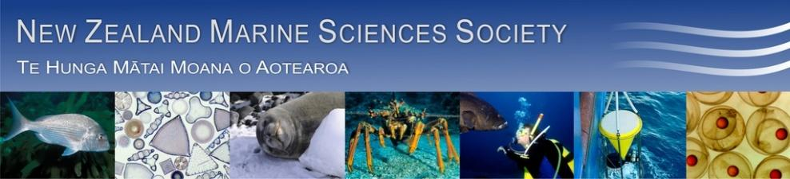

Minutes for 53rd AGM of NZMSS
Waikato University, Hamilton, New Zealand
August 21st 2013 3.45pm – 5.15pm

1. Attendees: Mary Livingston (chair), Helen Kettles (minutes), Helen Neil, Rochelle Constantine, Andrea C. Alfaro, Abby Smith, Paul Joutn, Stacie Lilley, Mike Hickford, Don Neale, Wendy Nelson, Kirsten Rodgers, Kareen Schnabel, Phil Ross, Drew Lohrer, Malcolm Francis, Kathy Walls, Lesley Bolton-Ritchie, Rich Ford, Michael Townsend, Rebecca Gladstone-Gallagher, Clarisse Niemand, Islay Marsden, Andrew Bell, Bob Hickman, Rachel Harris, Emily Douglas, Sarah Hailes, Kelly Carter, Natali Delorme, Mike Hudson, Leonardo Zamora, Hanieh Saeedi, Michelle Bentzhoff-Law, William Arlidge, Jeff Shima, Conrad Pilditch, Hilke Giles, Chris Conelisen, Chris Battershill.

2. Apologies – Will Rayment, Colin McLay, Nick Shears, Malcolm Clark.

3. Minutes of the 2012 AGM

A copy of the draft minutes are appended. Abby Smith moved they be accepted, Helen Neil seconded this and it was approved by members.

4. Matters arising from 2012 Minutes
No matters were raised.

5. Reports
a. President - Mary Livingston (page 6)
b. Treasurer - Chris Cornelisen (page 9)
c. Membership Secretary - Kerry South (page 11)
d. Website coordinator - Kerry South (page 11)

6. Matters arising from reports
It was noted that the 2013/14 budget was indicative. Chris thanked Abby for being able to authorise payments online.

Chris recommended an increase in the membership fee to $60.00 to account for an increase in fees associated with using on-line banking. Helen Neil moved that fees go up to $60 for professional membership, Rochelle Constantine seconded this and all present were in favour.

Abby strongly urged the Society to not elect as many as 26 people to Council but instead have a maximum of 16 (including 3 students). Conrad said he was happy to step down this year after long service to Council. He agreed with a leaner Council but encouraged Council to engage with the wider community via sub groups. Council members were reminded that they need to be committed to put time into the role. This year a number of important issues dropped through cracks and people should not be on Council if they are going to be away for blocks of time during the year.

It was suggested Council increase communication with members so they can raise issues to Council more. The new Council will be open to any suggestions for how to improve communications e.g. via listserve.

7. Election of Officers
- President
Nominations received: Mary Livingston (MPI) - nominated by Richard Ford, seconded by Colin McLay.

There were no further nominations from the floor. Helen N. (Vice President) declared Mary elected unopposed.

- Vice President
- Nominations received: Helen Neil (NIWA) - nominated by Scott Nodder, seconded by Alison MacDiarmid.

There were no further nominations from the floor. Mary declared Helen elected unopposed.

- Secretary (incumbent is not re-standing).
- Nominations received: Will Arlidge (MPI) – nominated by Mary Livingston, seconded by Neville Smith.

There were no further nominations from the floor. Mary declared Will elected unopposed.

- Treasurer (Chris Cornelisen is willing to re-stand but asks for trainee treasurer to move into role in 2014/15).
- Treasurer nominations received: Chris Cornelisen (Cawthron) - nominated by Hilke Giles, seconded by Ben Knight.
- Trainee treasurer nomination received: Michelle Beritzhoff (MPI) - nominated by Mary Livingston, seconded by Martin Cryer.

There were no further nominations from the floor. Mary declared Chris treasurer and Michelle as a trainee treasurer both elected unopposed.

- Council (at least 8).

Nominations received:
- Helen Kettles (DOC) – nominated by Sonja Miller, seconded by Helen Neil.
- Phil Ross (Uni Waikato) – nominated by Chris Battershill, seconded by Drew Lohrer.
- Kathy Walls (MPI) - nominated by Chris Battershill, seconded by Colin McLay.
- Abby Smith (Otago Uni) - nominated by Carolyn Lundquist, seconded by Mary Livingston.
- Nick Shears (Auck Uni)– nominated by Rochelle Constantine, seconded by Phil Ross.
- Hilke Giles (EW) – nominated by Judy Hewitt, seconded by Conrad Smith.
- Lesley Bolton (ECAN) – nominated by Kathy Walls, seconded by Richard Ford.

Mary officially thanked all those outgoing Council members: Don Neale, Drew Lohrer, Conrad Pilditch present at the AGM and willing to step down plus Will Rayment, Liz Slooten and Sharyn Goldstein.

Rochelle suggested a process similar for elections as the Marine Mammal Society runs where whole process is run electronically including voting.

- Membership Secretary (incumbent is not re-standing).
Helen Neil.

- Website/List Administrator (incumbent is not re-standing).
Phil Ross.

- Student Reps
Nominations received:
- Rebecca Gladstone-Gallagher nominated by Phil Ross, seconded by Drew Lohrer.
- Kristen Rodgers nominated by Abby Smith by Rochelle Constantine.

Don moved we accept all nominations, Rochelle seconded and all in attendance were in favour.

8. General Business

a. NZMSS Award – 2013 announcement
An announcement will be made at the conference dinner Thursday night.

b. Confirmation of next three conference locations (2014-2016)

2014 – Christchurch – 9-11 June are the preferred dates.

2015 – Auckland – Oceania Othicioan Society
Malcolm Francis said there is a lot of interest from this small society to join us. Nick Shears and Rochelle, involved in organising the Auckland conference, have spoken about this and have agreed.

2016 - Wellington (with AMSA) – we will need to firm up on ideas for this over the next 12 months.

Past conferences
2013 – Hamilton
2012 – Hobart/AMSA
2011 – Stewart Island
2010 – Wellington
2009 – Auckland
2008 – Christchurch/AMSA
2007 – Hamilton
2006 – Nelson
2005 – Wellington

c. Any other matters

Mary thanked all Council members who are stepping down. Helen has a gift of the 50th Anniversary Society Review document to give them.

Regarding the Annual Review
Do we still want to print off 450 pages for institutional members or print as Pdf and save some money? There has been some debate about whether to continue with this document. Part of the information is on the website (e.g. information about Council, conference abstracts), but two copies go to the National Library as a permanent record. It was noted that the National Library do save some information of Societys’ websites. Institutional contributions have declined over the years – there was only a 60% response rate this year so not as comprehensive as it could be. We could harvest information from Google scholar. New Council to discuss and make a decision well before next one is due.

Te Papa Relocation of Collections
There have been concerns about the restructure (loss of expertise, loss of the library and the plan now to move collections out of Wellington). The existing building was designed from Civil Defence so is safe, and there is little clarity around the reasons. A distributed network of collections has logistics issues for depositing specimens. Council sent a letter asking for information as have other Societies like Royal Society. No official response has been received from Te Papa yet. We also forwarded a copy of our letter to the Royal Society.

Wendy recommends the Council has a subcommittee to follow up on this issue. Volunteers from those attending were: Kareen Schnabel, Martin Cryer, Malcolm Francis, Chris Battershill, Rochelle Constantine.

Coastal Society Conference
Don Neale left a flyer for the Coastal Society Conference being held in Hokitika, 19-22 November. Hilke has been approached about a future joint conference with them.

On behalf of the Society, Abby thanked Helen for her work as secretary the past 3 years especially for her accuracy and strong organisational skills.

The new Council will meet briefly in the Foyer of SG Block at 11am tomorrow.

Close of meeting was 5.15pm.
NZMSS Council (2012-2013)

President: Mary Livingston MPI
Vice President: Helen Neil NIWA
Secretary: Helen Kettles DOC
Treasurer: Chris Cornelisen Cawthron
Immediate Past President: Colin McLay U Cant

Council Members:
Drew Lohrer NIWA
Kathy Walls MPI
Conrad Pilditch U Wkto
Simon Thrush NIWA
Liz Slooten U Otago
Kerry South U Cant
Dennis Gordon NIWA
Will Rayment U Otago
Sue Adkins U Cant
Abby Smith U Otago
Nick Shears U Auck
Hilke Giles Wkto RC
Don Neale DOC
Sharyn Goldstien U Cant
Chris Battershill U Wkto

Student Representatives:
Zeenatul Basher U Auck
Kirsten Rodgers U Auck
Darcy Webber Vic U
Matthew Desmond U Otago

Honorary Positions:
“Review” Editor: Stacie Lillie U Cant
Membership Secretary: Kerry South U Cant
Webmaster: Kerry South U Cant

President’s Report (2012-13) - Mary Livingston

Who we are
The New Zealand Marine Sciences Society, known as “NZMSS”, was formed in 1960 as a constituent society of New Zealand’s Royal Society, to encourage and assist marine science and related research across a wide range of disciplines in New Zealand and to foster communication among those with an interest in marine science.

NZMSS is a non-profit organization that provides access to and within the marine science community and identifies emerging issues through annual conferences, annual reviews, a listserve and this website. NZMSS membership covers all aspects of scientific interest in the marine environment and extends to the uptake of science in marine policy, resource management, conservation and the marine business sector. We speak for members of the society and we engage with other scientific societies as appropriate.

What We Do
- Organize and conduct an Annual Marine Science Conference, usually held in a New Zealand centre, but sometimes in conjunction with other New Zealand societies and our Australian colleagues.
- Periodically award the “New Zealand Marine Sciences Society Award” to any person who has made an outstanding contribution to the advancement of marine science. Nominations are called for and assessed annually.
- Provide First Overseas Conference Travel Funds travel assistance grants to student-members (applications due 1 Feb and 1 Aug).
- Provide Student Research Grant Funds (applications due 1 April) - to assist MSc and PhD candidates to take their work further than typical institutional funding allows.
- Provide written comment and independent submissions on relevant marine issues as they arise.
- Host a listserve where members can post, discuss, and debate marine science topics; advertise marine science positions and provide a calendar of conferences, workshops and relevant events; conduct society business.
- Publish the Annual New Zealand Marine Science Review that provides a directory of NZMSS members, marine research organizations and science personnel with a summary of research interests and publications.
- Raise public awareness of marine science through events, press releases, public activities, awards and the listserv

Council members July 2012 – August 2013
The Council this year has been one of the larger groups in recent years–26 including honorary positions – and I would like to take the opportunity of thanking each and every one of you for helping to get us through a very busy year. Having so many people on Council has its plus and minus sides. On the one hand, many hands make light work, but on the other, individuals can feel a bit lost on how best to contribute. This can be further exacerbated when we only meet by telephone conference calls for one hour per month! Council and I have prepared some role descriptions and itemised tasks that council members need to do during the year so that we can know who does what more readily when the new Council reconvenes.

Council activity 2012–13
The 2012-2013 year has been varied and full, and as well as business as usual, I gave outlined below some of the tasks that we have undertaken and completed:

- NZMSS has further updated its new web page which now has a Calendar of Events and provides access to student grant application forms and nomination forms http://nzmss.org/
- The listserve has been serviced by Council all year, providing members with news of marine interest, job vacancies, scholarships, Royal Society presentations and reports, as well as other items of interest.
- We revised our generic wording as above and agreed that we should use this as the background information source in all correspondence and on the website for the Society.
- Council has developed a new Advocacy Strategy whereby we have a procedure for developing submissions on marine issues. An integral part is the appointment of “Portfolio Groups” from within Council membership, and by invited contributions from outside experts. Currently we have three Portfolios: Marine Protected Areas (MPA), Oceans Policy (OP) and Education Outreach (EO). Draft Terms of Reference for all groups were finalised this year and some overall guidelines were completed. Functionally however, the Oceans Policy and Education Outreach groups have been relatively dormant.
- Submissions were prepared largely by the MPA Portfolio group for a number of marine protected area proposals, Conservation Management Plans and Strategies, and the Maui’s Threat Management Plans, during the year which you can download copies of from http://nzmss.org/documents/.
- We have also provided feedback to government processes for the National Science Challenges and the potential re-siting of the Te Papa collections.
- Last year’s conference was held jointly with the Australian Marine Sciences Association in Hobart. This was a very successful meeting with New Zealand delegates making up roughly 20% of the attendance. Thanks go particularly to Bob Hickman and to Kathy Walls for their efforts in liaising with Australia in preparation and follow-up.
- The 2013 NZMSS Conference is at Waikato University, Hamilton. It is another joint meeting, this time with the NZ Freshwater Society and the Australian Fish Biology Society, and I thank Conrad Pilditch, Drew Lohrer, Hilke Giles and the rest of the team in the Waikato Region for their untiring effort in what is NZMSS’ largest project each year.
- We are indebted to Stacie Lilley for assembling and illustrating the “NZMSS Annual Review” #53. This is a goldmine of information and what happened in Marine Science during 2011-2012. If you do not already have it, you can download a copy from http://nzmss.org/documents/.
- As many of you know, Kerry South is stepping down from her roles as website master and membership list manager. Kerry has completed this task for a small honorarium for the past 4 years, and we thank her profoundly for her steadfast commitment to the job during this time and the great improvements to our systems she has put in place.
- Chris Cornelisen has been brilliant in the role of Treasurer and this year we are seeking a “trainee treasurer” to work with Chris to transition into the role. Peter Scholtens has done a fine job in auditing our financial records and has provided invaluable suggestions to Council about ways to streamline our financial operations. Helen Kettles is stepping down after three years as secretary. Helen’s organisational skills are second to none and will be sorely missed by us, especially me...thanks Helen!
- Thanks also to Dennis Gordon and to our student reps who are stepping down this year as well.

The year has been one of ongoing change for marine sciences in New Zealand. The Ministry of Business Innovation and Employment has consulted on the new National Science Challenges offering the first increase in new research money in several years. The Natural Resource sector has been high-profile particularly with regard to opportunities for improving coordination of marine research and strategic development, and of course we have seen new legislation brought in for the EEZ. Some of the decision-making around hot topics such as Maui’s and Hector’s dolphins, the MPA in the Ross Sea and deep-sea drilling activities has been controversial, but what I do find encouraging is that New Zealanders are becoming more and more interested in their marine environment and that authorities are realising that in order to manage resources, they need an adequate information base, with competent scientists and expertise to advise and inform their deliberations.

Increased public participation has been seen in the Hauraki Gulf, Tasman Bay and the Kaipara Harbour providing three examples of renewed effort on community involvement in coastal issues. At the time of writing, it seems to me that the profile of marine science will continue to rise steeply over the next few years as New Zealand comes to grip with government direction and the evidence base for sustainable development in an environment that is already responding to the effects of existing human activities, climate change and ocean acidification. New Zealand contains significant marine world heritage sites, significant marine wildlife and unique biodiversity that needs appropriate stewardship and protection and I am looking forward to improved and better informed debate about marine issues in the public arena. I consider that as a professional scientific body, NZMSS is well positioned to take an increasingly active role in the quality of those debates.

Mary Livingston
President NZMSS, July 2013

Treasurer’s Report (2012-13) - Chris Cornelisen

Financial summary: Over the past year the Society’s income of approximately $21,000 matched its expenditures (Figure 1). Income included a surplus of $11,177 from the joint AMSA/NZMSS conference. A total of $9,301 and $4,000 was given to students for first overseas conference travel awards and research awards, respectively. Total assets, including term deposits (Figure 2), are currently $42,000.

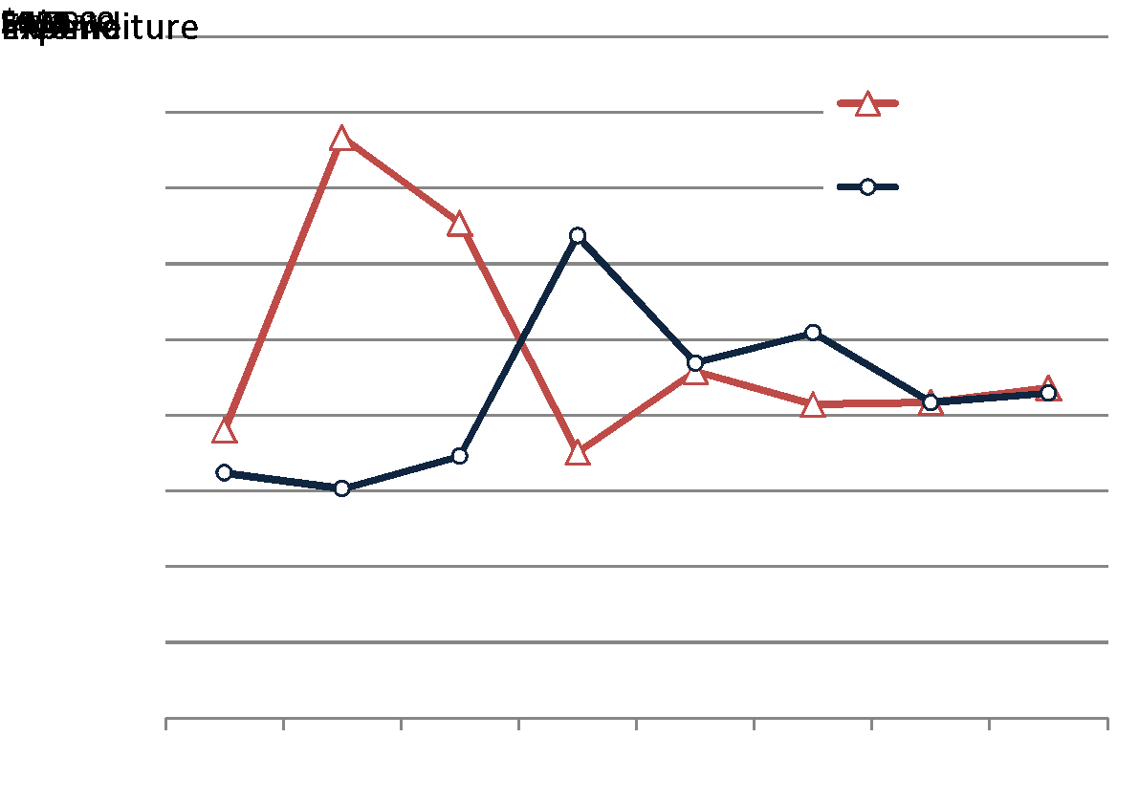
Figure 1: Annual NZMSS income and expenditures based on fiscal years (1 April to 31 March).

Proposed budget for 2013/2014: A proposed budget for the Society according to the current categories of spending is shown in Table 1. below. Nearly $30,000 remains in the Society’s term deposits. Some thought should be given by the Society and Council on additional ways NZMSS could be using (and generating) funds to support the Society’s mission.

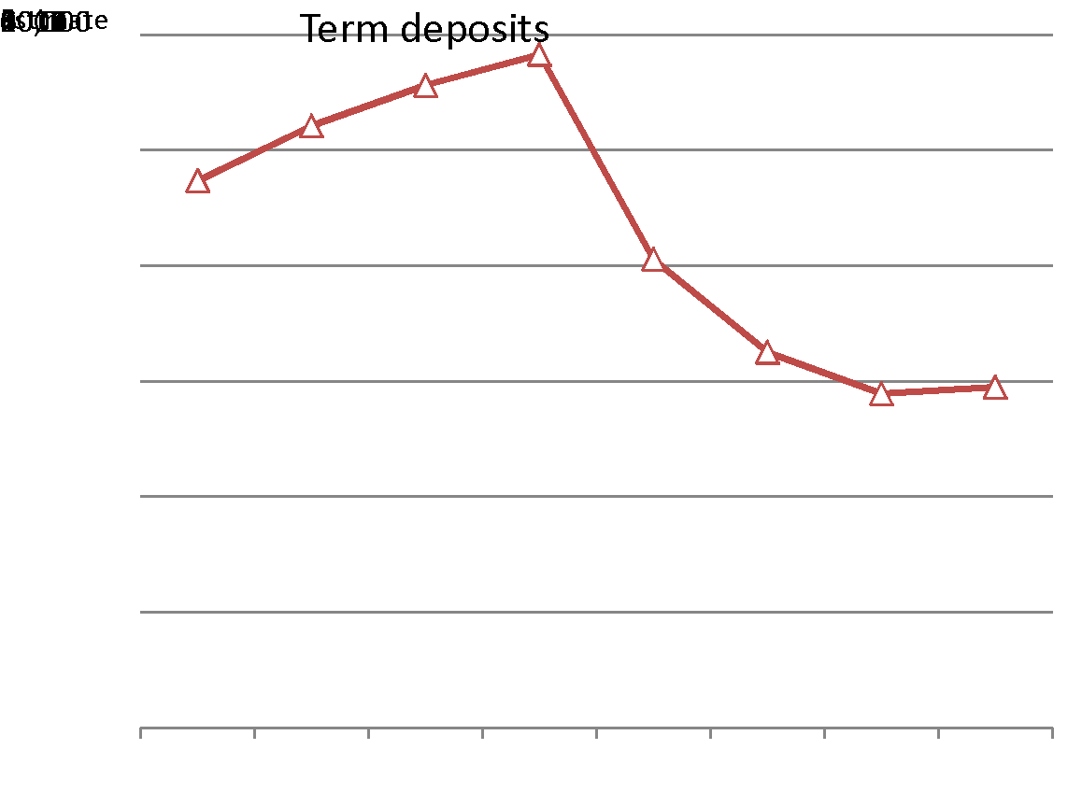
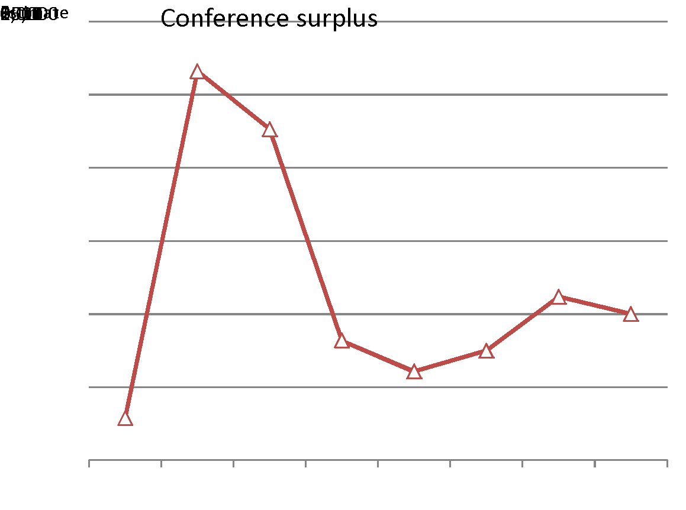
Figure 2: Term deposits (left) and conference surplus (right). Values for 2014 are estimates.

Table 1: NZMSS expenditures for last year and proposed budget for 2013/2014.

 | Last year | Proposed
 | 2012/2013 | 2013/2014
First overseas conf travel awards | 9301 | 9000
Student research awards | 4000 | 4000
Council general expenses | 848 | 900
Website maintenance/develop | 436 | 750
Royal Society Fees | 800 | 1000
Website honorarium | 500 | 500
Membership honorarium | 1500 | 1000
Annual Review | 1879 | 2000
Bank fees | 617 | 800
Audit/Accounting | 950 | 1500
Total expenditure | 20831 | 21450
Total Income | 20857 | 21800

Notes:
- There is some overlap between the fiscal year (1 April and 31 March) and budget amounts. For instance, student research awards budgeted in a given year may not be paid out until the next fiscal year due to timing.
- Payment of website and membership honorariums for last year is pending approval at AGM.
- Reduced budgets for honorariums are proposed due to more efficient systems put in place by Kerry South.
- An increased budget for accounting expenses is proposed for the coming year to improve systems for annual audits, reporting, etc.
- Total estimated Income for 2013/2014 includes interest received and an estimated conference revenue of $10,000 and membership revenue of $10,000.

Membership fees: Our current membership fees are $55 and $20 for professionals/institutes and students, respectively. We have not raised membership fees since 2010. Payments are now made almost exclusively using on-line banking, which in turn comes with increased banking fees (likely to be around $700-800 per annum). Based on this added cost alone, I recommend the Society consider raising the professional/Institute fee to $60 to cover this cost. Student fees could remain at $20.

Website Coordinator’s Report (2012-13) - Kerry South
website@nzmss.org

The website coordinator is responsible for maintaining the content of the NZMSS website and seeking technical support when required. This person also helps the Society maintain its domain name, email accounts, admin site access, and Google Account. Basic content maintenance is carried out by the coordinator once per month and council directed updates are made following council meetings and when requested by the NZMSS secretary.

Two new features have been added to the website this past year:
1. The majority of NZMSS membership payments are now made online through the membership page and paid for by credit card. As the membership secretary only processed memberships approximately every two weeks it was determined that automated invoice receipts were needed. This service was added in July 2013 and will address the need of many organisations to have a tax invoice for any credit card payments within 3-5 working days. The cost of adding this service was a one-time web developer fee.
2. The new calendar page shows NZMSS specific event dates and deadlines along with a second list of relevant marine science events. The top three upcoming dates are now displayed on the homepage in a new module found at the top right side of the page. It was agreed to leave the homepage calendar to be manually updated to keep the web developer fees lower when installing this new module.

This role will be turned over to Phil Ross following the AGM. In the upcoming year the new website coordinator will also be supported by a council subcommittee in order to facilitate focus on enhancing the content of the website. The new council will be responsible for deciding how much time is put into the website and if NZMSS needs to add new methods of communication (e.g. social media) to enhance the website.

Membership Secretary’s Report (2012-13) - Kerry South
membership@nzmss.org

Most years a large portion of membership payments are collected via the annual NZMSS conference. There is a core membership group who do renew their memberships each year but the Society does gain temporary memberships from individuals attending the conferences but who decide not to stay in NZMSS afterwards (students, individuals that move overseas). As the last conference was in Hobart, Australia run by the Australian Marine Science Association membership fees were not collected via the conference for the 2012-13 period. Instead members were reminded to renew their memberships via the NZMSS listserv (optional participation by NZMSS members) and through direct emails. This did require a much larger time commitment from the membership secretary and membership numbers are down likely as a result of this. There was also a decline in the 2011-12 memberships from 2010-11 but this is likely due to the smaller attendance at the NZMSS Conference that year (Stewart Island). The membership period for 2010-11 is highest most likely due to the 50th anniversary conference held that year which had high attendance.

Members | 2009-10 | 2010-11 | 2011-12 | 2012-13
Total members | 243 | 312 | 254 | 230
Institutional ($55) | 5 | 9 | 8 | 7
Full ($55) | 129 | 170 | 130 | 132
Life (waived) | 16 | 19 | 18 | 20
Retired ($20) | 1 | 3 | 2 | 2
Student ($20) | 92 | 111 | 96 | 75
*Fees include GST, no additional fee charged for credit card payment

The membership secretary role is being handed over after the AGM. As of this report the council is unaware of anyone willing to take over this role. The membership secretary’s role does require regular up-keep, communication with treasurer, attendance /reporting at monthly council meetings, and a willingness to learn how to use some associated online membership/banking systems. The previous membership secretary is happy to help guide the new secretary into this role. This role has recently experienced a drop in time commitment following the introduction of automated receipts for credit card payments. Please see the role description for more information.
2012-13 NZMSS Membership List (updated 27 July 2013)

Institutional Memberships/Subscriptions
Cawthron Institute
Department of Fisheries Western Australia
NSW Trade & Investment Library
NZ Rock Lobster Industry Council Ltd
Universitaetsbibliothek Johann Christian Senckenberg
University of California San Diego
WWF New Zealand

Full Membership
Abraham, Edward
Adkins, Sue
Arlidge, Will
Battershill, Chris
Bell, Andrew
Berry, Andrew
Blom, Wilma
Bolton-Ritchie, Lesley
Bradstock, Mike
Breen, Paul
Burrows, Sarah
Cameron, Marcus
Carbines, Megan
Carter, Kelly
Chiswell, Steve
Clarke, Chris
Clement, Deanna
Constantine, Rochelle
Cornelisen, Chris
Costello, Mark
Cryer, Martin
Currey, Rohan
Currie, Kim
Davey, Niki
Dawson, Steve
De Luca, Sharon
Dewhurst, Paul
Don, Graham
Douglas, Emily
Dunmore, Robyn
Dunn, Matthew
Dyck, Matthew
Ellis, Joanne
Ford, Rich
Froude, Victoria
Fyfe, Jim
Gault-Ringold, Melanie
Geange, Shane
Gibbs, Max
Giles, Hilke
Goldstien, Sharyn
Gorman, Richard
Grange, Ken
Grant, Coral
Hailes, Sarah
Hanchet, Stuart
Hayden, Barb
Hewitt, Judi
Hickford, Michael
Hills, Julie
Holdsworth, John
Hopkins, Grant
Hunt, Lou
Jacoby, Charles
Johnson, Sheri
Keeley, Nigel
Keen, Peter
Kelly, Shane
Kettles, Helen
Knight, Ben
Laing, Andrew
Lilley, Stacie
Livingston, Mary
Lohrer, Drew
Longdill, Peter
Lundquist, Carolyn
Mace, Chris
MacKenzie, Lincoln
Madarasz-Smith, Anna
Marsden, Islay
Mattlin, Rob
Maxwell, Kimberley
May, Stephanie
McKenzie, Jan
McLeod, Rebecca
Metcalf, Victoria
Mikaloff-Fletcher, Sara
Miller, Sonja
Mills, Sadie
Milne, Juliet
Neale, Don
Neil, Helen
Newcombe, Emma
Nodder, Scott
Northocote, Lisa
O'Driscoll, Richard
Oliver, Megan
Orpin, Alan
Osborne, Tracey
Paavo, Brian
Parker, Naomi
Patrick, Mike
Phillips, Nicole
Pickett, Vernon
Pilditch, Conrad
Pomerade, Marine
Pritchard, Daniel
Probert, Keith
Ragg, Norman
Rayment, Will
Read, Geoffery
Robinson, Natalie
Ryan, Ken
Savage, Candida
Schnabel, Kareen
Sharp, Ben
Shears, Nick
Slooten, Liz
Smith, Abigail
Smith, Murray
Smith, Neville
Smith, Shade
South, Kerry
South, Paul
Spong, Keren
Stevens, Craig
Stewart, Brian
Sullivan, Kevin
Taylor, David
Taylor, Richard
Thomsen, Mads
Tingley, Geoff
Tracey, Dianne
Tricklebank, Karen
Van Hale, Robert
Wade, Oliver
Wallace, Kath
Walls, Kathy
Ward, Nick
Wilson, Gary
Wilson, Oliver
Zhou (Victor) Yu

Retired Members
McLay, Colin
Troup, Christina

Life Members
Ballantine, Bill
Booth, John
Brodie, Jim
Carter, Lionel
Cassie-Cooper, Vivienne
Choat, Howard
Clark, Malcolm
Creese, Bob
Francis, Chris
Francis, Malcolm
Gordon, Dennis
Grieve, Janet
Hayward, Bruce
Heath, Ron
Hickman, Bob
Jillett, John
Mace, Pamela
Nelson, Wendy
Schiel, David
Thrush, Simon

Student Membership
Alestra, Tommaso
Alqaisi, Khalid
Armitage, Phoebe
Basher, Zeenatul
Boschan, Rachel
Boschetti, Simona
Braid, Heather
Brinkman, Johanna
Burrell, Tim
Bylenga, Christine
Cahill, Patrick
Chandurvelan, Rathishri
Cross, Cheryl
Culliford, David
Cumming, Rebecca
de Groot, Neeltje
Dwyer, Sarah
Evans, Aaron
Fairweather, Rex
Feng, Yuanyuan
Fernadez Subiabre Pamela Andrea
Getzlaff, Christy
Gladstone-Gallagher, Rebecca
Godomski, Kendall
Halliday, Katie
Hesse, Jan
Hill, Jessica
Hudson, Mike
Jackson, Susan
Jendersie, Stefan
Kelly, Jesse
Khan, Javad
Kolb, Juergan
Laferriere, Alix
Leal, Pablo
Lee, Tuan Meng Sonny
Lindsay, Rebecca
Long, Niharika
Lorange, Astrid
Macpherson, Diana
Malekar, Vanita
Miller, Ellen
Mullungal, Muhammed Nayeem
Paul, Sourav
Pecorino, Danilo
Peters, Catherine
Pine, Matt
Piraud Monsalve, Fernanda
Powell, Zack
Pratt, Daniel
Queenin, Jay
Rankmore, Krista
Rodgers, Kirsten
Rosli, Norliana
RS, Sruthi Thalayappilrasz
Saeedi, Hanieh
Scheuer, Kristin
Schuller, Susanne
Setiawan, Alvin
Sharp, Stacey
Shatova, Olga
Simpson, Linda
Skilton, Jen
Smith, Adam
Stuck, Ester
Suarez Jimenez, Rocio
Watts, Ashleigh
Webber, D'Arcy
Webby, Ashley
Webster, Trudi
Wilkinson, Shaun
Wilson, Peter
Woods, Emma
Yellapu, Bhargavi
Zhang, Jinhjing+

APPENDIX: 2012 AGM minutes for approval

Draft Minutes for 52nd AGM of NZMSS
Hobart, Tasmania
July 5th 2012

1. Present: Tommaso Alestra, Zeenatul Basher, Chris Battershill, Wilma Blom, Steve Chiswell, Malcolm Clark, Rochelle Constantine, Chris Cornelisen, Rohan Currey, Sarah Dwyer, Debbie Freeman, Rebecca Gladstone-Gallagher, Dennis Gordon, Katie Halliday, Mike Hickford, Bob Hickman, Mary Livingston, Jan McKenzie, Colin McLay (Chair), Don Neale, Helen Neil, Scott Nodder, Nicole Phillips, Daniel Pratt, Will Rayment, Kirsten Rodgers, Nick Shears, Liz Slooten (Minutes), Abby Smith, Jason Suwandy, Di Tracey, Kathy Walls, Darcy Webber (n=33).

2. Apologies: Mark Costello, Hilke Giles, Helen Kettles (Secretary), Conrad Pilditch (4).

3. Minutes of the 2010 AGM

Liz Slooten moved the minutes be accepted, seconded by Mary Livingston.

4. Matters arising from the minutes

None

5. Reports
a) Presidents Report (Colin McLay)

The New Zealand Marine Sciences Society (NZMSS) is a professional society of New Zealand’s marine scientists, affiliated to the Royal Society of New Zealand. We believe that the quality of use and protection of the New Zealand marine environment will be enhanced by the application of scientific knowledge and research. We must work together for a better future so that we leave a quality environment, high in biodiversity with adequate resources for posterity: this vital issue is in the public interest and should not be compromised for private gain. Perhaps most importantly we support the idea that balanced and sustainable use of the sea requires areas to be set aside where marine life can regenerate and seed surrounding areas.

We support, encourage and assist marine research by students registered for post-graduate degrees in New Zealand. Grants for students to assist their research and attend their first overseas conference are awarded as funds allow. In return successful applicants are asked to provide a report on benefits of the award. In addition student attendance to present their work at our annual conference is subsidized. Funding for student assistance comes from conference surpluses, sponsorships and donations to the Society. Graduates are the life-blood to improving our understanding and use of the sea and its inhabitants.

The 2011-2012 year has been very active and I outline below some of the tasks that we have undertaken and completed:

- NZMSS has a colourful new web page where many of the documents mentioned in this Report can be downloaded - http://nzmss.org/. This page also provides access to student grant application forms and nomination forms.
- We also have a new list server through which subscribed members can circulate news of marine interest. This has effectively replaced the periodic Newsletters that were previously circulated by email.
- Council has developed a new Advocacy Strategy whereby we have a procedure for developing submissions on marine issues. An integral part is the appointment of “Portfolio Groups” from within Council membership, and by invited contributions from outside experts. Currently we have three Portfolios: Marine Protected Areas (MPA), Oceans Policy (OP) and Education Outreach (EO).
- Submissions and contributions prepared by these groups and made on behalf of NZMSS concerned: the proposal for a Marine Reserve in Akaroa Harbour; evaluation of Coastal Plans for the Kermadec and Sub-Antarctic Islands; new legislation to define responsibilities and rules to manage the seas of the EEZ outside the territorial twelve-mile limit; commenting on the need to give science a high profile in the new super-ministry of Primary Industries, MPI; Best Fish Guide; Inshore fisheries observer program; Ecosystems Services paper prepared by the NZRS; the Kaikoura Te Korowai Marine Strategy (www.teamkorowai.org.nz) prepared by local Maori to integrate and manage the local marine environment in a sustainable way; you can download copies of these submissions from http://nzmss.org/.
- Last year’s conference was organized by Otago University members and held in Oban on Stewart Island. This very successful meeting was the first NZMSS conference to be held on the island and gave the opportunity to take advantage of the local hospitality and indulge in local delicacies. We all discovered that assembling marine scientists from all over the country within a small island community is a quite different experience than meeting on a campus in a large city. Council records its thanks to the OU organizers for their initiative.
- Council is involved with planning for the 2012 Conference which will be a joint meeting in Hobart, July 1-5, with the Australian Marine Science Association. The theme will be “Marine Extremes - And Everything In Between”. NZMSS was fortunate to receive support from several sponsors whose gifts enabled many students to attend. We are very grateful to two people in particular who have shouldered a lot of the load – Kathy Walls and Bob Hickman.
- The 2013 NZMSS Conference will be held at Waikato University, Hamilton and a local committee is already making plans for the event. It will be another joint meeting, this time with the NZ Freshwater Society and the Australian Fish Biology Society.
- This year the Council has undertaken revision of the NZMSS Rules. Basically the aim was to modernize the language used and to acknowledge what had become standard practice over the years. For example Council meetings are now conducted by teleconference among members in front of computer screens which can be scattered all the over New Zealand, and overseas if necessary. Decisions about motions in circulated digital documents must be made orally, rather than by show of hands, with the Secretary frantically keeping the minutes for later circulation by email. Potentially there can sometimes be no hard copies of any documents which are all stored on hard drives, rather than a filing cabinet. Defining what a “membership year” includes has become challenging now that members can join online at any time.
- The NZ Royal Society has restructured its fees for member organizations wherein only fulltime members (not students) attract a per capita fee and total fees are limited by a $500 minimum and $1500 maximum per organization. This will mean lower costs for NZMSS.
- We are indebted to Stacie Lilley for assembling and illustrating the “NZMSS Annual Review” #53. This is a goldmine of information and what happened in Marine Science during 2011-2012. If you do not already have it, you can download a copy from http://nzmss.org/

June 28 2012

b) Treasurer’s Report (Chris Cornelisen)

2010/11 Financial Report

Profit and Loss Account for the year ended 31 March 2011

 | 2011 |  | 2010
Income
Subscriptions Received | 13,569 |  | 6,573
Conference Net Income | 6,066 |  | 8,178
Interest Received | 3,249 |  | 2,794
Total Income | 22,884 |  | 17,545
Expenditure
Audit Fees | 595 |  | 556
Bank Fees | 470 |  | 371
Council and General Expenses | 2,846 |  | 2,334
First Overseas Conference Travel Awards | 8,600 |  | 19,500
Honorarium – Secretary/Website | 3,000 |  | 0
GST Arrears and Penalties | 0 |  | 784
NZ Marine Sciences Review | 1,964 |  | 1,466
NZMSS Award Sculpture | 0 |  | 700
Royal Society of NZ - affiliation fees | 631 |  | 631
Student Research Award | 5,330 |  | 4,000
Website Development | 0 |  | 1,500
 | 23,436 |  | 31,842
(Deficit) of Income over Expenditure for year | $(552) |  | $(14,297)
Balance Sheet as at 31 March 2011

 | 2011 |  | 2010
Members Funds
Balance 1 April | 66,050 |  | 80,347
(Deficit) of Income over Expenditure for Year | (552) |  | (14,297)
Balance 31 March | $65,498 |  | $66,050
Represented by:
Westpac Cheque Account | 3,588 |  | 2,060
Westpac Conference Bank Accounts | 24,905 |  | 0
Sculptures on Hand | 4,900 |  | 4,900
Accounts Receivable | 378 |  | 2,306
Westpac – Term Investments | 40,557 |  | 58,284
 | 74,328 |  | 67,550
Less Accounts Payable | 8,830 |  | 1,500
 | $65,498 |  | $66,050

Notes to the Financial Statements

Statement of General Accounting Policies
These financial statements have been prepared using the historical cost method. Accrual accounting has been used except as noted below, and reliance has been placed on the Society being a going concern.

Statement of Particular Accounting Policies
All subscription receipts have been accounted for on a cash basis.

These financial statements were prepared on a Goods and Services Tax (GST) exclusive basis.

Changes in Accounting Policies
There have been no changes in accounting policy. All policies have been applied on bases consistent with the previous year.

First Overseas Conference Travel Awards

2010/2011 2009/2010
Hazel Needham 500
Hannah Jones 600
Kathryn Lister 500
Sergio Carrasco 1,000
Andrea Varela 1,000
Tommaso Alestra 2,500
Adam Smith 2,500
$8,600 $19,500
There was no income specifically designated for the First Overseas Conference Travel Fund.
Student Research Awards
Katherine Jones and Danilo Pecorino

NZMSS Award Sculpture
No award (2010 – Dr Simon Thrush)

Accounts Receivable
GST Refund $378

Accounts Payable
FOCTA awards – March/April round 7,000
Research Award 1,830
Total $8,830

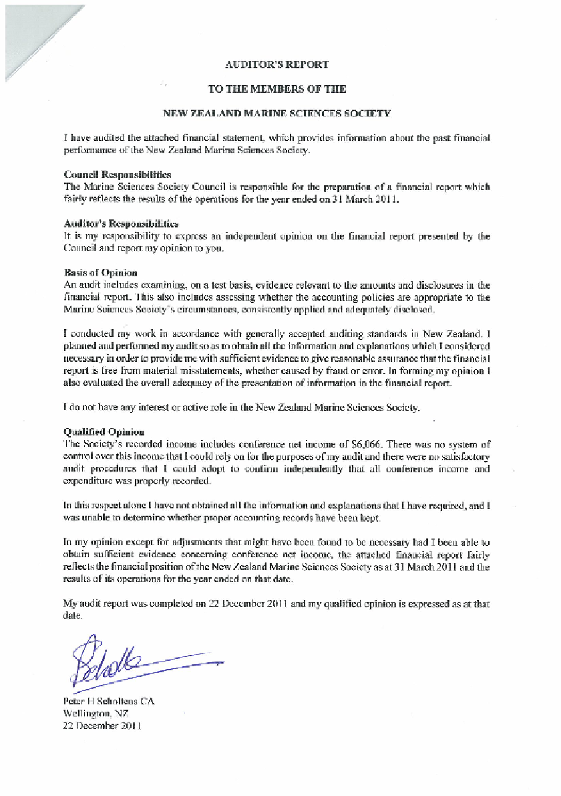

June 2012 Financial Report

The following covers the period 28 May 2012 to 26 June 2012

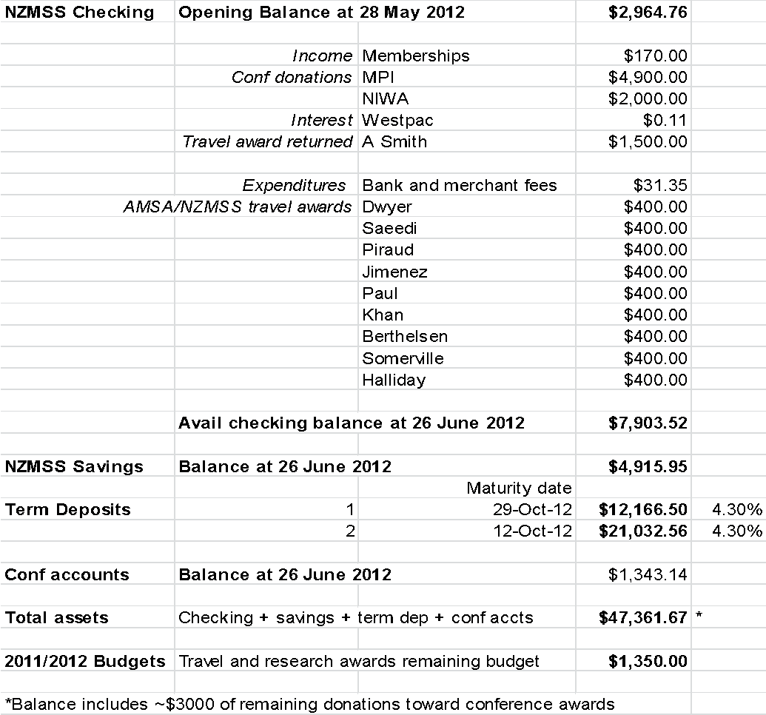

Income and Expenditure Account for the year ending 31 March

 | 2012* | 2011 | 2010 | 2009 | 2008 | 2007
Income
Subscriptions Received | 8,170 | 13,569 | 6,573 | 6,378 | 7,002 | 9,525
Conference Net Income | 2,403 | 6,066 | 8,178 | 22,644 | 26,604 | 2,885
Interest Received | 1,948 | 3,249 | 2,794 | 3,642 | 4,738 | 1,614
Total Income | $12,521 | $22,884 | $17,545 | $32,664 | $38,344 | $19,024
Expenditure
Audit Fees | 950 | 595 | 556 | 525 | 195 | 175
Bank Fees | 311 | 470 | 371 | 288 | 471 | 368
Council and General Expenses | 2,284 | 2,846 | 2,334 | 1,992 | 3,396 | 3,702
First Overseas Conference Travel Fund | 9,120 | 8,600 | 19,500 | 7,000 | 5,500 | 9,500
Honorarium – Secretary/Website | 0 | 3,000 | 1,500 | 1,600 | 0 | 0
GST Arrears and Penalties | 0 | 0 | 784 | 0 | 0 | 0
Lecture Tour NZMSS Award recipient | 0 | 0 | 0 | 796 | 568 | 0
NZ Marine Sciences Review | 2,157 | 1,964 | 1,466 | 1,306 | 1,155 | 1,808
NZMSS Award Sculpture | 0 | 0 | 700 | 700 | 700 | 0
Royal Society of NZ - affiliation fees | 1,417 | 631 | 631 | 595 | 669 | 643
Student Research Award | 1,830 | 5,330 | 4,000 | 2,500 | 2,500 | 0
Student Travel Grants** | 0 | 0 | 0 | 5,272 | 3,035 | 6,240
Total Expenditure | $18,069 | $23,436 | $31,842 | $22,574 | $18,189 | $26,537
Surplus (deficit) of Income over Expenditure | $(5,548) | $(552) | $(14,297) | $10,090 | $20,155 | ($7,513)

*The shaded column (2011/2012 year) is currently in “draft” form for the purpose of review/discussion at the AGM - the annual audit is currently being conducted by Peter Scholtens and final numbers may vary from those shown (or in some cases have not been fully calculated).
**Student travel subsidies paid from the conference account from 2010 onward.
 | 2012 | 2011 | 2010 | 2009 | 2008 | 2007
Members Funds
Balance 1 April | 65,498 | 66,050 | 80,347 | 70,257 | 50,102 | 57,615
Surplus (Deficit) of Income over Expenditure for Year | (5,548) | (552) | (14,297) | 10,090 | 20,155 | (7,513)
Balance 31 March | $59,950 | $65,498 | $66,050 | $80,347 | $70,257 | $50,102
Represented by:
Westpac accounts | 25,889 | 28,493 | 2,060 | 22,274 | 7,425 | 214
Sculptures on Hand | 4,900 | 4,900 | 4,900 | 5,600 | 6,300 | 0
Accounts Receivable | -- | 378 | 2,306 | 631 | 16,569 | 3,140
Westpac – Term Investments | 32,508 | 40,557 | 58,284 | 55,605 | 52,086 | 47,353
 | 63,927 | 74,328 | 67,550 | 84,110 | 82,380 | 50,707
Less Accounts Payable | -- | 8,830 | 1,500 | 3,763 | 12,123 | 605
Total | -- | $65,498 | $66,050 | $80,347 | $70,257 | $50,102

b) Membership Secretary’s Report (Kerry South)
membership@nzmss.org

Website update:
The website is now fully established and periodic updates are carried out by Kerry South as required by council. The website coordinator reviews the website on a monthly basis to ensure homepage is up-to-date and liaises with technical support when required. Managing the listserve is now a separate task headed by Colin McLay with backup support by Kerry South.

Membership process:
Online membership registration/renewal is available through the NZMSS website. This service seems to have assisted with making it easier for people to pay their membership fees. Credit card payments do require a quicker receipt turnaround time though so membership requires monitoring at least every two weeks. The secretary usually spends about an hour every two weeks processing memberships. While the secretary position still requires a significant amount of time, the treasurer time has been reduced for this process as almost all payments are processed via bank deposit or credit card now. The secretary is able to view these payments and provide receipts without treasurer input except in special circumstances.

Membership collection:
Lower numbers of full registrants this period are most likely due to the smaller 2011 conference as membership fees are collected with conference registration fees and there were ~100 less people as compared to the previous event. As no fees have been collected for 2012-12 through the Hobart conference extra efforts will have to be made this year to chase up individuals for their dues.

~$9480 in membership fees were collected for the 2011-12 membership period

Members | 2009-10 | 2010-11 | 2011-12
Institutional ($55) | 5 | 9 | 8
Full ($55) | 129 | 170 | 130
Life (waived) | 16 | 19 | 18
Retired ($20) | 1 | 3 | 2
Student ($20) | 92 | 111 | 96
*Fees include GST and no additional fee charged for credit card payment

6. Matters arising from reports.

The Treasurer (Chris Cornelisen) gave a short report on the statements. The accounts stand at about $40,000, there is a slow decline in funding. We need to consider how much money we’d like to spend on student travel to conferences and research awards. The Treasurer proposes not increasing membership fees – as these are on a par with other, similar societies. Our membership fees for institutions are very low compared to other organisations. Motion carried.

Abby Smith congratulated the Council for spending more on student travel than on administration. In general an organisation like this should have at least one year’s funding in reserve and we have much more than that.

Mary Livingston put forward a motion that Council should consider adding a marine award to the Royal Society awards. Mike Hickford asked that Council keep in mind possible conflict between any new award and our existing NZMSS Award.

Colin McLay moved that the reports be accepted. This was accepted by those present.

7. Election of officers

The following officer’s were confirmed:
President: Mary Livingston
Vice President: Helen Neil
Immediate Past President: Colin McLay
Secretary: Helen Kettles
Treasurer: Chris Cornelisen

Councillors:
1. Will Rayment
2. Abby Smith
3. Chris Battershill
4. Hilke Giles
5. Liz Slooten
6. Kathy Walls
7. Drew Lohrer
8. Sue Adkins
9. Denis Gordon
10. Sharon Goldstein
11. Nick Shears
12. Don Neale

Student members of council:
13. Kirsten Rogers (Auckland)
14. Zeenatul Basher (Auckland)
15. Darcy Webber (Wellington)

It was noted that we will need to find a couple more student representatives from the South Island – one from Canterbury and one from Otago.

8. General Business

8a. Awards were confirmed for: John Booth and Malcolm Clark. Malcolm was present and was congratulated by the meeting. A certificate will be presented at the Conference Dinner, but the Award trophies for both John and Malcolm will be presented at NIWA, Greta Point at a later date.

8b. Society Rules update
We need to follow up on the Society’s common seal which has been lost.

A document proposing changes to the Rules, which had been endorsed by Council, was circulated to members (see below). All the changes to the Rules were approved by the AGM except section 11 that the proposed abandonment of the Common Seal, and substitution of a digital form of the official letterhead, was questioned. This will require further investigation and reconsideration of the proposed change at the 2013 AGM. See: http://www.societies.govt.nz/cms/incorporated-societies/rules-of-incorporated-societies

8c. Motion: Council review current portfolios to see if they all should be supported and to see if we need new ones (moved by Mary Livingston, seconded by Kathy Walls. Motion approved.

8d. Chris Battershill would like to initiate a new portfolio group on Marine Biotechnology. This proposal will be discussed by the new Council.

8e. The next conference (2013) will be in Hamilton. Conrad Pilditch and Drew Lohrer are on the organising committee. It will be joint with the New Zealand Freshwater Society and Fish Biology Society.

Bob Hickman said we should look further ahead than the next conference (or two). We should decide 3-4 years ahead where the conferences will be held.
8f. Other general business:

Submissions on West Coast MPA’s are due soon. New Council to address.

Chris Battershill asked if NZMSS has links with the Coastal Society? Colin encouraged Chris to bring this up at Council. Mary said the new Council should explore working with the Coastal Society and other appropriate expert societies to build expertise in our portfolios.

Mary proposed a vote of thanks to Colin, as the outgoing President, and thanked him for his contribution to the Council. This was carried with acclamation.

