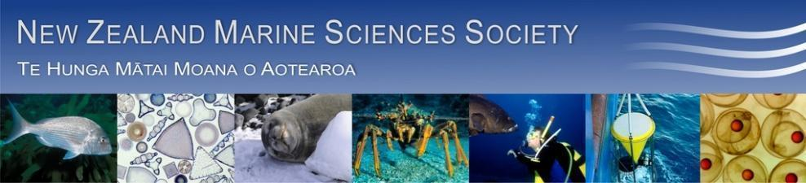
Minutes for 54th AGM of NZMSS.
Rutherford Hotel, Nelson, New Zealand.
1pm Wednesday 13th August 2014

Present: Mary Livingston (President/Chair), William Arlidge (Minutes), Helen Kettles, Helen Neil, Hilke Giles, Chris Cornelisen, Ross Sneddon, Robyn Dunmore, Robert Major, David Taylor, Nick Shears, Malcolm Francis, Rochelle Constantine, Jenny Hillman, Ben Knight, Hannah Jones, Emily Douglas, Rebecca Gladstone, Julien Huteau, Seiha Yen, Mark Camera, Simon Coubrough, Judy Rodda, Pamela Mace, Andrean Bell, Kathy Walls, Tuikolougahan Halafihi, Sharyn Goldstiene, Ashleigh Watts, Kristin Schewer, Abby Smith, Alison MacDiarmid, Lesley Bolton-Ritchie, Mark Kaemingk, Shane Kelly, Xavier Pochon, Anastasija Zaiko, Chris Battersohill, Conrad Pilditch, Steve Bird, Phil Ross, Michael Townsend, Malcolm Clark, Ken Grange, Katrina Goddard, Anna Berthelsen, Sally Carsan, Mike Hickford, Simon Childerhouse, Ros Squire, Kevin Heasman, Weimin Jiang, Michelle Beritzhoff.

- Apologies received: Colin McClay, Stacie Lilly.

- Minutes of the 2013 AGM - approved.

- A copy of the draft minutes is appended for approval (Appendix 1).

Moved by: Helen Neil Seconded by: Malcolm Clark

- Matters arising from 2013 Minutes
  - Te Papa relocation of collections (Appendix 2); follow up Agenda item 7b.
    - There was discussion on the most recent communication from Te Papa to the Society.
    - Mary Livingston noted that anyone could contact the council (secretary@nzmss.org) if they have a definite interest or concern over the collection.

  - Application to Royal Society for marine sciences medal outcome (Appendix 3); follow up Agenda item 7c.
    - Mary Livingston informed members of what happened with Council’s proposal to acknowledge John Morton with a Royal Society medal for marine sciences named after him.
    - Conrad Pilditch noted that if the Society was to go forward with the idea of such a medal, that there should be more of a differentiation with this medal than previously stated by Council.
    - There was general support for the proposal and it was thought that this should be an idea that should be put forward to the Royal Society in two years time.
    - Participants agreed that Mary Livingston could draw on Council members to form a sub-committee in which to take this idea forward in future.
    - Participants gave Council permission to continue to look into this idea, as there was general consensus that this would be a good initiative for the Society.

  - NZMSS Annual Review (Appendix 4); follow up Agenda item 7d.
    - Lesley Bolton-Ritchie acknowledged the Communications Portfolio Group for all their hard work on this topic and on other items throughout the year.
    - Participants all agreed that Council should continue with the proposal outlined in Appendix 4.

  - Audit from 2012-13 received (see Appendix 7a); follow up in Agenda Item 4b below.
    - NZMSS participants formally accepted the audit.

- Reports tabled to the AGM 2014
  - President - Mary Livingston (Appendix 6) - moved by Kathy Walls, seconded by Pamela Mace.
    - Mary Livingston discussed her president’s report, acknowledging that the smaller size of Council this year has been very beneficial as well as the benefits of mid-year meetings.
    - Mary Livingston proposed that the incoming Council continue the mid-year meetings.
    - Mary Livingston acknowledged the student Council members support.

  - Treasurer - Chris Cornelisen (Appendix 7) - moved by Abby Smith, seconded by Helen Neil.
    - Chris Cornelisen discussed the treasurer’s report, noting that the Council had a balanced budget this year.
    - Chris Cornelisen noted that as a result of the February 2014 Council face-to-face meeting, Council was able to stick more closely to the proposed budget for the remainder of the year.
    - Chris Cornelisen noted that following this years conference it is looking like there will be around an $8000-9000 profit.
    - Michelle presented the financial visio diagram to participants.
    - Chris Cornelisen reminded members that Council raised the NZMSS membership fees by $5 last year and that these are now in place. The reasoning behind raising the fees was a result of higher bank fees that the Council is receiving.
    - Chris Cornelisen reiterated to member that the profits made by conferences is passed on to students members through travel support to the conferences.
    - Michelle Beritzhoff noted her thanks to Chris Cornelisen for all his work as Council treasurer over the last 5 years.
    - Pamela Mace mentioned the high prices the Council is currently paying for bank fees and the audit fees, querying whether there is another way to bring these prices down? Chris Cornelisen made mention that the bank fees also includes the credit facility.
    - As an alternative to the use of a a credit facility, the idea of doing all transactions through direct deposit was floated by Pamela Mace.
    - Mary Livingston mentioned that there was a law change that required full auditing and that is why there have been large audit fees.
    - Participants agreed that Council should follow up in lowering the audit and bank fees for the Society.

  - Membership Secretary - Helen Neil (Appendix 8) - moved by William Arlidge, seconded by Kathy Walls.
    - Nothing to note beyond what is included in Appendix 8.

- Election of Officers for 2014-15 (Appendix 9 lists current Council) - Nominations received to date are listed below. Further nominations may be made at the AGM.

  - President (Mary Livingston is stepping down as she has held office for the maximum period).
    - Helen Neil nominated by Abby Smith, seconded by William Arlidge. Accepted

  - Vice President (Helen Neil is stepping down as she has held office for the maximum period). Hilke Giles was nominated by Mary Livingston, seconded by Helen Neil. Hilke Giles accepted the position of Vice President.
    - Nick Shears was nominated by Mary Livingston, seconded by Pamela Mace. Nick declined the nomination offer.

  - Secretary (William Arlidge is willing to re-stand).
    - Nominated by Kathy Walls, seconded by Helen Kettles. William accepted the position of Secretary.

  - Treasurer (Chris Cornelisen is stepping down after 5 years).
    - Michelle Beritzhoff was nominated by Phil Ross, seconded by Chris Cornelisen. Michelle accepted the position of Treasurer.

  - Council (at least 5).
    - Helen Kettles is willing to re-stand.
      - Nominated by William Arlidge, seconded by Kareen Schnabel.
    - Lesley Bolton-Ritchie is willing to re-stand.
      - Nominated by Kathy Walls, seconded by Nick Shears.
    - Kathy Walls is willing to re-stand.
      - Nominated by Mary Livingston, seconded by Lesley Bolton-Ritchie.
    - Nick Shears is willing to re-stand.
      - Nominated by Mary Livingston, seconded by Kathy Walls.

  - Abby Smith is standing down after 2 years (Abby’s previous stints on Council are also acknowledged).

  - Immediate Past President Colin McLay is standing down after his major contribution of 10 years on Council.

  - Chris Cornelisen is standing down after 5 years as Treasurer. Chris mentioned that he is happy to keep a shadow treasurer role should he be needed throughout the year.

  - One position on Council is open. Council strongly recommends that someone from Auckland step-up to provide the link between Council and the Conference 2015 sub-committee.
    - Will Rayment was nominated by Abby Smith, seconded by Michelle Beritzhoff. Will Rayment was welcomed onto the Council.
    - Sharyn Goldstien was nominated by Mike Hickford, seconded by Dave Taylor. Sharyn Goldstien was welcomed onto the Council.

  - Student Reps (at least 2).
    - Emily Douglas is willing to re-stand.
      - Nominated by Conrad Pilditch, seconded by Drew Lohrer.
    - Rebecca Gladstone-Gallagher is willing to re-stand.
      - Nominated by Michael Townsend, seconded by Carolyn Lundquist.
    - Jenny Hillman was nominated by Rochelle, seconded by Malcolm Francis. Jenny Hillan was welcomed onto the Council.

  - Immediate Past President Mary Livingston

  - Membership Secretary no nominations received Lesley Bolton-Ritchie

  - Website/List Administrator Phil Ross

Malcolm Clark moved an offer of thanks for the outgoing offices.

- General Business
  - NZMSS Award for 2014 has been evaluated and will be announced at the dinner.

  - Te Papa and ongoing interactions (Appendix 2).

  - Follow up on Royal Society award. Recommendation for a 2nd award within Council (Appendix 3).
    - The proposal for a John Morton medal was discussed again with the wording put forward by Council read out to participants (see Appendix 6 - Presidents report for wording).
      - Participants were in favour of the proposal.
      - Mary Livingston moved that the proposal be approved, seconded by Helen Neil.

  - NZMSS Annual Review recommendations (Appendix 4)
    - Already discussed previously, see agenda item 4, b) above.

  - Council advocacy and portfolio groups (Appendix 6)
    - The Ocean Policy Portfolio Group was discussed and it was proposed that this group be parked for the meantime.
      - All participants were in favour.
    - Communications Portfolio Group
      - Kerry South expressed interest to be part of the Communication Portfolio Group in the coming year.

  - NZMSS photographic competition proposal (Appendix 5)
    - Mary Livingston mentioned that this idea it intended to be more of an exhibition than a competition and that there are still some items to be worked out.
    - Participants thought it was a good idea and that it should be pursued through the Communications Portfolio Group.

  - Future NZMSS Conferences
    - Mary Livingston thanked the Council Organising Committee for organising the Nelson 2014 Conference, especially at late notice regarding dates.
    - Mike Hickford requested that the Council ensure that future conferences occur during the University holidays.
      - Apologies were given from Council as this years Council was scheduled during the University term time.
    - Confirmed 2015 –Auckland, (University of Auckland) - joint with Oceania Chondrychthyan Society - theme to be finalised.
      - Rochelle Constantine confirmed that next years conference will be held during 6-9th July. With the 6th July is being registration day and activities, and the 7th-9th being conference days.
    - Confirmed 2016 – Wellington, (MPI and Victoria University) - joint with AMSA. This also coincides with 30 Years of the QMS. A strong fisheries focus in a Shared Ocean theme.
      - The need to set up the sub-committee now to start planning was discussed.
        - Sub-committee – Matt Dunn, Alistair Dunn and Alison MacDiarmid have put their names forward.
      - Follow up on joint conference proposal with NZ Coastal Society required
    - Where next for 2017 and beyond?
      - A South Island conference for 2017 was discussed.
      - Phil Ross mentioned that the Society could hold a Conference in Tauranga potentially in 2018.

- Any Other Business
  - Kaikoura Marine Guardians Group – nominations?
    - Sharyn Goldstien has been appointed already.
    - Further nominations to be emailed to Mary Livinston (Mary.Livingston@mpi.govt.nz).

Close of meeting.

Appendix 1 – 2013 AGM minutes for approval

Minutes for 53rd AGM of NZMSS
Waikato University, Hamilton, New Zealand
August 21st 2013 3.45pm – 5.15pm

1. Attendees: Mary Livingston (chair), Helen Kettles (minutes), Helen Neil, Rochelle Constantine, Andrea C. Alfaro, Abby Smith, Paul Joutn, Stacie Lilley, Mike Hickford, Don Neale, Wendy Nelson, Kirsten Rodgers, Kareen Schnabel, Phil Ross, Drew Lohrer, Malcolm Francis, Kathy Walls, Lesley Bolton-Ritchie, Rich Ford, Michael Townsend, Rebecca Gladstone-Gallagher, Clarisse Niemand, Islay Marsden, Andrew Bell, Bob Hickman, Rachel Harris, Emily Douglas, Sarah Hailes, Kelly Carter, Natali Delorme, Mike Hudson, Leonardo Zamora, Hanieh Saeedi, Michelle Bentzhoff-Law, William Arlidge, Jeff Shima, Conrad Pilditch, Hilke Giles, Chris Conelisen, Chris Battershill.

2. Apologies – Will Rayment, Colin McLay, Nick Shears, Malcolm Clark.

3. Minutes of the 2012 AGM

A copy of the draft minutes are appended. Abby Smith moved they be accepted, Helen Neil seconded this and it was approved by members.

4. Matters arising from 2012 Minutes
No matters were raised.

5. Reports tabled with the agenda and circulated 2 weeks prior to the 2013 AGM
a. President - Mary Livingston b. Treasurer - Chris Cornelisen c. Membership Secretary - Kerry South d. Website coordinator - Kerry South Who moved and seconded that the reports be received

6. Matters arising from reports
It was noted that the 2013/14 budget was indicative and subject to approval by the auditor. Chris thanked Abby for being able to authorise payments online.

Chris recommended an increase in the membership fee to $60.00 to account for an increase in fees associated with using on-line banking. Helen Neil moved that fees go up to $60 for professional membership, Rochelle Constantine seconded this and all present were in favour.

Abby strongly urged the Society to not elect as many as 26 people to Council but instead have a maximum of 16 (including 3 students). Conrad said he was happy to step down this year after long service to Council. He agreed with a leaner Council but encouraged Council to engage with the wider community via sub groups. Council members were reminded that they need to be committed to put time into the role. This year a number of important issues dropped through cracks and people should not be on Council if they are going to be away for blocks of time during the year.

It was suggested Council increase communication with members so they can raise issues to Council more. The new Council will be open to any suggestions for how to improve communications e.g. via listserve.

7. Election of Officers
- President
Nominations received: Mary Livingston (MPI) - nominated by Richard Ford, seconded by Colin McLay.

There were no further nominations from the floor. Helen N. (Vice President) declared Mary elected unopposed.

- Vice President
- Nominations received: Helen Neil (NIWA) - nominated by Scott Nodder, seconded by Alison MacDiarmid.

There were no further nominations from the floor. Mary declared Helen elected unopposed.

- Secretary (incumbent is not re-standing).
- Nominations received: Will Arlidge (MPI) – nominated by Mary Livingston, seconded by Neville Smith.

There were no further nominations from the floor. Mary declared Will elected unopposed.

- Treasurer (Chris Cornelisen is willing to re-stand but asks for trainee treasurer to move into role in 2014/15).
- Treasurer nominations received: Chris Cornelisen (Cawthron) - nominated by Hilke Giles, seconded by Ben Knight.
- Trainee treasurer nomination received: Michelle Beritzhoff (MPI) - nominated by Mary Livingston, seconded by Martin Cryer.

There were no further nominations from the floor. Mary declared Chris treasurer and Michelle as a trainee treasurer both elected unopposed.

- Council membership (at least 5).

Nominations received:
- Helen Kettles (DOC) – nominated by Sonja Miller, seconded by Helen Neil.
- Phil Ross (Uni Waikato) – nominated by Chris Battershill, seconded by Drew Lohrer.
- Kathy Walls (MPI) - nominated by Chris Battershill, seconded by Colin McLay.
- Abby Smith (Otago Uni) - nominated by Carolyn Lundquist, seconded by Mary Livingston.
- Nick Shears (Auck Uni)– nominated by Rochelle Constantine, seconded by Phil Ross.
- Hilke Giles (EW) – nominated by Judy Hewitt, seconded by Conrad Smith.
- Lesley Bolton (ECAN) – nominated by Kathy Walls, seconded by Richard Ford.

Mary officially thanked all those outgoing Council members: Don Neale, Drew Lohrer, Conrad Pilditch present at the AGM and willing to step down plus Will Rayment, Liz Slooten and Sharyn Goldstein.

Rochelle suggested a process similar for elections as the Marine Mammal Society runs where whole process is run electronically including voting.

- Membership Secretary (incumbent is not re-standing).
Helen Neil.

- Website/List Administrator (incumbent is not re-standing).
Phil Ross.

- Student Reps
Nominations received:
- Rebecca Gladstone-Gallagher nominated by Phil Ross, seconded by Drew Lohrer.
- Kristen Rodgers nominated by Abby Smith by Rochelle Constantine.

Don moved we accept all nominations, Rochelle seconded and all in attendance were in favour.

8. General Business

a. NZMSS Award – 2013 announcement
An announcement will be made at the conference dinner Thursday night.

b. Confirmation of next three conference locations (2014-2016)

2014 – Christchurch – 9-11 June are the preferred dates.
Some discussion followed to suggest that early June might be very difficult for the incoming Council to deal with, and that it was outside the agreed conference window of July-August. It was agreed that the new Council would discuss alternative dates further with Mike Hickford.

2015 – Auckland – Oceania Chondrichthyan Society
Malcolm Francis said there is a lot of interest from this small society to join us. Nick Shears and Rochelle, involved in organising the Auckland conference, have spoken about this and have agreed.

2016 - Wellington (with AMSA) – we will need to firm up on ideas for this over the next 12 months.

Past conferences
2013 – Hamilton
2012 – Hobart/AMSA
2011 – Stewart Island
2010 – Wellington
2009 – Auckland
2008 – Christchurch/AMSA
2007 – Hamilton
2006 – Nelson
2005 – Wellington

c. Any other matters

Mary thanked all Council members who are stepping down. Helen Kettles has a gift of the 50th Anniversary Society Review document to give them.

Annual Review
Do we still want to print off 450 pages for institutional members or print as Pdf and save some money? What was the answer for this?

There has been some debate about whether to continue with this document. Part of the information is on the website (e.g. information about Council, conference abstracts), but two copies go to the National Library as a permanent record. It was noted that the National Library do save some information from institutional websites including NZMSS. Institutional contributions to the review have declined over the years – there was only a 60% response rate this year so not as comprehensive as it could be. We could harvest information from Google scholar. New Council to discuss and make a decision well before next one is due.

Te Papa Relocation of Collections
There have been concerns about the restructure (loss of expertise, loss of the library and the plan now to move collections out of Wellington). There is little clarity around the reasons for this. A widely distributed network of collections has logistics issues for depositing specimens. Council sent a letter asking for information as have other Societies like Royal Society. No official response has been received from Te Papa yet. We also forwarded a copy of our letter to the Royal Society.

Wendy recommended the Council has a subcommittee to follow up on this issue. Volunteers from those attending were: Kareen Schnabel, Martin Cryer, Malcolm Francis, Chris Battershill, Rochelle Constantine.

Coastal Society Conference
Don Neale left a flyer for the Coastal Society Conference being held in Hokitika, 19-22 November. Hilke has been approached about a future joint conference with them.

On behalf of the Society, Abby thanked Helen for her work as secretary the past 3 years especially for her accuracy and strong organisational skills.

The new Council will meet briefly in the Foyer of SG Block at 11am tomorrow.

Close of meeting was 5.15pm.

Appendix 2 – Te Papa Collections update (June 2014)

Correspondence received by NZMSS president from Karen Mason, the Associate Director for “Museum for the Future” at Te Papa after the CE Michael Houlihan moved to his new role.
“I [Karen Mason] can confirm that planning for the relocation of selected Te Papa collections has not advanced any further. This is because Cabinet has requested that we undertake further external consultation in order to inform the business case and architectural brief for the proposed new Collections and Learning Centre in Manukau. The consultation programme is expected to begin in August. (No alternative or additional sites are being considered at this time).
In the first instance, it will involve consulting with various South Auckland community leaders, members of local Boards, educators and a range of individuals about their aspirations for the Centre. During this process, it will be explored which collections from Te Papa, Auckland Museum and/or Auckland Art Gallery would be most relevant to the needs of local communities.
Subsequent recommendations will then be considered by staff at Te Papa and our partner institutions.
In parallel, much broader consultation around science at Te Papa, and our natural history collections, is about to begin. This will be led by a Panel of external scientists who have been tasked with reviewing our current research activities and collection development plans. In essence, the Panel's role is to help identify how Te Papa can sustainably maximise current research and collection strengths, and to identify new opportunities for public engagement and mutually beneficial partnerships. Future collection access and storage needs will be factored into the process.
Both organisations that you represent [NZMSS and MPI] will be invited to participate. (I'll shortly forward a Press Release which went out earlier today that provides further background info about the Panel, along with news of the appointment of Professor Peter Gluckman to our Board).
I can also confirm that a capital maintenance plan remains in place for our Tory Street facility to ensure the care and safety of national collections at that site, the majority of which are natural history collections.
Please don't hesitate to contact either of us again with any further queries.

Best regards
Karen [Mason]
Appendix 3 – Response from Royal Society with respect to NZMSS proposal for recognition of marine science in New Zealand

Dear Mary

Thank you for your letter of 27 January. This was discussed at the meeting of the Royal Society Council last week. I hope you will excuse a reply by email, because tomorrow I have to leave to chair a WHO meeting in Geneva.

You made a very persuasive case for establishing a new medal in marine science, but I am sorry that - after much discussion - the Council felt that the Royal Society should not take this on itself. There has been some proliferation in RSNZ medals and awards in recent years, to the extent that we are no longer able to present all of these at our annual Research Honours Dinner. Hence it is considered that we should now add to the list only in the most exceptional circumstances.

Council members pointed out that there are a number of medals awarded by constituent organisations such as yours, and that the recipients enjoy receiving these from their peers.

I am sorry that this decision will be disappointing, and we do hope that the NZMSS will proceed to establish its own medal. As someone who enjoyed John Morton's Zoology 1 lectures in Auckland, I also think it is an excellent idea to name the medal after him!

With kind regards

David

David Skegg
President
Royal Society of New Zealand

Appendix 4 – Future of the Annual Review – recommendations from the Communications Portfolio Group, endorsed by Council:

The NZMSS has been producing the Annual Review for 54 years. Over that time is has provided a very valuable record of the Society’s business but in the last few years there have been discussions about whether it should continue in its current form because of advances in the online environment. This needs to be given due consideration by Council and the membership so that we do not make rash decisions and lose the value it gives to us as a Society.
The Communications Portfolio Group has assessed the content, and pros and cons of the options, and provided a report that is under assessment by Council. The following recommendations ensures all content in the Annual Review is either keep as a record in Council documents (e.g. AGM minutes, Conference Proceedings) or will be available via the website.

For 2014/15 we recommend that the Society:
- Discontinues the Annual Review in its current form but ensures that the content is made accessible elsewhere, where possible.
- Develops a Policy for Society Records that will detail where records of the Society are kept including Google documents library, AGM minutes, Conference Proceedings, Conference Report, hard copy documents to be sent to the National Library.
- Make some core changes to the website pages:
  - The “Resources” tab will be changed to “Connecting our Science Community”. Each contributing organisation’s pages (similar to those on the Annual Review) will be accessed from here.
  - A new tab called “Science News” will be set up to showcase items of interest. Ideas for this will be canvased from the listserv monthly.
- That Council considers using up to the amount of the annual budget ($2,000) previously used for the Annual Review for these items. There may also be some additional costs if we are to have a more engaging website. The incoming Council should weigh up the priorities for the budget.

Communications Portfolio Group: Helen Kettles (convenor), Phil Ross, Sally Carson, Kareen Schnabel.

Appendix 5 – Proposal to members at AGM re the potential for an NZMSS annual photographic exhibition

a. A proposal has been received by Council for the development of a photographic exhibition as part of the annual conference. The main goal would be for Society members to have a forum to explore visual communication of our science through photography. It would also enable us to build up a pool of images that communicate our science for general use and promotion of the activities of the Society.
b. To raise the profile, it has been suggested that local photographers of note be invited to assess the entries and identify Best Photo and up to 3 Highly Commended photos.
c. The proposal is “that the incoming Council explores the concept of an annual photographic exhibition for NZMSS members with a view to a trial run at the 2015 conference” proposed by Mary Livingston seconded by William Arlidge.

Appendix 6 – President’s Report 2013/14

The Council had 16 members (2 were student representatives) and through the year there were 12 meetings. The 2013-2014 year has again been a very busy one and I outline below some of the tasks that we have undertaken and completed as Council:
- NZMSS has a colourful new web page where many of the documents mentioned in this Report can be downloaded - http://nzmss.org/.
- We also have a list server through which subscribed members can circulate news of marine interest. Please contact anyone on Council to get your contribution uploaded
- Council has finalised its Advocacy and Portfolio Guidelines whereby we have a procedure for developing submissions on marine issues. An integral part is the appointment of “Portfolio Groups” from within Council membership, and by invited contributions from outside experts. Currently we have two Portfolios: Marine Protected Areas (MPA) which remains active and Oceans Policy (OP) which is has not. A third portfolio “Science Communication” is under development and appears to be active.
- Responsive submissions prepared by Council and made on behalf of NZMSS during the year included:
    - Draft Exclusive Economic Zone and Continental Shelf (Environmental Effects - Non- Notified Activities) Regulations 2013 (30 January 2014);
    - NPS Freshwater and National Objectives Framework (31 January 2014);
    - MfE Environmental Reporting Bill (17 April 2014); and
    - The Kaikoura (Te Tai-o-Marokura) Marine Management Bill (17 April 2014).
    - Appearances before committees to speak to our submissions was made on one occasion by Nick Shears to the select committee on Kaikoura MPA design.
  - You can download copies of these submissions from http://nzmss.org/documents/documents-of-public-statement-or-release.
- Proactive letters were sent on the following topics:
- NZMSS letter to Te Papa regarding collections submitted July 2013 (see http://nzmss.org/documents/documents-of-public-statement-or-release for copies).
- Congratulations to Professor Dave Schiel for receipt of his award for outstanding contributions to marine science, presented at the 10th International Reef Symposium in Perth.
- Application to the Royal Society Executive Council for a Marine science Award “The John Morton Medal” was made.
- Planning for the 2015 Conference which will be held jointly with the Chondrychthyan Society meeting in Auckland, July 1-5 is progressing.
- Planning for the conference in Wellington to be held jointly with AMSA in early July, 2016 is also underway.
- NZMSS supported eight students to attend their first overseas conference and gave one grant to support student research.
- Three years ago the Society acknowledged the passing of one of its best-known and most influential identities, Professor John Morton. Council placed a proposal to the Royal Society for a medal to honour John Morton and marine sciences to the Royal Society. Our proposal was eventually rejected. Instead, Council has proposed that an award that commemorates John Morton be made by NZMSS “The John Morton Medal for marine conservation and sustainability - “Periodically the Council of the Society may present an award, known as the "Morton Medal for advances in Marine Conservation and Sustainability to any person who they believe has made an outstanding contribution to the scientific advancement of marine conservation and sustainability in New Zealand”, (Agenda Item).
- After considerable discussion, Council eventually decided that an early June conference in 2014 was not feasible given the membership of Council and the timing of government and CRI financial years. Thanks to Mike Hickford and his team in Canterbury for their flexibility about this decision; and of course to the new conference committee who stepped up under considerable time pressure to convene and organise our 2014 meeting in Nelson. We are indebted to Kerry O’Connell for working with the Organizing Committee to prepare for the 2014 Conference in Nelson.
- A welcome guide outlining different council roles and modus operandum for Council members was completed
- A conference guideline was also prepared by Council
- Council has identified a way forward to replace the Annual Review
- Nominations for NZMSS Award for Excellence in Marine Science in 2014 have been evaluated and will be announced at the dinner during the conference in Nelson this year.

I believe that Council efficiency and modus operandum has been improved this year by having fewer people on Council and by holding a face-to-face meeting in February.
The face-to-face Council Meeting enabled us to discuss the annual budget and identify some of society goals for the coming two or three years for the first time. It was great to get to know everyone and to see the students participate. I recommend that Council continue this activity.

Many heartfelt thanks to the Council Members and the Conference sub-committee for their hard work and responsiveness to issues as they have arisen during this year and for supporting me during the last two years. These are challenging times and everyone seems to have such high workloads in their day jobs that it is increasingly difficult to find the will and the energy to fulfil Council on top of everything else. The fact that things still get done reflects the level of commitment and passion to marine science and to NZMSS that we share.

I have enjoyed the challenge of being President over the past two years and look forward to continuing to support the Society as past president and in its future directions.

Mary Livingston, President, 18 July 2014.

Appendix 7 – Treasurer’s Report (2013-2014) - Chris Cornelisen

Appendix 7a – Auditor’s Report for 2013/2014 received
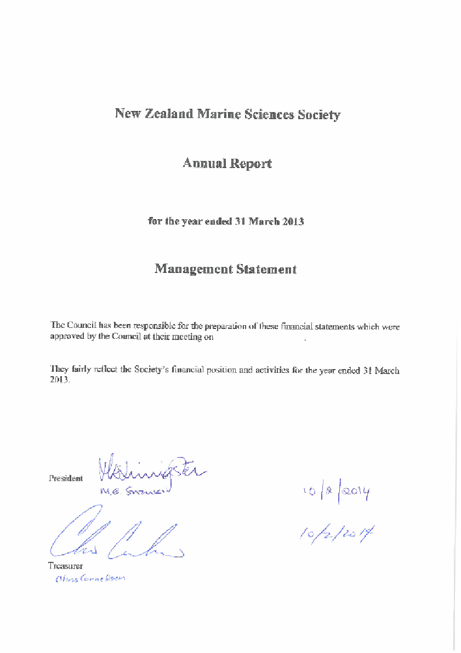

Appendix 7a (Continued) – 2013 Financial Statement
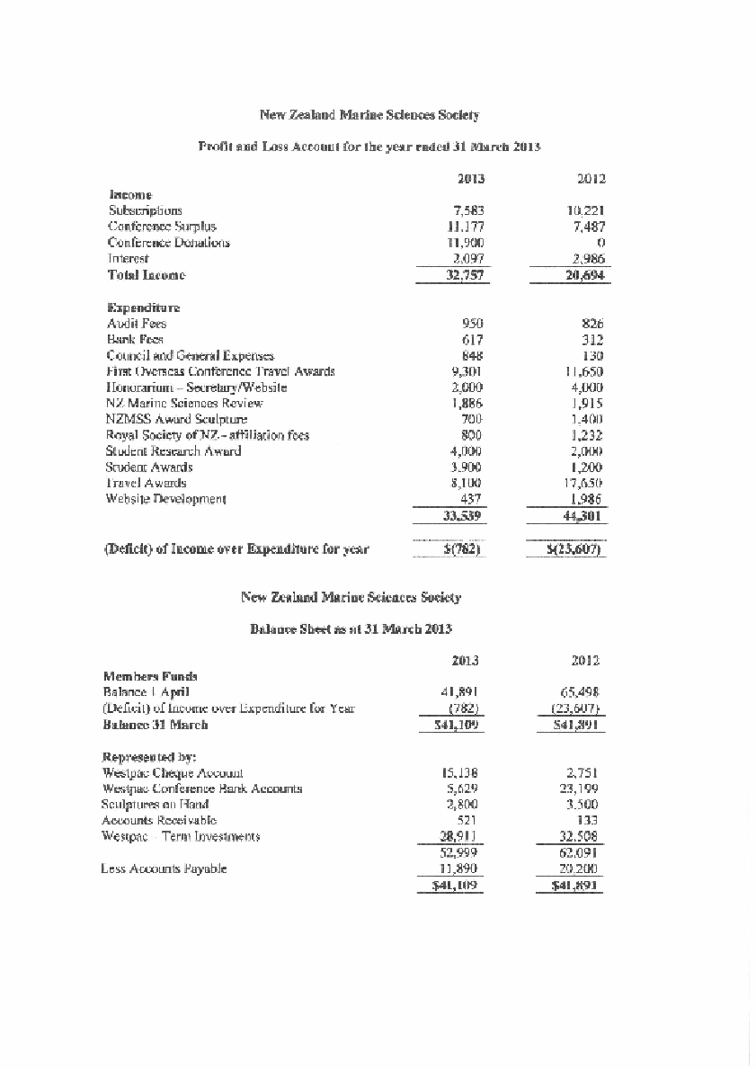

Appendix 7b – Financial summary
Over the 2013-2014 fiscal year (ending 31 March) the Society’s income roughly equalled expenditures (Figure 1). Income included a surplus of $9,110 from the 2013 conference in Hamilton. The balance of accounts (Figure 2) and a breakdown of this past year’s income and expenditures (Table 1 attached) are provided along with previous years for comparison.

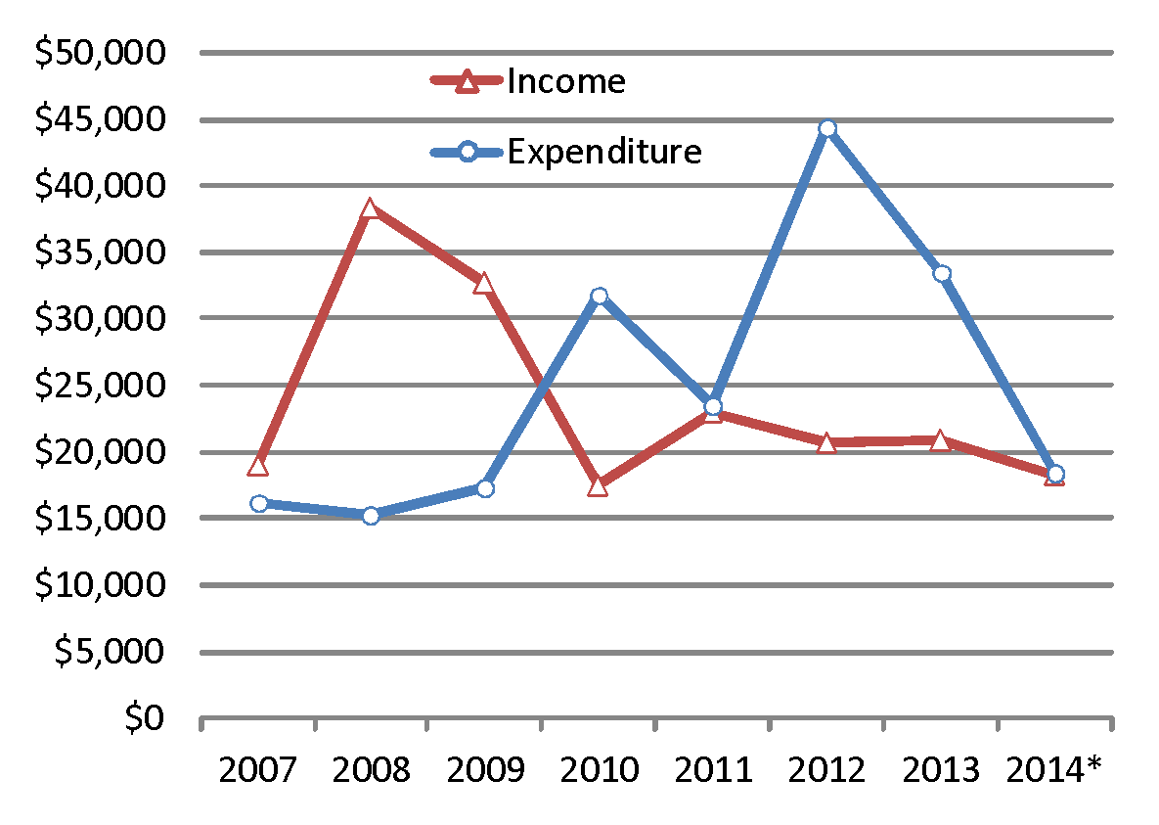
Figure 1: Annual NZMSS income and expenditures based on fiscal years (1 April to 31 March). Note that 2014 is still awaiting official audit and final numbers may change. This year’s graph looks different than last year’s because student travel assistance to the NZMSS conference is now included, as is the Society awards for conference presentations. Approximately $17,000 and $8,000 in 2012 and 2013, respectively, is associated with student travel assistance to the 2012 AMSA/NZMSS conference in Tasmania.

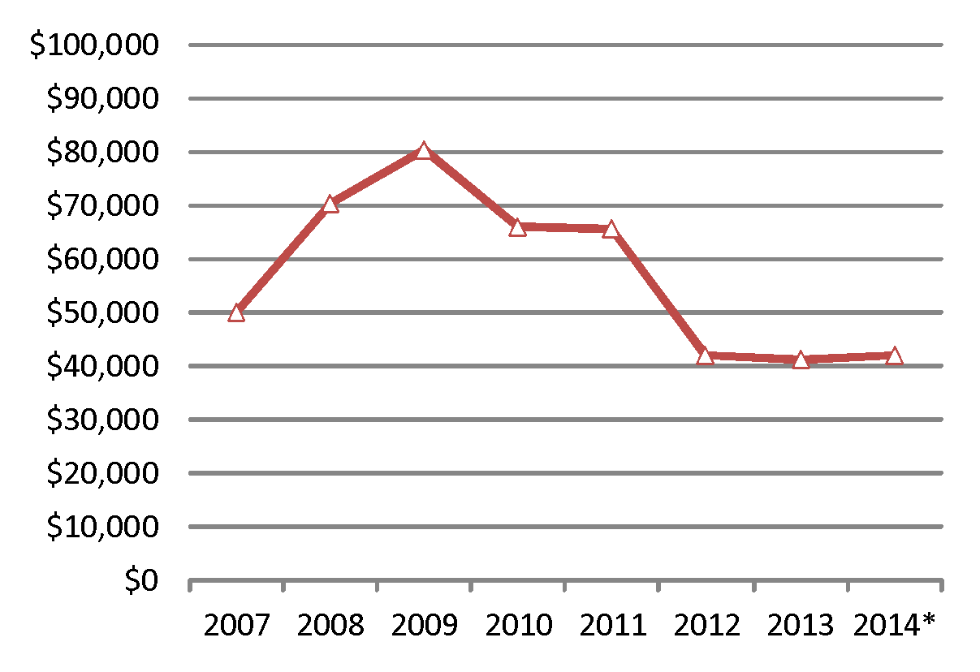
Figure 2: Total balance in NZMSS checking, savings, term deposits and award sculptures on hand. *The audit for 2014 is currently underway, so the final balance may vary slightly from that shown.

Table 1: NZMSS income and expenditures for. *2014 is currently being audited and final numbers may change.

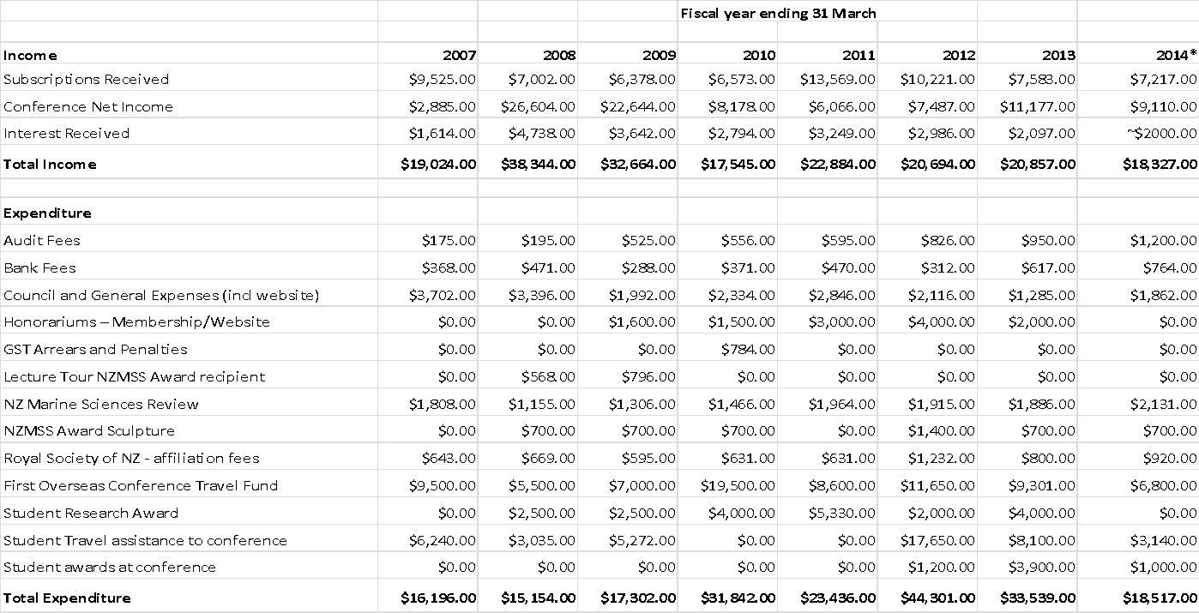

Figure 3: NZMSS generates income in three main ways: through membership fees, surplus from the NZMSS conference, and capital from society investments. How expenses are paid for depend on the variability and value of the expense. NZMSS’s core business, the basic cost of running the society, is paid for through membership fees. NZMSS awards are paid from conference surplus and donations, where as all deposits needed for conferences or one off NZMSS costs are paid for by using capital from NZMSS investments. The council reviews the expenditures from the previous year, to budget for the upcoming year.

Appendix 7c - DRAFT budget for coming year
Indicative budget for 2014-2015
Income
Subscriptions Received | $9,000.00
Conference Net Income | $8,000.00
Interest Received | $2,000.00
Total Income | $19,000.00
Expenditure
Audit Fees | $1,250.00
Bank Fees | $800.00
Council and General Expenses* | $2,500.00
Honorariums – Membership/Website | $0.00
Lecture Tour NZMSS Award recipient | $500.00
NZ Marine Sciences Review | $1,500.00
Royal Society of NZ - affiliation fees | $950.00
First Overseas Conference Travel Fund | $5,000.00
Student Research Award | $3,000.00
Student Travel assistance to NZMSS conference | $2,000.00
Conference awards (best paper and poster) | $1,000.00
Total Expenditure | $18,500.00
*Includes website and annual in person council mtg
Assumptions/considerations
- Subscriptions will be higher than last year due to high conference attendance (and therefore increased membership dues).
- Honorariums are not provided to membership/website roles - Council may wish to provide these.
- There is overlap between the fiscal year (1 April and 31 March) and budget amounts e.g. student research awards in a given year may not be paid out until the next fiscal year.
Risk - action
- Conference and subscriptions are overestimated - reduce award amounts or utilise term deposit/savings

Appendix 8 – Membership Secretary’s Report – Helen Neil
membership@nzmss.org

Website update:
The website is now fully established and periodic updates are carried out by Kerry South as required by council. The website coordinator reviews the website on a monthly basis to ensure homepage is up-to-date and liaises with technical support when required. Managing the listserve is now a separate task headed by Colin McLay with backup support by Kerry South.

Membership process:
Online membership registration/renewal is available through the NZMSS website. This service seems to have assisted with making it easier for people to pay their membership fees. Credit card payments and bank transfer payments are notified via bank records to the treasurer position. The secretary is unable to view these payments.

Membership collection:
Lower numbers of full registrants this period are most likely due to the smaller numbers of membership fees collected as part of the last conference registration fees, there were only ~80 NZMSS associated registrants Income from memberships was ~$7217

Members | 2009-10 | 2010-11 | 2011-12 | 2012-13 | 2013-14
Institutional ($55) | 5 | 9 | 8 | 7 | 7
Full ($55) | 129 | 170 | 130 | 131 | 109
Life (waived) | 16 | 19 | 18 | 18 | 19
Retired ($20) | 1 | 3 | 2 | 2 | 2
Student ($20) | 92 | 111 | 96 | 74 | 88
*Fees include GST and no additional fee charged for credit card payment

Appendix 8 (Continued) – 2013-14 NZMSS Membership List (updated July 2014)

Full Membership
Abraham, Edward | Hilton, Zoe | Pickett, Vernon
Aladaileh, Saleem | Holdsworth, John | Pilditch, Conrad
Alfaro, Andrea C. | Hurum, Merethe | Pine, Matthew
Arlidge, William | Kaemingk, Mark | Pritchard, Daniel
Barr, Neill | Keeley, Nigel | Rock, Jennifer
Battershill, Chris | Kettles, Helen | Ross, Phil
Beard, Catherine | Knight, Benjamin | Rush, Nicola
Bell, Andrew | Laman Trip, Elizabeth | Safi, Karl
Bell, Jacqui | Lass, Hamish | Savage, Candida
Bolstad, Kat | Lavery, Shane | Schiel, David
Bolton-Ritchie, Lesley | Lilley, Stacie | Schmidt, Jochen
Cameron, Marcus | Livingston, Mary | Schnabel, Kareen
Carbines, Megan | Lohrer, Drew | Sharma, Ashish
Carter, Kelly | Lundquist, Carolyn | Sharp, Ben
Clark, Malcolm | Lyon, Warrick | Shears, Amy
Constantine, Rochelle | MacDiarmid, Alison | Shima, Jeffrey
Cornelisen, Chris | Mackenzie, Lincoln | Singleton, Nathan
Cryer, Martin | Madarasz-Smith, Anna | Smith, Abigail
Davey, Niki | Marsden, Islay | South, Paul
De Luca, Sharon | Marsden, Islay | Stevens, Craig
Dunmore, Robyn | Mattlin, Rob | Stoliarova, Iana
Dunn, Alistair | McCowan, Tom | Subedar, Katrina
Dunn, Matt | McKenzie, Jan | Tait, Leigh
Fairweather, Rex | McKenzie, Jeremy | Taylor, David
Felsing, Malene | McLay, Colin | Taylor, Paul
Focht, Becky | Metcalf, Victoria | Thomas, Sam
Ford, Rich | Miller, Sonja | Thomsen, Mads
Francis, Malcolm | Miller, Sonja | Thrush, Simon
Funnell, Greig | Milne, Juliet | Troup, Christina
Geange, Shane | Neale, Don | Wade, Oliver
Giles, Hilke | Neil, Helen | Walker, Jarrod
Gillespie, Paul | Nelson, Wendy | Walls, Kathy
Graeme, Meg | Newcombe, Emma | Ward, Nicholas
Hailes, Sarah | Nodder, Scott
Hayden, Barb | O'Callaghan, Joanne
Hewitt, Chad | Orpin, Alan
Hewitt, Judi | Osborne, Tracey
Hickford, Mike | Parsons, Darren
Hillock, Kristina | Paul-Burke, Kura
Student Membership
Ainley, Edwin | Huteau, Julien | Webber, Darcy
Alestra, Tommaso | Jackson, Susan | Wilson, Peter
Armitage, Phoebe | James, Kate | Wylie, Matthew
Bates, Tracey | Jones, Matthew | Zamora, Leonardo
Beer, Anusha | Kane, Pamela | Zazzaro, Davide
Benham, Amy | Laferriere, Alix
Berthelsen, Anna | Liang, Christine
Braid, Heather | MacPherson, Diana
Brinkman, Johanna | Malekar, Vanita
Brooke, Nathania | Markic, Ana
Byfield, Tamsen | McGrath, Emily
Bylenga, Christine | McSweeney, Caleb
Cardenas, Cesar | Mint, Nick
Chand, Namrata | Niemand, Clarisse
Culliford, David | Paul, Sourav
Davies , Kathryn | Port, Alex
Davis, Christine | Pratt, Daniel
de Groot, Neeltje | Pryor Rodgers, Rata
Delorme, Natali | Raea, Taputukura
Dempsey, Te Puea | Rayes, Courtney
Desmond, Matthew | Riekkola, Leena
Egan, Eimear | Rodda, Judith
Elliott, Nicholas | Rodgers, Kirsten
elliott, riley | Roth, Sarah
Farthing, Courtney | Saeedi, Hanieh
Forcen-Vazquez, Aitana | Scheuer, Kristin
Gadomski, Kendall | Schofield, Max
Gladstone-Gallagher, Rebecca | Schuller, Susanne
Greenfield, Barry | Seers, Blake
Halafihi, Tuikolongahau | Shatova, Olga
Hannan, Danielle | Skilton, Jennifer
Harris, Rachel Joy | Smith, Angela
Haskell, Todd | Smith, Rebecca
Hickman, Robert | Sparks, Kate
Hildebrand, Thomas | Stephens, Tiffany
Hill, Jessica | Sturgess, Nicole
Hohaia, Aysha | Vaughan, Melanie
Howard, Sunkita | Vaughan-Walker, Felix
Hudson, Mike | Wang, Kelvin
Life Members | Institutional Membership/Subscriptions
Ballantine, Bill | Cawthron Institute
Booth, John  Brodie, Jim | NSW Trade & Investment Library
Carter, Lionel  Cassie-Cooper, Vivienne | Department of Fisheries Western Australia
Choat, Howard  Clark, Malcolm  Creese, Bob | Universitaetsbibliothek Johann Christian Senckenberg
Francis, Malcolm  Francis, Chris | NZ Rock Lobster Industry Council Ltd
Gordon, Dennis  Grieve, Janet | University of California San Diego
Hayward, Bruce | WWF New Zealand
Heath, Ron
Hickman, Bob
Jillett, John
Mace, Pamela
McDiarmid, Alison
Nelson, Wendy
Schiel, David
Appendix 9 – NZMSS Council Elected Membership (2013-2014)

President: | Mary Livingston | MPI
Vice President: | Helen Neil | NIWA
Secretary: | William Arlidge | DOC
Treasurer: | Chris Cornelisen | Cawthron

Immediate Past President: | Colin McLay | U Cant

Council Members:
 | Helen Kettles | DOC
 | Kathy Walls | MPI
 | Michelle Beritzhoff | MPI
 | Phil Ross | U Wkto
 | Lesley Bolton-Ritchie | Cant RC
 | Abby Smith | U Otago
 | Hilke Giles | Wkto RC
 | Nick Shears | U Auck
 | Colin McLay | U Cant

Student Representatives:
 | Rebecca Gladstone-Gallagher | U Wkto
 | Emily Douglas | U Wkto

Honorary Positions:
NZMSS Review Editor: | Stacie Lillie | U Cant
Membership Secretary: | Helen Neil | NIWA
Webmaster: | Phil Ross | U Wkto

Conference Committee 2014:
 | Chris Cornelisen | Cawthron
 | Robyn Dunmore | Cawthron
 | Helen Mussely | Cawthron
 | Ken Grange | NIWA
 | Jenny McLean | NIWA
 | Tara Anderson | NIWA
 | Danette Olsen | P&F
 | Suzy Black | P&F
 | Matthew Miller | P&F
 | Mark Burdass | NMIT
 | Hamish Wilson | MPI
 | Paul Creswell | MPI

