Minutes of 57th AGM of NZMSS
Victoria University of Wellington, Wellington, New Zealand
12.50 pm Tuesday 5th July 2016

Present: Anna Madarasz-Smith, Megan Carbines, Steve Urlich, Helen Kettles, Elisabeth Myers, Abby Smith, Rebecca McMullin, Susan Wells, Tyler Northern, Rebecca Zitouvn, Stina Kolodzey, Scott Nodder, Fenna Beets, Di Tracey, Malcolm Clarke, Becky Focht, Eimear Egan, Jan McKenzie, Islay Marsden, Cath Wallace, Barry Webber, Megan Oliver, Tom Trnski, Phil Ross, Pamela Mace, Mary Livingston, Josie Crawshaw, Tarn Drylie, Rebecca Gladstone-Gallagher, Hannah Jones, Emily Douglas, Hilke Giles, Steve Dawson, Chris Battershill, Ken Grange, Sadie Mills, Katrin Berkenbush, Will Rayment, Liz Slooten, Kathy Walls, Rochelle Constantine, Emma Newcombe, Dana Clark, Malcolm Francis, Marta Guerra, Bob Hickman, Maren Preuss, Andrea Glockner, Wendy Nelson, Judy Sutherland, Lesley Bolton-Ritchie, Te Puea Dempsey, Helen Neil.

- Apologies received: Don Neale, Nick Shears, Phoebe Argyle.

- Minutes of the 2015 AGM
A copy of the draft minutes is appended for approval (Appendix 1).

Moved by: Wendy Nelson Seconded by: Malcom Clarke
All agree

- Matters arising from 2015 Minutes – no matters arising

- Actions that arose from this meeting:
Minute | Action
5) c) ix | Conference guidelines are to be updated and to include a policy regarding sponsorship.
5) d) ii | The council contact list on website to be updated
5) d) iv | Helen Kettles is to be involved to the next phase of communications development
7) g) | Send out Society Rule changes as a referendum to the society for comments or adoption
8) b) ii | The bid from Napier to host the conference in 2018 be circulated via email and feedback sought

- Reports tabled to the AGM 2015
  - President - Helen Neil (Appendix 2) - moved by Hannah Jones, seconded by Malcolm Clarke.
    - Helen N is standing down as President and thanked the council members and society for the experience.
    - Helen leaves council in a position of reasonable financial stability with income streams aligned to spend of income earned in previous year.
    - Recommends that every year any available money is put into capital to build the society’s capital.
    - Council thanks Helen N for all of her work as President

  - Treasurer - Hannah Jones (Appendix 3) - moved by Pamela Mace, seconded by Hilke Giles.
    - Realignment of finances in previous years means we now spend money we already have. Accounts are relatively healthy so in a good place for following year
    - Auditors reports for years ending March 2014 and 2015 have now been received. Report for year ending March 2016 is almost complete. We have confidence in our procedures and reports.
    - Conference is biggest financial risk but also generates our income. Added conference income and expenditure within the report to highlight cash flow. Acknowledgement to fantastic job of conference organiser.

  - Proposed Budget – Helen Neil & Hannah Jones (Appendix 3) - moved by Cath Wallace, seconded by Hilke Giles.
    - Proposed budget follows the principles that were agreed at last AGM for the new flow of money.
    - Aims to invest conference surplus from previous year into society capital
    - Recommended we invest $5000 in website rebuild in 2016/17 as current platform is unsecure. Two AGM’s ago is was agreed to update website but previously had no income to support this. NZMSS review is to be hosted online through this space.
    - Projected income is from membership. Actual income is the surplus from previous conference. Bank fees is mostly related to credit card fees.
    - Student research award is at the discretion of the incoming council to assess income and make fiscally responsible decisions later in financial year.
    - Abby S comments that a society should have savings of ~1 year’s cash flow (~$30k) to reduce risk. Endorse idea of building capital.
    - Sponsorship is a major factor that cause the fluctuation of conference surplus. There is the option of raising attendance price but that can have a negative effect. We make less in surplus with joint meetings. Joint conference (AMSA) every 8th year in Australia brings no income.
    - Cath W asks if there a sponsorship policy? Sponsorship shouldn’t have implications to programme and integrity of the decision making. Helen N comments that conference themes were set before sponsors came to the table. Mary L comments that there was no influence from MPI, who increased their sponsorship support this year.
    - ACTION Conference guidelines are to be updated and to include a policy regarding sponsorship.
    - Conference expenses vary depending on location and local arrangements. Example, this conference is paying internal rental rates for this venue as a VUW staff member is on the committee.
    - There were concerns about the fiscal climate and ability for members to attend. Conference fees were extensively thought through. A comparison across many different inter/national symposia show we’re in the mid-range.
    - MOTION To give incoming council mandate to decide what to do with our credit card facility; whether to retain, change or add credit card fees
Moved by Helen Neil, seconded by Hannah Jones. All agree
    - MOTION $5k of surplus be spent by council to rebuild website
Moved by Helen Neil, seconded by Katrin Berkenbush. All agree

  - Other Council reports – Helen Neil (Appendix 4) - moved by Helen Neil, seconded by Abby Smith.
    - Website rebuild will give greater transparency to membership and we can push invoices to rebuild membership.
    - ACTION The council contact list on website to be updated
    - Chris reports there is a communications plan to be submitted to the new communications portfolio group. It will include options on social media, communications and the website.
    - ACTION Helen Kettles is to be involved to the next phase of communications development

- Election of Officers and Council members for 2016-17 (Appendix 5 lists current Council)

  - President (Hilke Giles is willing to stand)
    - Nominated by Megan Oliver, seconded by Pete Wilson.

  - Vice-president
    - Liz Slooten was nominated by Kathy Walls, seconded by Chris Battershill.

  - Secretary (Te Puea Dempsey is standing down)
    - Dana Clark is nominated by Te Puea Dempsey, seconded by Abby Smith.

  - Treasurer (Hannah Jones is willing to re-stand)
    - Nominated by Hilke Giles, seconded by Phil Ross.

  - Website/List Administrator
    - (Vacant) – position not filled

  - Immediate Past President (non-elected) – Helen Neil

  - Council (at least 5).
    - Lesley Bolton-Ritchie is willing to re-stand.
      - Nominated by Hannah Jones, seconded by Helen Kettles.
    - Kathy Walls is willing to re-stand.
      - Nominated by Hamish Lass, seconded by Anjali Pande.
    - Will Rayment is willing to re-stand.
      - Nominated by Abby Smith, seconded by Liz Slooten.
    - Nick Shears is willing to re-stand.
      - Nominated by Rochelle Constantine, seconded by Helen Kettles.
    - Islay Marsden is willing to re-stand.
      - Nominated by Sharyn Goldstein, seconded by Helen Kettles.
    - Chris Battershill is willing to re-stand.
      - Nominated by Phil Ross, seconded by Simon Muncaster.
    - Emma Newcombe is nominated by Hilke Giles, seconded by Chris Battershill

  - Student Reps (at least 2).
    - Becky Focht (Victoria U.) is willing to re-stand.
      - Nominated by Hannah Jones, seconded by Helen Kettles.
    - Tarn Drylie (U.Waikato) has been nominated by Rebecca Gladstone-Gallagher, seconded by Conrad Pilditch
    - Phoebe Argyle (U.Canterbury) was nominated by Eimear Egan, seconded by Islay Marsden.
    - Rebecca Zitovn (U.Otago) was nominated by Abby Smith, seconded by Will Rayment

- Society Rules (Appendix 6)
  - MBIE has a new draft legislation (Exposure Draft of the Incorporated Societies Bill) that affects all societies. RSNZ sent out guidelines and we were able to receive legal guidance.
  - Changes to rules don’t impact how NZMSS is run or organised. We still have mandate around student research awards, society awards, communication and engagement in marine research.
  - Hilke G runs through key changes made. These include internal consistency on wording, good modern practice such as allow electronic transfer of funds, clarification of requirements for council members and officers, and addressing core requirements for consistency and compliance with new Bill. More complex matters can be reviewed at a later stage.
  - Discussion on conflict of interest declaration form, qualification declaration form of officers and the assessment procedure.
    - Suggested the Immediate Past President assess these, as they would have already gone through the process and they are not an officer. Suggestion that alternative assessors also be included in case of unforeseen circumstances. Suggestion include the auditor, a nominated society member or a returning council member be considered.
  - Currently rules state we need to be audited annually. Auditing requirements have changed substantially and auditor won’t have the capacity to audit us annually. This would incur a huge cost to the society. Cath W comments that there is provision for a review rather that a full audit
  - Rules can be adopted via an email vote. This allows more time to review changes. Adopted with proviso maybe?
  - ACTION Send out Society Rule changes as a referendum to the society for comments or adoption.

- General Business
  - NZMSS Award and Inaugural John Morton Medal for 2016 have been evaluated and the recipients will be announced at the dinner.

  - Future NZMSS Conferences
    - Confirmed 2017 – Christchurch, (Canterbury University)
Islay Marsden and David Schiel are conference organisers
    - Where next for 2018 and beyond? (Appendix 7).
ACTION The bid from Napier to host the conference in 2018 be circulated via email and feedback sought.

- Any Other Business

Close of meeting. 1:44pm
Appendix 1 – 2015 Minutes of 55th AGM for approval

Minutes for 55th AGM of NZMSS
University of Auckland, Auckland, New Zealand
12:45pm Wednesday 8th July 2015

Present: Hilke Giles, Nick Shears, Pete Wilson, Hannah Jones, Islay Marsden, Steve Urlich, Jeremy McKenzie, Chris Cornelison, Pamela Mace, Megan Carbines, Pamela Kane, Wendy Nelson, Anna Madarasz-Smith, Tarn Drylie, Bradley Monahan, Emily Douglas, Richard Bulmer, Teri O’Meara, Katrina Goddard, Jenny Hillman, Rebecca Gladstone-Gallagher, Bob Hickman; James Robertson, Cath Wallace, Eimear Egan, Malcom Clarke, Te Puea Dempsey, Chris Battershill, Melanie Vaughan, Candace Loy, Kevin Tay, Rosalyn Putland, Sam Hesse, Sorrel O’Connell-Milne, Josie Crawshaw, Kathy Walls, Lesley Bolton-Ritchie, Helen Neil, Michelle Beritzhoff-Laws; Will Alridge.

- Apologies received: Will Rayment, Bruce Hayward, Mary Livingston, Phil Ross

- Minutes of the 2014 AGM

- A copy of the draft minutes is appended for approval (Appendix 1).

Moved by: Malcolm Clark Seconded by: Lesley Bolton-Ritchie

- Matters arising from 2014 Minutes

- Reports tabled to the AGM 2015
  - President - Helen Neil (Appendix 2) - moved by Michelle B, seconded by Hilke G.
    - Discussion on re-aligning of council finances. Aligning conference surplus to student awards was required and therefore there was a required hiatus period. In doing this alignment this gives council much more assurance in terms of what we have to spend.
    - Helen N. thanked the conference sub-committee as well as council members standing down.

  - Treasurer - Michelle Beritzhoff-Laws (Appendix 3) - moved by Nick Shears, seconded by Hilke Giles.
    - Michelle B thanks Helen N for all her work as president.
    - Michelle ran through the NZMSS finance system, presenting the finance system diagram and then outlined in the 2014-15 financial summary.
    - Total assets increased in 2015 and budgeting for an increase in funds for the 2016 conference.
    - Net income was lower than initially budgeted and there was a high GST payment this year. Council decided to take an alternate approach to GST this year.
    - Proposed budget was presented. Chris asked a question regarding sponsorship and whether or not council asked to include GST? Going forward GST will be requested.

  - Membership Secretary - Lesley Bolton-Ritchie (Appendix 4) - moved by Malcolm Clark, seconded by Kathy Walls.
    - Council has lost its institutional members as we no longer print out our annual report. Membership has been steady but council is looking to capture those that do not attend the annual conference.
    - Nick Shears mentioned that fewer professional members attended this year’s conference and that council should track down those individuals. Chris Battershill mentioned that some of those people are likely to be attending the annual Coastal Conference meeting.

There was mention of reporting to members in that Council will need to report what has been achieved as well as the basic reporting aspects such as finances etc. It was recommended that the incoming council members should be prepared for those reporting matters.

- Election of Officers for 2015-16 (Appendix 5 lists current Council) - Nominations received to date are listed below. Further nominations may be made at the AGM.

  - President (Helen Neil is willing to re-stand).
    - Nominated by Di Tracey, seconded by Alison MacDiarmid.

  - Vice-president (Hilke Giles is willing to re-stand)
    - Nominated by Pete Wilson, seconded by Anna Madarasz-Smith.

  - Secretary (William Arlidge is standing down after 2 years).
    - Te Puea Dempsey was nominated by Chris Battershill and seconded by Hannah Jones.

  - Treasurer (Michelle Beritzhoff-Laws is standing down).
    - Hannah Jones was nominated by Hilke Giles and seconded by Lesley Bolton Ritchie.

  - Website/List Administrator (Phil Ross is standing down).
    - Will Rayment to stand as webmaster. Nominated by Nick Shears and seconded by Hilke Giles.

  - Immediate Past President Mary Livingston. Nominated by Pamela Mace and seconded by Wendy Nelson.

  - Council (at least 5).
    - Lesley Bolton-Ritchie is willing to re-stand.
      - Nominated by Chris Battershill, seconded by Chris Hepburn.
    - Kathy Walls is willing to re-stand.
      - Nominated by Chris Battershill, seconded by Helen Neil.
    - Will Rayment is willing to re-stand.
      - Nominated by Chris Hepburn, seconded by Helen Neil.
    - Nick Shears is willing to re-stand.
      - Nominated by Rochelle Constantine, seconded by Chris Hepburn.

  - Helen Kettles is standing down after 5 years with 3 of those years as Council Secretary.

  - Sharyn Goldstein is standing down.
  - Student Reps (at least 2).
    - Jenny Hillman is willing to re-stand.
      - Nominated by Conrad Pilditch, seconded by Chris Battershill.
    - Emily Douglas is willing to re-stand.
      - Nominated by Conrad Pilditch, seconded by Chris Battershill.
    - Rebecca Gladstone-Gallagher is standing down after 2 years on Council.

  - 6 positions on Council are open. Comprising 1 x Secretary and 1 x Treasurer roles, 1 x Student Rep and up to 3 council members.
    - Te Puea Dempsey and Hannah Jones were nominated for secretary and treasurer roles respectively. See above.
    - Chris Battershill. Nominated by Kathy Walls. Seconded by Islay Marsden.
    - Islay Marsden nominated by Lesley and seconded by Malcolm Clark.
Students
    - James Robertson (Auckland University) nominated by Nick Shears, seconded by Emily Douglas.
    - Eimear Egan nominated by Islay Marsden and seconded by Malcolm Clark.
    - Becky Focht (Victoria University of Wellington) nominated by Jeff Sheman and seconded by Matt Dunn.

- General Business
  - NZMSS Award for 2015 has been evaluated and the recipient will be announced at the dinner.

  - Council advocacy and portfolio groups
    - Communications Portfolio Group (Helen Kettles) (Appendix 4)
    - Discussion on a NZMSS Portfolio for marine biotechnology (proposed by Chris Battershill).
      - Chris announced that there is a new Australian/NZ marine biotech society. He mentioned they are keen to know how they can align with the NZMSS society in future and gave a short five minute presentation.
        - Posing the question as whether is there a mechanism in which the marine biotechnology society can work with NZMSS society and whether or not there is a role for portfolio group on this to work within NZMSS.
        - Lesley nominated. Kathy Seconded.

  - Future NZMSS Conferences
    - Confirmed 2016 – Wellington, (MPI and Victoria University) - joint with AMSA. This also coincides with 30 Years of the QMS. A strong fisheries focus in a Shared Ocean theme.
    - Where next for 2017 and beyond? (Helen Neil)
      - Mention that certain universities have been hit more than others in terms of conferences being in term time i.e. Otago University.
      - University of Canterbury put their hand up for 2017 (need to check regarding Canterbury’s semester dates are and if they fall in this year’s financial year.
      - It was noted that there are thoughts of aligning a conference with the coastal society in future.
      - July 6 2016 were mentioned as being tentative for next year’s conference.

- Any Other Business
  - Jeremy McKenzie asked if there is an online document for Council affiliations that is available to members. It was noted that there is in the council documents but this isn’t on the website and that council will look into making this list available online.

Close of meeting at 1:48pm.

Appendix 2 – President’s Report 2015/16

The 2015-2016 year has been another full year and one where we have had to start rebuilding our role in the wider marine science community, especially our financial support to students, in the wake of the financial constraints on the society in the 2014/15 year. We are now in a positon of having fully aligned our income streams to expenditure, and while I see a need to continue with a level of fiscal restraint and sustained building of capital, it is now with a high level of confidence council can propose future budgets to the membership.

The Council had 15 members (4 were student representatives) and through the year there were 10 meetings. I wish to take this opportunity to thank council for their efforts over the year as increasingly the time both council and our membership have available is diminished by the demands of our respective roles outside of the society.

I briefly outline below some of the tasks that have been undertaken by Council:
- Responsive submissions prepared by the MPA Portfolio group, Council and membership and made on behalf of NZMSS included:
- Submission on A New Marine Protected Areas Act consultation document, where NZMSS did not support the proposed legislation in its current form;
- Submission on Kermadec Ocean Sanctuary Bill, where in general NZMSS supports the Kermadec Ocean Sanctuary Bill.
You can download copies of NZMSS submissions from http://nzmss.org/documents/documents-of-public-statement-or-release.
I thank Kathy Walls and the MPA Portfolio Group for their efforts with both of these submissions.
- Nominations for the NZMSS Awards have been evaluated and the recipients will be announced at the Wellington conference dinner. The society now presents two awards i) NZMSS Award (inaugurated in 1985) for a person’s continued outstanding contribution to marine science in New Zealand; and ii) John Morton Medal (inaugural year 2016) for a person, or persons, whose work has made an outstanding contribution to the advancement of marine conservation and sustainability in New Zealand. The nominations this year, for both awards, were all meritorious and I thank the council student members and Hilke Giles for their efforts with this award sub-committee.
- NZMSS supported three student to attend their first overseas conference, but no student research award was made in this year.
- Council documents are located on a google documents library, these include documents (along with website text) that outline society rules and regulations. The NZMSS Rules follow the requirements of the Incorporated Societies Act 1908 and were last revised at the 2012 AGM held in Hobart. However, in response to the Ministry of Business, Innovation and Employment (MBIE) draft of the Incorporated Societies Bill (“draft Bill”), the council proposes updates to, in particular, account for modern practices and to reinforce our approach relating to officers’ duties and conflicts of interest (Appendix 6).
- Remember to use the list server through which subscribed members can circulate news of marine interest.
- Council have elected to plan future conferences several years in advance in order to address both the variable semester times that hamper conference attendance and to provide conference committees longer than a single year to develop their conference planning. Conference for 2017 will be held in Canterbury, and a proposal for the 2018 Conference has been submitted by Hawkes Bay Regional Council (Appendix 7). Nominations for 2019 Conference can also be tabled at the AGM.
- A need was identified at the 54th AGM for development of the NZMSS website as well as an online content to replace the Annual review. This development was delayed in the past year due to fiscal constraints, but council recommends that this task proceed in 2016/2017 in light of aligned income being available, as well as capacity for a small capital investment and resumption of support to student awards (Appendix 3c). Thanks to the society’s new treasurer, Hannah Jones, for her ongoing improvement of the societies financial system.
- Council continued with a February face-to-face meeting which enabled council to discuss the budget and identify our upcoming goals for the coming two to three years. I strongly recommend council continues this activity.

Thanks to the 2016 NZMSS- AMSA joint ‘Sharing Ocean Resources - Now and in the Future’ conference sub-committee (Mary Livingston, Helen Neil, Megan Oliver, Alison MacDiarmid, Matt Dunn, Alistair Dunn – NZMSS; Tim Lynch, Olaf Meynecke, Kate Naughton – AMSA) for all their hard work. The conference subcommittee are indebted to Kerry South for her outstanding organisational skills and getting us all onto task! Thanks again to all the council members for their hard work and support over the past year. Standing down at this time are Emily Douglas and Jenny Hillman (Student Representatives) who are completing their PhDs and moving on to new adventures, and Mary Livingston (Immediate Past President) who has held officer roles within the society for the past 6 years and whose wisdom has been invaluable.

The past two years have not been without their challenges and while I step down from the role of President I look forward to continuing to support NZMSS in its future endeavours as your Immediate Past President.

Helen Neil, President (outgoing), 15 June 2016.

Appendix 3 – Treasurer’s Report (2015-2016)

Society accounts
As of 31 March 2016 there was a total of $65,697 in the Society’s accounts (Table 1). The Society generated a substantial surplus of income over expenditure ($21,619) for two main reasons. Firstly, the 2015 conference generated a surplus of $20,662. Secondly, the previous year Council decided to realign spending so that awards are allocated in the financial year following the conference, to reflect the amount the Society can afford from known conference surplus. There was no student research award allocated in 2015/2016, although there were First Overseas Conference Travel Awards, and NZMSS student prizes awarded at the 2015 conference.

Figure 1 shows the 2015/2016 year in the context of previous years. The Society’s funds had mostly been decreasing since 2009, but this past year has reversed that trend and increased funds significantly. This should put the Society in a much stronger position financially in the year(s) to come.

Future work
The intention for the coming year is to improve the Society’s financial accounting systems. Currently the Society incurs a large bill each year from our Auditor due to the complex nature of the accounts and inefficient record keeping. Improved accounting systems will reduce Auditor’s fees, and ensure consistency and stability when the treasurer role passes from person to person. It would also be beneficial to dynamically link the financial systems with the membership database.

Table 1: NZMSS Balance Sheet
 | 2015-16 | 2014-15
NZMSS Funds
Balance 1 April | $44,078 | $42,391
Surplus income over expenditure for year | 21,619 | 1,687
Cheque accounts | 51,675 | 27,033
Savings accounts | 2,832 | 2,769
Sculptures on hand | 700 | 1,400
Accounts receivable/prepayments | 287 | 340
Westpac term investments | 19,666 | 18,895
Less Accounts payable | 9,463 | 6,359
Balance as of 31 March | $65,697 | $44,078

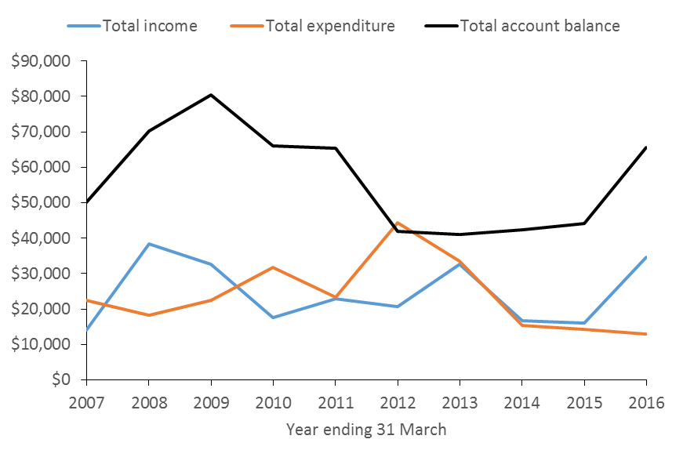
Figure 1: NZMSS total income, total expenditure and total account balance over time

Appendix 3a – Auditor’s Reports

The auditor’s report for 2015/2016 is still being processed (as at 15 June 2016). However, our Auditor has now completed the audits for both the 2014/2014 and 2014/2015 years, and the reports are provided below.

Appendix 3b – Financial summary
Table 2 shows income and expenditure for the 2015/2016 year and is prepared on a GST exclusive basis. However, note that our GST payable for 2015/2016 was $7,357. The Society pays GST on memberships, conference registration and sponsorship, and can claim GST on some expenditure (e.g. website), but not on others (e.g. student awards).

Conference profit and loss is included in this summary to show that the Society is exposed to significant risk with this event due to the large amount of money that is received and spent (i.e. conference income and expenditure each exceed $100,000). The Society relies on conference organisers to demonstrate financial acumen and to aim to return a surplus of c. $10,000. Thank you to Kerry South and the conference organising committee for managing this so well for the 2015 conference. Figure 3 shows the conference surplus for 2015/2016 in the context of previous years.

Table 2: NZMSS income and expenditure for the year ended 31 March 2016

 | 2015/2016 (GST exc.)
Conference profit and loss
Conference income minus membership | 125,591
Conference expenditure | 103,041
Conference surplus after payment to OCS | $20,662
NZMSS Income
Membership | 8,122
Conference surplus | 20,662
Interest | 1,282
Other income | 4,500
Total income | $34,566
NZMSS Expenses
Audit fees | 1,950
Bank fees | 2,390
Council and general expenses | 827
NZMSS award sculpture | 700
RSNZ affiliation fee | 800
First Overseas Conference Travel Award | 4,300
NZMSS student prizes | 1,000
Website | 531
GST penalties and interest | 449
Total expenditure | $12,947
Surplus income over expenditure for year | $21,619
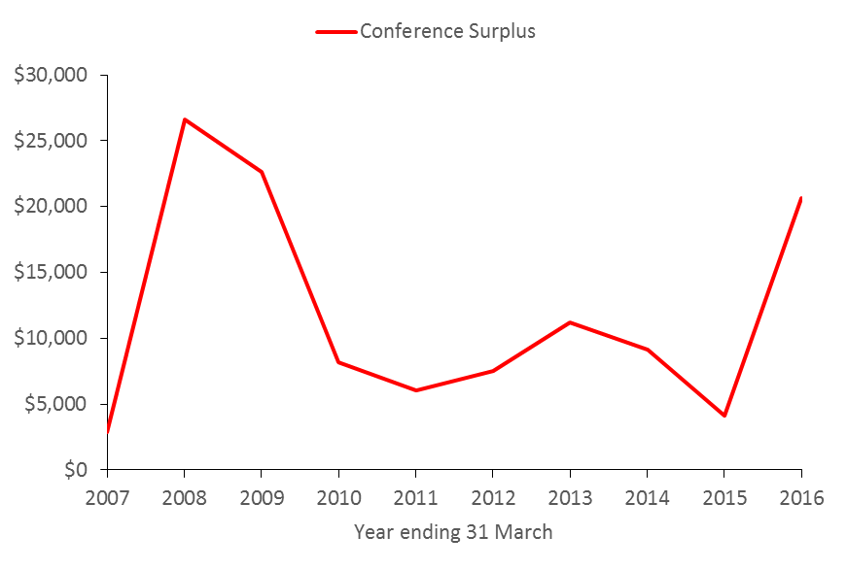
Figure 2: NZMSS conference surplus over time

Appendix 3c - Proposed Budget for 2016/17
To ensure that the council follows the financial system as outlined in Appendix 3d and accepted by 2015 AGM, the proposed budget:

    - Aligns income received from the previous year’s conference to student awards that are awarded each financial year following the conference, to reflect the amount the Society can afford from known conference surplus,
    - Aims to increase capital as reasonable, thus reducing financial risk to the Society in the future,
    - Recommends that $5,000 is spent in 2016/2017 on a website rebuild, which is required due to the outdated code and content of the current website.

The budget includes a mix of projected and actual income to reflect the amount of funds available for the 2016/2017 year. Projected income includes subscriptions and bank interest, and actual income is from the 2015 conference.

Note that the budget has been prepared on a GST exclusive basis to reflect the amount of money available, and to be consistent with the financial summary and auditor’s reports. GST paid in the 2015/2016 year was c. $7,000, and we expect the amount to be similar in 2016/2017.

With these recommendations in mind the council proposes the following budget for 2016-17 financial year:

Table 3: Proposed budget for 2016/2017

 |  | 2016/2017 (exc. GST)
 | Projected income
 | Membership | 8,000
 | Interest received | 1,500
 | Actual income
 | Conference surplus (from 2015 conference) | 20,662
 | Total projected and actual income | $30,162
 | Budgeted expenditure
Core functions | Audit fees | 1,500
 | Bank fees | 2,500
 | General council expenses (inc. website upkeep) | 2,500
 | Potential event sponsorship | 500
 | Lecture tour NZMSS recipient | 0
 | NZMSS review (web based inc. one-off website rebuild) | 6,500
 | NZMSS award sculpture and John Morton Award | 900
 | Royal Society of NZ - affiliation fees | 800
Awards | First Overseas Conference Travel Awards | 4,500
 | Student research award | 3,000
 | Student travel assistance to conference | 0
 | Student awards at conference | 1,000
 | Total budgeted expenditure | $23,700
 | Projected surplus of income over expenditure | $6,462

Appendix 3d - NZMSS finance system (updated June 2016)

The NZMSS finance system diagram has been updated to remove some inconsistencies in the original one. The original diagram listed “capital” (now renamed “investments”) as income. Investments are not income and the Society will run into some problems if they are treated as such. In the same way, having a uni-directional arrow running from “investments” to “one-off costs” will eventually result in complete depletion of the investments. Income needs to be diverted into investments if required, and investments are there to provide cash for conference deposits and to cover unforeseen or unfortunate expenses (e.g. the conference running at a loss). There are some other minor edits, and the conference finance system has been specifically noted. The finance system diagram has been redesigned to make this clear (Figure 3). The previous finance system diagram also is included below (Figure 4) for comparison.

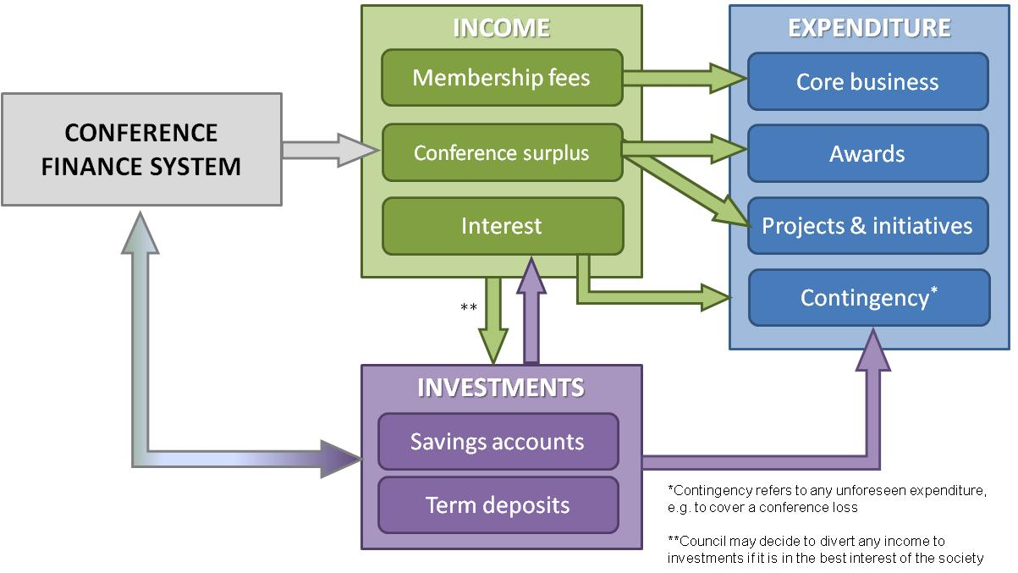
Figure 3: NZMSS generates income in three main ways: membership fees, conference surplus and interest from society investments. Society expenditure includes core business (the costs of running the society), projects and initiatives (e.g. website redesign) and awards (e.g. First Oversees Conference Travel Awards, student conference prizes). The conference finance system uses the society investments to outlay funds such as conference deposits, which should then be returned to the society investments after the conference. However, in the event of the conference running at a loss, or any other unforeseen expenses, the society requires sufficient investments to bear those expenses.

Previous Finance Diagram – 2015

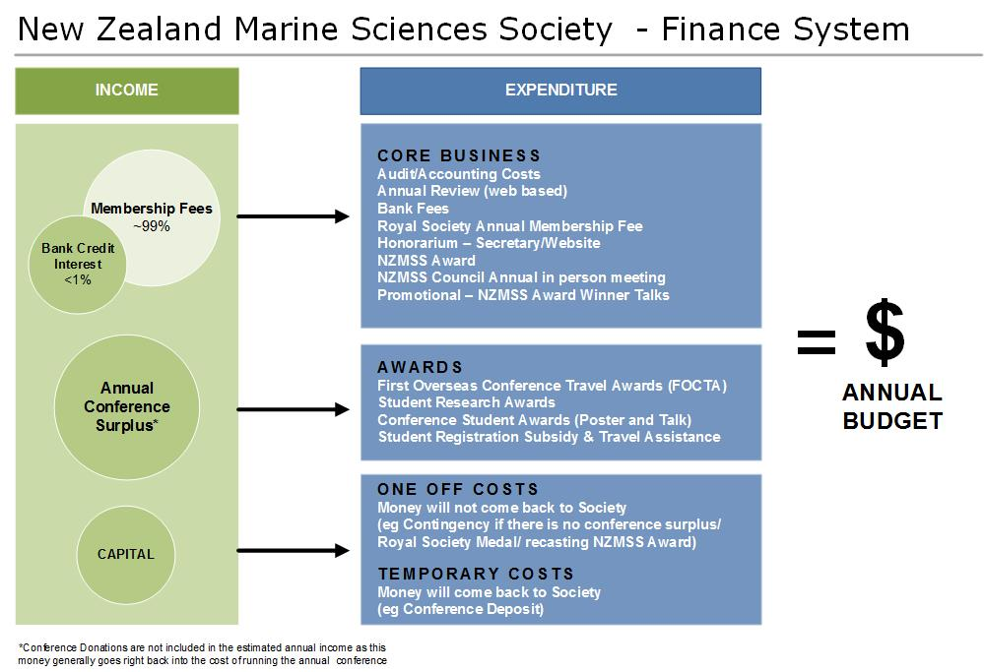

Figure 4: NZMSS generates income in three main ways: through membership fees, surplus from the NZMSS conference, and capital from society investments. How expenses are paid for depend on the variability and value of the expense. NZMSS’s core business, the basic cost of running the society, is paid for through membership fees. NZMSS awards are paid from conference surplus and donations, where as all deposits needed for conferences or one off NZMSS costs are paid for by using capital from NZMSS investments. The council reviews the expenditures from the previous year, to budget for the upcoming year

Appendix 4 – Council Reports

Website update: Minimal updates are carried out on the website while the decision to change the platform to meet today’s security requirements and rebuild the website is progressed. Managing the listserve is a task headed by council members Nick Shears and Te Puea Dempsey.

Marine sciences communications portfolio group update
It has been identified that a concise and simple strategic plan is needed to guide the communications portfolio group. The plan is continuing to be developed alongside the website update.

Membership update:
Online membership/renewal for new members or society members that do not renew their registration via conference attendance is available through the NZMSS website. Payments are notified via bank records to the treasurer position. Institutional members will be reinstated once an annual review service is online. Income from memberships was $9,340 GST inclusive.

Members | 2010-11 | 2011-12 | 2012-13 | 2013-14 | 2014-15 | 2015-16*
Institutional ($55, none in 14-15#) | 9 | 8 | 7 | 7 | - | -
Full ($55, inc to $60 in 14-15) | 170 | 130 | 131 | 109 | 189 | 109
Life (waived) | 19 | 18 | 18 | 19 | 20 | 21
Retired/student ($20) | 114 | 98 | 76 | 90 | 86 | 116
# Institutional members are none as they paid to receive the printed annual review – which is now not produced
*As at end May 2016
Note: Fees include GST and no additional fee charged for credit card payment

membership@nzmss.org

2015-16 NZMSS Membership List (updated May 2016)
Full membership
Aguirre, David | Giles, Hilke | Pohl, Irene
Ainley, Edwin | Goddard, Katrina | Pook, Chris
Alestra, Tommaso | Goldstien, Sharyn | Pritchard, Daniel
Alqaisi, Khalid | Haggitt, Tim | Ratana, Kelly
Arlidge, William | Hall, Julie | Rayment, William
Atalah, Javier | Hannan, Danielle | Redvers, Grant
Battershill, Chris | Hayden, Barb | Ritchie, Peter
Bell, Andrew | Hewitt, Judi | Robertson, John
Berkenbusch, Katrin | Hore, Jacob | Ross, Phil
Berlin, Caren | Ingley, Rhian | Roux, Marie-Julie
Bock, Tiffany | James, Mark | Setiawan, Alvin
Bolstad, Kat | Johnston, Olivia | Sewell, Mary
Bolton-Ritchie, Lesley | Jones, Arron | Shears, Nick
Brown, Stephen | Jones, Hannah | Shima, Jeff
Cameron, Marcus | Kane, Pamela | Short, Katherine
Carbines, Megan | Kelly, Shane | Singleton, Nathan
Chapman, Bruce | Kinsey, Richard | Smith, Adam
Cid Torres, Joana | Laman Trip-Jensen, Elizabeth | Stanley, Storm
Constantine, Rochelle | Lass, Hamish | Stewart, Michael
Cooper, Jeremy | Liu, Cathy | Tait, Leigh
Cornelisen, Chris | Lohrer, Drew | Tellier, Pierre
Couzens, Gemma | Lundquist, Carolyn | Tezanos-Pinto, Gabriela
Cryer, Martin | Mackay, Kevin | Thomas, Sam
Curtis, Helen | Madarasz-Smith, Anna | Townsend, Michael
Davis, Cat | Marsden, Islay | Tracey, Di
Ellenberg, Ursula | McCowan, Tom | Trnski, Tom
Ericson, Jess | McGregor, Vidette | Urlich, Steve
Fenaughty, Jack | McKenzie, Jeremy | Vaughan, Melanie
Fish, Sarah | McLeod, Rebecca | Vopel, Kay
Fletcher, Lauren | Moran, Damian | Wade, Oliver
Ford, Rich | Neil, Helen | Wakelin, Laura
Freeman, Debbie | O'Meara, Theresa | Walker, Nathan
Funnell, Greig | Parsons, Darren | Walls, Kathy
Galland, Annie | Patel, Bhakti | Wilson, Oliver
Gardiner, Sarah | Pawley, Matthew | Zintzen, Vincent
Gargiulo, Sharleen | Pilditch, Conrad

Student or retired membership
Allison, Andrew | Glazier, Sian | Nelson, Kathryn
Argyle, Phoebe | Gooday, Oliver | Northern , Tyler
Asaad, Irawan | Graham, Ken | O'Connell-Milne, Sorrel
Balfour, Georgia | Hamilton, Olivia | Orr, Melanie
Bates, Tracey | Hesse, Jan | Platt, Amy
Beets, Fena | Heyns, Karlien | Preuss, Maren
Bennet, Della | Hillman, Jenny | Putland, Rosalyn
Bennion, Matthew | Hossain, Md Afzal | Rapinel , Niels
Betty, Emma | Howard, Sunkita | Robertson, James
Bottcher, Jessie | Hudson, Mike | Rodgers, Kirsten
Braid, Heather Elizabeth | Hupman, Krista | Rouchon, Agnes
Brooke, Nathania | Huteau, Julien | Roycroft, Emily
Brough, Tom | Izadi, Sahar | Sagar, Rachael
Browne, Ashleigh | Jollands, Victoria | Schofield, Max
Bulmer, Richard | Kainamu, Ani | Seers, Blake
Burgess, Sophie | Kellett, Melissa | Shaffer, Megan
Cadwallader, Helen | Kessel, Gustav | Siciliano, Alfonso
Caie, Phoebe | Kim, Julie | Smith, Rebecca
Caiger, Paul | Kramer, Michael | Sorensen, Stine Tang
Chaudhary, Chhaya | Laferriere, Alix | Sparks, Kate
Crawshaw, Josie | Llano, Stephanie | Spyksma, Arie
Cumming, Hana | Loy, Candace | Suyadi,
Davies, Kathryn | Major, Robert | Taikato, Vannesa
De Silva, Nuwan | Markic, Ana | Tay, Kevin
Del rio, Cintya | Marsh, Craig | Templeton, Callum
Delorme, Natali | Maxwell, Kimberley | Tremlett, James
Dempsey, Te Puea | Mc Cormack, Sam | van Oosterom, Lucinda
Dohner, Melanie | McArley, Tristan | Visconti, Valerio
Douglas, Emily | McDowall, Chris | Wallace, Catherine
Drylie, Tarn | McKenzie, Connor | Wallace, Lisa
Egan, Eimear | McLeod, Laura | Wilson, James
Evans, Aaron | McMullin, Rebecca | Wilson, Pete
Focht, Becky | McNaughtan, Daniel | Wolf, Robert Paul
Frowst, Emily Joy | Meyer, Stefan | Wood, Vinnie
Gammon, Malindi | Meysick, Lukas | Zazzaro, Davide
Germanov, Elitza | Moginie, Ben | Zhang, Jingjing
Gilmer, Greer | Monahan, Bradley
Gladstone-Gallagher, Rebecca | Neilson, Conor

Life members
Booth, John | Francis, Malcolm | MacDiarmid, Alison
Carter, Lionel | Gordon, Dennis | Mace, Pamela
Cassie-Cooper, Vivienne | Grieve, Janet | Murdoch, Rob
Choat, Howard | Hayward, Bruce | Nelson, Wendy
Clark, Malcolm | Heath, Ron | Probert, Keith
Creese, Bob | Hickman, Bob | Schiel, David
Francis, Chris | Jillett, John | Thrush, Simon

Appendix 5 – NZMSS Council Elected Membership (2015-2016)

President: | Helen Neil | NIWA
Vice President: | Hilke Giles | Wkto RC
Secretary: | Te Puea Dempsey | U Wkto
Treasurer: | Hannah Jones | Wkto RC

Immediate Past President: | Mary Livingston | MPI

Council Members:
 | Chris Battershill | U Wkto
 | Kathy Walls | MPI
 | Islay Marsden | U Cant
 | Lesley Bolton-Ritchie | Cant RC
 | Nick Shears | U Auck
 | Will Rayment | U Otago

Student Representatives:
 | Eimear Egan | U Cant
 | Emily Douglas | U Wkto
 | Jenny Hillman | U Auck
 | Becky Focht | VuW

Conference Committee Joint NZMSS/AMSA 2016:
 | Helen Neil | NIWA
 | Mary Livingston | MPI
 | Matt Dunn | VuW
 | Megan Oliver | Greater Wgtn RC
 | Alison MacDiarmid | NIWA
 | Alistair Dunn | NIWA
 | Tim Lynch | AMSA
 | Olaf Meynecke | AMSA
 | Kate Naughton | AMSA

Appendix 6 – Proposed changes to the NZMSS Rules (2016 AGM)
Background
The NZMSS Rules follow the requirements of the Incorporated Societies Act 1908 and were last revised at the 2012 AGM held in Hobart.
The current version of the NZMSS Rules contains some internal inconsistencies and requires updates to account for modern practices such as electronic payments.
Furthermore, in November 2015 the Ministry of Business, Innovation and Employment (MBIE) published the exposure draft of the Incorporated Societies Bill (“draft Bill”) and standard provisions for society constitutions, which, pending potential modifications made during the legal process, will become the Incorporated Societies Act 2016. The current NZMSS Rules do not say anything about several important matters that are being reinforced by the draft Bill, specifically relating to officers’ duties and conflicts of interest.
Proposed revision
The NZMSS Council proposes to revise the NZMSS Rules to improve consistency and clarity, ensure good and modern practice in the operation of the society and achieve alignment and compliance with the key aspects of the draft Bill.
Consistent with the rationale outlined above, all proposed changes have been made for one of the following reasons:
- Achieve internal consistency of the Rules;
- Support good and modern practice;
- Clarify requirements for NZMSS members and NZMSS Council members, including Officers; and
- Achieve consistency/compliance with the key aspects of the draft Bill.
None of the proposed changes impact on the objectives of the society.

Appendix 6a – Document showing strike through edits of Proposed changes to the NZMSS Rules (2016 AGM). See Appendix 6b for proposed Society Rules document with accepted changes.
Draft revision of the Rules presented to the 2016 AGM held in Wellington

New Zealand Marine Sciences Society
Te Hunga Mātai Moana O Aotearoa

Society Rules
1. NAME

The name of the Society shall be the New Zealand Marine Sciences Society Incorporated and its Māori equivalent, Te Hunga Mātai Moana O Aotearoa Manatōpū, hereinafter called the Society or NZMSS.

2. OBJECTIVES

The objectives of the Society shall be:

- To encourage and assist marine science and research in New Zealand and to advance its understanding and application in New Zealand.

- To provide means of communication among persons interested in marine science and research and to provide opportunity for them to meet by holding an annual conference. An integral part of this role is to maintain a Society website, electronic mailing list and other communication media to provide information and services to members.

- To speak when required, on behalf of the interests of marine science and research in New Zealand.

- To co-operate with other scientific bodies and to seek such affiliations as may be appropriate.

3. MEMBERS OF THE SOCIETY

- Members of the Society (“Members”) shall be classified as follows:
- Professional Members
- Student Members (enrolled at educational institutions)

- Retired Members
- Honorary Life Members
- Institutional Members

- Any person with an interest in marine science may become a Member by paying the annual subscription.

- The membership period is 1 April to 31 March.

- A membership year shall normally include one annual conference.

- Any member who has given outstanding service to marine science in New Zealand may, on the recommendation of the Council, be elected as an Honorary Life Member at any Annual or Special General Meeting. Honorary Life Members are exempt from annual subscriptions.

- Any member of the Society may cancel their membership by giving notice in writing to the Secretary, paying all annual subscriptions due and ceasing to pay future annual subscription.

- Any member requiring a copy of the rules of the Society may do so by requesting a copy from the Secretary or by downloading a copy from the NZMSS website.

4. ANNUAL SUBSCRIPTION

- The annual subscription shall be such sum as any Annual or Special General Meeting shall from time to time decide.

- All subscriptions are payable from 1 April and should be paid before the end of the annual conference.

- By default the appropriate subscription will normally be included as part of the registration cost when the conference is held in New Zealand.

- Members can pay their annual subscription at other times between conferences.

- An email confirmation or receipt indicating that the current annual subscription has been paid is notice of membership.

- Payment reminders shall be sent out after the annual conference to members who have not paid their annual subscription.

- In exceptional circumstances the Council may, by resolution, remit the payment of an annual subscription or part thereof.

5. OFFICERS OF THE SOCIETY

The Officers of the Society (“Officers”) shall consist of a President, a Vice-President, a Secretary and a Treasurer, elected by the Members at the Annual General Meeting.

6. MEMBERS OF COUNCIL

- The Society Council (“Council”) shall consist of the following Members (“Members of Council”):
- The Officers elected by the Annual General Meeting
- The Immediate Past President
- A minimum of four (4) additional Members (“General Members of Council”) elected by the Annual General Meeting.

- Candidates for Members of the Council, including Officers, shall be nominated by any two (2) Members of the Society members at the Annual General Meeting, or in writing signed by any two (2) Members and received by the Secretary before the time of such meeting. Every candidate shall before election signify personally or in writing his or her acceptance of nomination.

- All Members of Council shall be eligible for immediate re-election with the provision that no person shall hold the office of President or Vice-President for more than two successive years.

- The Officers (President, Vice-President, Secretary and Treasurer) shall be elected by successive ballots in that order at the Annual General Meeting.

- Each Member of Council, including Officers, shall complete a Conflict of Interest Declaration Form within twenty (20) working days of election and submit this to the Immediate Past President.

- Each Officer shall complete a Qualifications of Officers Declaration Form within twenty (20) working days of election and submit this to the Immediate Past President.

- The General Members of the Council shall be elected by vote at the Annual General Meeting after the Officers have been elected.

- The Members of Council shall take office immediately after the close of the Annual General Meeting at which they are elected and shall have full control of the management of the Society except where otherwise provided for in these rules.

- The Council shall have powers to appoint members of the Society to fill any casual vacancies.

7. COUNCIL OPERATIONS

- At any meeting of the Council four (4) Members, including at least one Officer, shall form a quorum.

- The Council may delegate any of its powers and duties to sub-committees consisting of such member or members of the Society as it may resolve, provided that at least one member (1) of each sub-committee shall be a member of the Council, and may grant to such sub-committees the power to co-opt other persons whether members of the Society or not.

- Meetings of the Council shall be called by the Secretary on the instructions of the President or on the receipt of a request signed by not fewer than four (4) Members of the Council.

- Council meetings may be conducted face-to-face with decisions by voice or by show of hands, as well as by audio/video conference calls wherein decisions may be made by oral votes alone.

8. FINANCES

- The control and investment of the funds of the Society shall be wholly within the power of the Council, which may open and operate accounts at any bank or banks as it deems fit. The signatories of any such accounts shall be the Treasurer and at least three (3) other Members of Council appointed by the Council for that purpose. Electronic payments, cheques and withdrawal warrants shall be signed or authorised by any two of the signatories.

- The Treasurer shall keep a correct account of all funds received and expended by the Society and provide a report on all financial activity for each meeting of the Council, and shall prepare at the end of each financial year a Balance Sheet and Statement of Accounts for that year.

- The accounts of the Society shall be audited or reviewed at the end of each financial year by an Auditor, who shall hold professional qualifications in accountancy. The Auditor shall be appointed each year at the Annual General Meeting.

- The financial year of the Society shall end on the 31st March each year.

- The Society shall not have the power to borrow money.

9. SOCIETY MEETINGS

- The Society shall hold at least one General Meeting in each financial year. At one such meeting there shall be a business session, which shall constitute the Annual General Meeting of the Society. At this meeting the Society shall:
- Receive from the Council a Report, Balance Sheet, and Statement of Accounts for the preceding financial year.
- Elect the Officers and Council and appoint an Auditor for the ensuing year.
- Decide on any motion which may be duly submitted to the meeting.

- The Annual General Meeting must be conducted face-to-face unless in a force majeure situation. In a force majeure situation, the Annual general Meeting may be held via audio/video conference call wherein decisions may be made by oral votes alone.

- A Special General Meeting shall be held at any time by resolution of the Council or within six weeks of receipt by the Secretary of a requisition signed by at least ten (10) members specifying the purpose for which the meeting is to be called.

- Notice and agenda of each Annual and Special General Meeting shall be posted/emailed to each member at least fourteen days before that meeting/vote.

- The Annual Report, Balance Sheet and Statement of Accounts for each financial year shall be posted/emailed to all members at least fourteen (14) days before the next Annual General Meeting.

- At any Annual or Special General Meeting fifteen (15) members shall constitute a quorum.

- At any Annual or Special General Meeting, or Council Meeting, the chair shall be taken by the President, or if the President is absent the Vice-President, or failing that a member elected by the meeting.

- At any meeting voting shall be on the voices or by show of hands or by ballot at the discretion of the chair PROVIDED THAT if any member so demand, voting shall be by ballot. The chair shall have a deliberative and a casting vote.

10. ALTERATION OF RULES

- Any alteration, addition or rescission of these rules shall be made only at an Annual or Special General Meeting or by email voting with all emails returned to and votes counted by a non-voting returning officer appointed by the Council.

- Notice of the proposed alteration, addition or rescission shall be posted/emailed to every member at least fourteen (14) days prior to the meeting/vote.

- The meeting may amend any such proposals.

- No resolution shall effect any alteration of these rules unless assented to by two-thirds of the members present at the meeting.

- No addition to or alteration of the rules affecting the Society’s non-profit aims or winding up clause shall be made without the approval of theRegistrar of Incorporated Societies, and the provisions and effect of this clause shall not be removed from this document and shall be included and implied into any document replacing this document.

1110. INTERPRETATION OF THE RULES

The decision of the Council as to the interpretation of these rules shall be final and binding on all parties except at any Annual or Special General Meeting when the decision of the chair of such meeting will be final and binding on all parties.

1211. COMMON SEAL, LETTERHEAD AND LOGO

The common seal of the Society shall be in the custody of the Secretary (or Secretary-Treasurer), who shall in pursuance of a resolution of the Council to that effect, affix the same to all instruments requiring the same.

Use of the NZMSS digital letterhead or logo is restricted to documents, real and virtual, that represent the opinion of the Society, as endorsed by the NZMSS Council or General Meeting. Copies of the letterhead and logo shall be held by the Secretary.

1312. WINDING UP

If upon winding up or dissolution of the organization there remains after the satisfaction of all its debts and liabilities any property whatsoever, it shall not be paid to or distributed among the members but shall be given or transferred to an income tax exempt organization with similar objectives or to some other charitable purpose within New Zealand.

1413. AWARDS

Periodically the Council may present an award, known as the New Zealand Marine Sciences Society Award (“NZMSS Award”) to any person who they believe has made an outstanding contribution to the advancement of marine science. The presentation of the NZMSS Award shall be accompanied by a trophy, whose nature shall be determined by Council from time to time, and by Honorary Life Membership.

The Council may also present an award, known as the New Zealand Marine Sciences Society John Morton Medal (“NZMSS John Morton Medal”) to any person whose scientific work has, in the opinion of the Council, made an outstanding contribution to the advancement of marine conservation and sustainability in New Zealand. The presentation of the NZMSS John Morton Medal shall be accompanied by a plaque, whose nature shall be determined by Council from time to time. A call for nominations and presentation of the NZMSS John Morton Medal is at Council’s discretion.

The Council may present awards to Student Members, including a NZMSS Student Research Grant (targeted at allowing graduate researchers to extend their work beyond the limits of restricted academic funding and providing exposure to outstanding young scientists), a NZMSS First Overseas Conference Travel Fund (targeted at allowing outstanding young scientists to present their research to an international audience at an overseas conference) and NZMSS Conference Prizes (awarded during the NZMSS annual conference).

Dated:

Appendix 6b –Document with Proposed changes accepted to the NZMSS Rules (2016 AGM)

Draft revision of the Rules presented to the 2016 AGM held in Wellington

New Zealand Marine Sciences Society
Te Hunga Mātai Moana O Aotearoa

Society Rules
1. NAME

The name of the Society shall be the New Zealand Marine Sciences Society Incorporated and its Māori equivalent, Te Hunga Mātai Moana O Aotearoa Manatōpū, hereinafter called the Society or NZMSS.

2. OBJECTIVES

The objectives of the Society shall be:

- To encourage and assist marine science and research in New Zealand and to advance its understanding and application in New Zealand.

- To provide means of communication among persons interested in marine science and research and to provide opportunity for them to meet by holding an annual conference. An integral part of this role is to maintain a Society website, electronic mailing list and other communication media to provide information and services to members.

- To speak when required, on behalf of the interests of marine science and research in New Zealand.

- To co-operate with other scientific bodies and to seek such affiliations as may be appropriate.

3. MEMBERS OF THE SOCIETY

- Members of the Society (“Members”) shall be classified as follows:
- Professional Members
- Student Members (enrolled at educational institutions)
- Retired Members
- Honorary Life Members
- Institutional Members

- Any person with an interest in marine science may become a Member by paying the annual subscription.

- The membership period is 1 April to 31 March.

- A membership year shall normally include one annual conference.

- Any member who has given outstanding service to marine science in New Zealand may, on the recommendation of the Council, be elected as an Honorary Life Member at any Annual or Special General Meeting. Honorary Life Members are exempt from annual subscriptions.

- Any member of the Society may cancel their membership by giving notice in writing to the Secretary, paying all annual subscriptions due and ceasing to pay future annual subscription.

- Any member requiring a copy of the rules of the Society may do so by requesting a copy from the Secretary or by downloading a copy from the NZMSS website.

4. ANNUAL SUBSCRIPTION

- The annual subscription shall be such sum as any Annual or Special General Meeting shall from time to time decide.

- All subscriptions are payable from 1 April and should be paid before the end of the annual conference.

- By default the appropriate subscription will normally be included as part of the registration cost when the conference is held in New Zealand.

- Members can pay their annual subscription at other times between conferences.

- An email confirmation or receipt indicating that the current annual subscription has been paid is notice of membership.

- Payment reminders shall be sent out after the annual conference to members who have not paid their annual subscription.

- In exceptional circumstances the Council may, by resolution, remit the payment of an annual subscription or part thereof.

5. OFFICERS OF THE SOCIETY

The Officers of the Society (“Officers”) shall consist of a President, a Vice-President, a Secretary and a Treasurer, elected by the Members at the Annual General Meeting.

6. MEMBERS OF COUNCIL

- The Society Council (“Council”) shall consist of the following Members (“Members of Council”):
- The Officers elected by the Annual General Meeting
- The Immediate Past President
- A minimum of four (4) additional Members (“General Members of Council”) elected by the Annual General Meeting.

- Candidates for Members of the Council, including Officers, shall be nominated by any two (2) Members of the Society members at the Annual General Meeting, or in writing signed by any two (2) Members and received by the Secretary before the time of such meeting. Every candidate shall before election signify personally or in writing his or her acceptance of nomination.

- All Members of Council shall be eligible for immediate re-election with the provision that no person shall hold the office of President or Vice-President for more than two successive years.

- The Officers (President, Vice-President, Secretary and Treasurer) shall be elected by successive ballots in that order at the Annual General Meeting.

- Each Member of Council, including Officers, shall complete a Conflict of Interest Declaration Form within twenty (20) working days of election and submit this to the Immediate Past President.

- Each Officer shall complete a Qualifications of Officers Declaration Form within twenty (20) working days of election and submit this to the Immediate Past President.

- The General Members of the Council shall be elected by vote at the Annual General Meeting after the Officers have been elected.

- The Members of Council shall take office immediately after the close of the Annual General Meeting at which they are elected and shall have full control of the management of the Society except where otherwise provided for in these rules.

- The Council shall have powers to appoint members of the Society to fill any casual vacancies.

7. COUNCIL OPERATIONS

- At any meeting of the Council four (4) Members, including at least one Officer, shall form a quorum.

- The Council may delegate any of its powers and duties to sub-committees consisting of such member or members of the Society as it may resolve, provided that at least one member (1) of each sub-committee shall be a member of the Council, and may grant to such sub-committees the power to co-opt other persons whether members of the Society or not.

- Meetings of the Council shall be called by the Secretary on the instructions of the President or on the receipt of a request signed by not fewer than four (4) Members of the Council.

- Council meetings may be conducted face-to-face with decisions by voice or by show of hands, as well as by audio/video conference calls wherein decisions may be made by oral votes alone.

8. FINANCES

- The control and investment of the funds of the Society shall be wholly within the power of the Council, which may open and operate accounts at any bank or banks as it deems fit. The signatories of any such accounts shall be the Treasurer and at least three (3) other Members of Council appointed by the Council for that purpose. Electronic payments, cheques and withdrawal warrants shall be signed or authorised by any two of the signatories.

- The Treasurer shall keep a correct account of all funds received and expended by the Society and provide a report on all financial activity for each meeting of the Council, and shall prepare at the end of each financial year a Balance Sheet and Statement of Accounts for that year.

- The accounts of the Society shall be audited or reviewed at the end of each financial year by an Auditor, who shall hold professional qualifications in accountancy. The Auditor shall be appointed each year at the Annual General Meeting.

- The financial year of the Society shall end on the 31st March each year.

- The Society shall not have the power to borrow money.

9. SOCIETY MEETINGS

- The Society shall hold at least one General Meeting in each financial year. At one such meeting there shall be a business session, which shall constitute the Annual General Meeting of the Society. At this meeting the Society shall:
- Receive from the Council a Report, Balance Sheet, and Statement of Accounts for the preceding financial year.
- Elect the Officers and Council and appoint an Auditor for the ensuing year.
- Decide on any motion which may be duly submitted to the meeting.

- The Annual General Meeting must be conducted face-to-face unless in a force majeure situation. In a force majeure situation, the Annual general Meeting may be held via audio/video conference call wherein decisions may be made by oral votes alone.

- A Special General Meeting shall be held at any time by resolution of the Council or within six weeks of receipt by the Secretary of a requisition signed by at least ten (10) members specifying the purpose for which the meeting is to be called.

- Notice and agenda of each Annual and Special General Meeting shall be posted/emailed to each member at least fourteen days before that meeting/vote.

- The Annual Report, Balance Sheet and Statement of Accounts for each financial year shall be posted/emailed to all members at least fourteen (14) days before the next Annual General Meeting.

- At any Annual or Special General Meeting fifteen (15) members shall constitute a quorum.

- At any Annual or Special General Meeting, or Council Meeting, the chair shall be taken by the President, or if the President is absent the Vice-President, or failing that a member elected by the meeting.

- At any meeting voting shall be on the voices or by show of hands or by ballot at the discretion of the chair PROVIDED THAT if any member so demand, voting shall be by ballot. The chair shall have a deliberative and a casting vote.

10. ALTERATION OF RULES

- Any alteration, addition or rescission of these rules shall be made only at an Annual or Special General Meeting or by email voting with all emails returned to and votes counted by a non-voting returning officer appointed by the Council.

- Notice of the proposed alteration, addition or rescission shall be posted/emailed to every member at least fourteen (14) days prior to the meeting/vote.

- The meeting may amend any such proposals.

- No resolution shall effect any alteration of these rules unless assented to by two-thirds of the members present at the meeting.

- No addition to or alteration of the rules affecting the Society’s non-profit aims or winding up clause shall be made without the approval of the Registrar of Incorporated Societies, and the provisions and effect of this clause shall not be removed from this document and shall be included and implied into any document replacing this document.

11. INTERPRETATION OF THE RULES

The decision of the Council as to the interpretation of these rules shall be final and binding on all parties except at any Annual or Special General Meeting when the decision of the chair of such meeting will be final and binding on all parties.

12. COMMON SEAL, LETTERHEAD AND LOGO

The common seal of the Society shall be in the custody of the Secretary (or Secretary-Treasurer), who shall in pursuance of a resolution of the Council to that effect, affix the same to all instruments requiring the same.

Use of the NZMSS digital letterhead or logo is restricted to documents, real and virtual, that represent the opinion of the Society, as endorsed by the NZMSS Council or General Meeting. Copies of the letterhead and logo shall be held by the Secretary.

13. WINDING UP

If upon winding up or dissolution of the organization there remains after the satisfaction of all its debts and liabilities any property whatsoever, it shall not be paid to or distributed among the members but shall be given or transferred to an income tax exempt organization with similar objectives or to some other charitable purpose within New Zealand.

14. AWARDS

Periodically the Council may present an award, known as the New Zealand Marine Sciences Society Award (“NZMSS Award”) to any person who they believe has made an outstanding contribution to the advancement of marine science. The presentation of the NZMSS Award shall be accompanied by a trophy, whose nature shall be determined by Council from time to time, and by Honorary Life Membership.

The Council may also present an award, known as the New Zealand Marine Sciences Society John Morton Medal (“NZMSS John Morton Medal”) to any person whose scientific work has, in the opinion of the Council, made an outstanding contribution to the advancement of marine conservation and sustainability in New Zealand. The presentation of the NZMSS John Morton Medal shall be accompanied by a plaque, whose nature shall be determined by Council from time to time. A call for nominations and presentation of the NZMSS John Morton Medal is at Council’s discretion.

The Council may present awards to Student Members, including a NZMSS Student Research Grant (targeted at allowing graduate researchers to extend their work beyond the limits of restricted academic funding and providing exposure to outstanding young scientists), a NZMSS First Overseas Conference Travel Fund (targeted at allowing outstanding young scientists to present their research to an international audience at an overseas conference) and NZMSS Conference Prizes (awarded during the NZMSS annual conference).
Dated:

Appendix 7 – Proposed Conference Venue 2017

Projected conference surplus from 2016 Conference ~$10,000, for use in 2017 financial year.
This is mostly credit card fees. Consider removing credit card access from website and upload a PDF membership form instead of an online form; majority of memberships are paid (and can still be paid via credit card) during conference registration.
Budgeted funds to help support community or regional events such as SeaWeek, which aligns with the aims of the Society and can help improve the profile of the NZMSS.
Council also recommends that $5,000 is spent in 2016/2017 on a website rebuild, which is required due to the outdated code and content of the current website.
Expenditure aligned here; however committee has 2 options for these funds as financial year progresses: a) awarding research grant for this financial year; or b) no award, instead monies are rolled into capital to ensure societies ongoing ability to operate and return to regular student awards.
At this time no expenditure aligned here; reflected in discounted registration rate for 2016 NZMSS/AMSA conference.
Projected surplus of income over expenditure for capital investment ~$6k.
http://www.mbie.govt.nz/info-services/business/business-law/incorporated-societies/incorporated-societies-bill-exposure-draft/incorporated_societies_bill.pdf

