Minutes for 58th AGM of NZMSS
University of Canterbury, Christchurch, New Zealand
12.15 pm Wednesday 5th July 2017

Present: Dana Clark, Hilke Giles, Hannah Jones, Anna Madarasz-Smith, Pete Wilson, Will Rayment, Kathy Walls, Phoebe Argyle, Islay Marsden, Ken Grange, Lesley Bolton-Ritchie, Liz Slooten, Megan Carbines, Lizzy Myers, Bailey Lovett, Leena Riekkola, Helen Neil, Conrad Pilditch, Drew Lohrer, Emily Douglas, Steve Dawson, Richard Bulmer, Lisa McCartarin, Fabrice Stevenson, Rebecca Gladstone-Gallagher, Tarn Drylie, Bradley Monahan, Phil Ross, John Pirker, Bryce Peebles, Nadjejda Espinel, Tom Brough, Emma Kearny, Mike Hickford, David Aguirre.

- Apologies received: none

- Minutes of the 2016 AGM

A copy of the draft minutes is appended for approval (Appendix 1).

Moved by: Liz Slooten Seconded by: Will Rayment

- Matters arising from 2016 AGM

Minute | Action | Status
5) c) ix | Conference guidelines are to be updated and to include a policy regarding sponsorship. | In progress – see agenda item on sponsorship policy
5) d) ii | The council contact list on website to be updated | Completed
5) d) iv | Helen Kettles is to be involved to the next phase of communications development | No progress due to change in Council focus for the year – no specific follow-up action required
7) g) | Send out Society Rule changes as a referendum to the society for comments or adoption | Completed – revised rules are available on the NZMSS website
8) b) ii | The bid from Napier to host the conference in 2018 be circulated via email and feedback sought | Completed - Napier confirmed for 2018

- Reports tabled to the AGM 2017

  - President – Hilke Giles (Appendix 2) - moved by Pete Wilson, seconded by Kathy Walls.
Due to efforts over the previous two years, the NZMSS started the year in a good financial position and was able to give out all of the student awards. The council continued to run the society in a responsible manner and worked on putting the finances into a modern system and addressing compliance and reporting related requirements, which included the rule changes. The council has been focussing on value proposition to the membership and trying to provide benefits beyond the annual conference. We want to find out what members want to see from the society and how we can encourage membership renewal. Hilke mentioned that the Royal Society of New Zealand has been doing a good job of helping out their Constituent Organisations (e.g. mentoring guidelines) and encouraged people to look at their website. Hilke also thanked the council members with a special mention to those who are not re-standing.

  - Treasurer - Hannah Jones (Appendix 3) – moved by Lesley Bolton-Ritchie, seconded by Carolyn Lundquist.
NZMSS generated a surplus this past financial year, particularly because the 2016 conference made a good profit. Hannah has been tidying up the accounting system so that records are kept properly and we meet compliance requirements. The bank would like to see the AGM minutes within one month of holding the meeting to ensure that council officers are logged into the bank system as signatories. For this reason, the AGM minutes will be sent to the membership for approval in the next few weeks. Hannah showed a figure of conference profit to show how much income the conference provides. She pointed out that this one off profit exposes the society to a lot of risk and explained that we need to make sure we have some capital income in our bank accounts to make sure we can cover the cost of a conference that does not make much profit. Hannah suggested setting aside $50,000. Support was shown by the members for putting aside money and $50,000 was agreed as a reasonable figure.
ACTION: Dana to circulate the AGM minutes to members before the end of the month

  - Proposed Budget – Hannah Jones and Hilke Giles (Appendix 4) - moved by Helen Neil, seconded by Anna Madarasz-Smith.
The council propose to keep incremental expenses roughly the same as in the past but to increase the society’s capital by diverting some of the conference profit ($50,000) into investments. The council also allocated some money towards website design and purchasing new NZMSS awards ($800 per piece and we require 10). Hannah explained that although the NZMSS awards are a big outlay, they will be held in our account as assets. The overall budget still results in a surplus. Support was shown by the members for the shift to using the Xero financial system. A question arose about why some conferences made more profit than others and it was largely attributed to sponsorship and having to develop new relationships with sponsors when you move to new areas. Although regional conferences are usually sponsorship earners, the other benefits of having conferences in regional areas were acknowledged. Discussion was had around how to maximise sponsorship opportunities for the Napier conference. Comment was made that face-to-face approaches might be better than a letter when trying to gain sponsorship.

  - Other Council reports – Hilke Giles (Appendix 5) - moved by Islay Marsden, seconded by Pete Wilson
    - Membership numbers are steady but different people make up the membership each year – high turnover. Most memberships come from the conference. NZMSS does not have a compulsory renewal but perhaps this approach may increase our number of members. Some support was shown for compulsory membership, however, at this stage, the council has decided not to have compulsory renewal until we can offer more value to our members.
    - The council is now providing monthly updates to our members in an effort at better communication.
    - In terms of the society rules changes, the key rule change is that officers have to complete a Conflict of Declaration form and a Qualification of Officers form, which are now compliance requirements according to the exposure draft of the Incorporated Societies Bill, which is to be enacted in 2020.
    - The council made some submissions this year and would like to incorporate the members into submissions more. People are welcome to suggest areas for submissions and non-council members can lead a submission in consultation with the council.
    - Hilke congratulated the student award recipients and pointed out that the council has updated the criteria for the First Overseas Conference Travel Fund.
    - Hilke discussed the development of the website in conjunction with RSNZ and people to contact her if they were keen to being involved. There is an option to pay a student to do the content if no members volunteer.

- Election of Officers and other Council members for 2017-18

  - President
Hilke Giles was willing to re-stand.
Nominated by Stephen Hunt, seconded by Conrad Pilditch.

  - Vice-president
Liz Slooten was willing to re-stand.
Nominated by Bruce Robertson, seconded by Steve Dawson.

  - Secretary
Dana Clark was willing to re-stand.
Nominated by Ben Knight, seconded by Alaric McCarthy.

  - Treasurer
Hannah Jones was willing to re-stand.
Nominated by Pete Wilson, seconded by Hilke Giles.

  - Immediate Past President (non-elected) – Helen Neil

  - Council
    - Kathy Walls was willing to re-stand.
Nominated by Lesley Bolton-Ritchie, seconded by Pamela Mace.

    - Will Rayment was willing to re-stand.
Nominated by Steve Dawson, seconded by Dana Clark.

    - Nick Shears was willing to re-stand.
Nominated by Rochelle Constantine, seconded by Craig Radford.

    - Emma Newcombe was willing to re-stand.
Nominated by Patrick Cahill, seconded by Paul South.

    - Islay Marsden was willing to re-stand.
Nominated by Sharyn Goldstien, seconded by Dana Clark.

    - Anna Madarasz-Smith is willing to stand.
Nominated by Islay Marsden, seconded by Carolyn Lundquist.

  - Student Reps
    - Tarn Drylie (University of Waikato) is willing to re-stand.
Nominated by Conrad Pilditch, seconded by Rebecca Gladstone-Gallagher.

    - Phoebe Argyle (University of Canterbury) is willing to re-stand.
Nominated by Islay Marsden, seconded by Travis Foster.

    - Sam Thomas (University of Otago) is willing to stand.
Nominated by Conrad Pilditch and seconded by Rebecca Gladstone-Gallagher.

    - Monique Holmes (Victoria University) is willing to stand.
Nominated by Becky Focht and seconded by Nicole Phillips.

    - Bailey Lovett (University of Auckland) is willing to stand.
Nominated by Rosalyn Putland and seconded by Craig Norrie.

    - Leena Riekkola (University of Auckland) is willing to stand.
Nominated by Nick Shears and seconded by Carolyn Lundquist.

    - Elizabeth Myers (Massey University) is willing to stand.
Nominated by David Eme and seconded by David Aguirre.

It was agreed that due to the conference being in Napier next year and having no associated university, it would be beneficial to have more students on council to help.

MOTION: Student vacancies and general council vacancies will be filled by the above people.
Moved by Hilke Giles, seconded by Dana Clark. All were in favour.

MOTION: Council members that were will to re-stand be re-elected.
Moved by Anna Madarasz-Smith, seconded by Lesley Bolton-Ritchie. All were in favour.

- Sponsorship Guidelines
The need for a sponsorship policy was raised at the 2016 AGM. Council proposes that sponsorship guidelines are more appropriate than a policy. Draft sponsorship guidelines have been prepared by Council for discussion (Appendix 8). The draft guidelines have also been sent to our main current and past sponsors for feedback.

Sponsorship provides much of the funding for conferences and this document is intended to provide some guidance and ensure the integrity of our brand is maintained. The document is still in draft format so people can email feedback if they wish.

- Membership fee – addition of GST to existing membership fees
The society has been registered with the IRD for GST for several years; however, GST has not been added to the membership fees. As a result, the society’s income through membership fees has effectively decreased.

Council has discussed this at their face-to-face meeting in February 2017. Council proposes not to increase membership fees but to add GST to the existing membership fees from 2018-19 onwards.

MOTION: Add GST to existing membership fees.
Moved by Hilke Giles, seconded by Dana Clark. All were in favour.

- Annual reviews
The NZMSS has not produced an Annual Review since 2012. There have been many discussions since then on how to develop a replacement that is more modern, easier to update and, in the current context, of greater value to the membership. At the same time Council is eager to archive all Annual Reviews.

Council proposes that the services of the Annual Review will be provided through the new NZMSS website. How exactly that will look requires careful discussion and engagement from members.

Council also proposes that a complete digitised set of Annual Reviews will be compiled, put on the NZMSS website and provided to Archives New Zealand. All in favour

A request has been put out to members for electronic copies. All remaining copies can be digitised at NIWA Wellington.

A comment was made that getting the Annual Reviews into a different form should be a high priority because there has been no annual review since 2012. The council is only missing one Annual Review copy and will send out an email to members to see if anyone has it. The council would still appreciated electronic versions of other copies.

MOTION: Discontinue printed Annual Reviews and instead provide this service through the website.
Moved by Hilke Giles, seconded by Dana Clark. All in favour.

- General Business
  - Applications for the 2017 NZMSS Award and 2017 John Morton Medal have been evaluated and the awards will be presented at the NZMSS 2017 conference dinner. The 2017 NZMSS Award recipient will be announced on Thursday, 6 July, at 4pm and the recipient will give a plenary speech before the closing session.

  - Future NZMSS Conferences
Conference for 2018 will be held in Napier (3rd July start date)
Conference for 2019 will be held in Otago (tentative 1st July start date)
Conference for 2020 will be a join NZMSS/AMSA conference in Australia

- Any Other Business

Close of meeting
Appendix 1 – Minutes of 57th AGM 2016 for approval

Minutes of 57th AGM of NZMSS
Victoria University of Wellington, Wellington, New Zealand
12.50 pm Tuesday 5th July 2016

Present: Anna Madarasz-Smith, Megan Carbines, Steve Urlich, Helen Kettles, Elisabeth Myers, Abby Smith, Rebecca McMullin, Susan Wells, Tyler Northern, Rebecca Zitouvn, Stina Kolodzey, Scott Nodder, Fenna Beets, Di Tracey, Malcolm Clarke, Becky Focht, Eimear Egan, Jan McKenzie, Islay Marsden, Cath Wallace, Barry Webber, Megan Oliver, Tom Trnski, Phil Ross, Pamela Mace, Mary Livingston, Josie Crawshaw, Tarn Drylie, Rebecca Gladstone-Gallagher, Hannah Jones, Emily Douglas, Hilke Giles, Steve Dawson, Chris Battershill, Ken Grange, Sadie Mills, Katrin Berkenbush, Will Rayment, Liz Slooten, Kathy Walls, Rochelle Constantine, Emma Newcombe, Dana Clark, Malcolm Francis, Marta Guerra, Bob Hickman, Maren Preuss, Andrea Glockner, Wendy Nelson, Judy Sutherland, Lesley Bolton-Ritchie, Te Puea Dempsey, Helen Neil.

- Apologies received: Don Neale, Nick Shears, Phoebe Argyle.

- Minutes of the 2015 AGM
A copy of the draft minutes is appended for approval (Appendix 1).
Moved by: Wendy Nelson Seconded by: Malcom Clarke
All agree

- Matters arising from 2015 Minutes – no matters arising

- Actions that arose from this meeting:
Minute | Action
5) c) ix | Conference guidelines are to be updated and to include a policy regarding sponsorship.
5) d) ii | The council contact list on website to be updated
5) d) iv | Helen Kettles is to be involved to the next phase of communications development
7) g) | Send out Society Rule changes as a referendum to the society for comments or adoption
8) b) ii | The bid from Napier to host the conference in 2018 be circulated via email and feedback sought
- Reports tabled to the AGM 2015
  - President - Helen Neil (Appendix 2) - moved by Hannah Jones, seconded by Malcolm Clarke.
    - Helen N is standing down as President and thanked the council members and society for the experience.
    - Helen leaves council in a position of reasonable financial stability with income streams aligned to spend of income earned in previous year.
    - Recommends that every year any available money is put into capital to build the society’s capital.
    - Council thanks Helen N for all of her work as President

  - Treasurer - Hannah Jones (Appendix 3) - moved by Pamela Mace, seconded by Hilke Giles.
    - Realignment of finances in previous years means we now spend money we already have. Accounts are relatively healthy so in a good place for following year
    - Auditors reports for years ending March 2014 and 2015 have now been received. Report for year ending March 2016 is almost complete. We have confidence in our procedures and reports.
    - Conference is biggest financial risk but also generates our income. Added conference income and expenditure within the report to highlight cash flow. Acknowledgement to fantastic job of conference organiser.

  - Proposed Budget – Helen Neil & Hannah Jones (Appendix 3) - moved by Cath Wallace, seconded by Hilke Giles.
    - Proposed budget follows the principles that were agreed at last AGM for the new flow of money.
    - Aims to invest conference surplus from previous year into society capital
    - Recommended we invest $5000 in website rebuild in 2016/17 as current platform is unsecure. Two AGM’s ago is was agreed to update website but previously had no income to support this. NZMSS review is to be hosted online through this space.
    - Projected income is from membership. Actual income is the surplus from previous conference. Bank fees is mostly related to credit card fees.
    - Student research award is at the discretion of the incoming council to assess income and make fiscally responsible decisions later in financial year.
    - Abby S comments that a society should have savings of ~1 year’s cash flow (~$30k) to reduce risk. Endorse idea of building capital.
    - Sponsorship is a major factor that cause the fluctuation of conference surplus. There is the option of raising attendance price but that can have a negative effect. We make less in surplus with joint meetings. Joint conference (AMSA) every 8th year in Australia brings no income.
    - Cath W asks if there a sponsorship policy? Sponsorship shouldn’t have implications to programme and integrity of the decision making. Helen N comments that conference themes were set before sponsors came to the table. Mary L comments that there was no influence from MPI, who increased their sponsorship support this year.
    - ACTION Conference guidelines are to be updated and to include a policy regarding sponsorship.
    - Conference expenses vary depending on location and local arrangements. Example, this conference is paying internal rental rates for this venue as a VUW staff member is on the committee.
    - There were concerns about the fiscal climate and ability for members to attend. Conference fees were extensively thought through. A comparison across many different inter/national symposia show we’re in the mid-range.
    - MOTION To give incoming council mandate to decide what to do with our credit card facility; whether to retain, change or add credit card fees
Moved by Helen Neil, seconded by Hannah Jones. All agree
    - MOTION $5k of surplus be spent by council to rebuild website
Moved by Helen Neil, seconded by Katrin Berkenbush. All agree

  - Other Council reports – Helen Neil (Appendix 4) - moved by Helen Neil, seconded by Abby Smith.
    - Website rebuild will give greater transparency to membership and we can push invoices to rebuild membership.
    - ACTION The council contact list on website to be updated
    - Chris reports there is a communications plan to be submitted to the new communications portfolio group. It will include options on social media, communications and the website.
    - ACTION Helen Kettles is to be involved to the next phase of communications development

- Election of Officers and Council members for 2016-17 (Appendix 5 lists current Council)

  - President (Hilke Giles is willing to stand)
    - Nominated by Megan Oliver, seconded by Pete Wilson.

  - Vice-president
    - Liz Slooten was nominated by Kathy Walls, seconded by Chris Battershill.

  - Secretary (Te Puea Dempsey is standing down)
    - Dana Clark is nominated by Te Puea Dempsey, seconded by Abby Smith.

  - Treasurer (Hannah Jones is willing to re-stand)
    - Nominated by Hilke Giles, seconded by Phil Ross.

  - Website/List Administrator
    - (Vacant) – position not filled

  - Immediate Past President (non-elected) – Helen Neil
  - Council (at least 5).
    - Lesley Bolton-Ritchie is willing to re-stand.
      - Nominated by Hannah Jones, seconded by Helen Kettles.
    - Kathy Walls is willing to re-stand.
      - Nominated by Hamish Lass, seconded by Anjali Pande.
    - Will Rayment is willing to re-stand.
      - Nominated by Abby Smith, seconded by Liz Slooten.
    - Nick Shears is willing to re-stand.
      - Nominated by Rochelle Constantine, seconded by Helen Kettles.
    - Islay Marsden is willing to re-stand.
      - Nominated by Sharyn Goldstein, seconded by Helen Kettles.
    - Chris Battershill is willing to re-stand.
      - Nominated by Phil Ross, seconded by Simon Muncaster.
    - Emma Newcombe is nominated by Hilke Giles, seconded by Chris Battershill

  - Student Reps (at least 2).
    - Becky Focht (Victoria U.) is willing to re-stand.
      - Nominated by Hannah Jones, seconded by Helen Kettles.
    - Tarn Drylie (U.Waikato) has been nominated by Rebecca Gladstone-Gallagher, seconded by Conrad Pilditch
    - Phoebe Argyle (U.Canterbury) was nominated by Eimear Egan, seconded by Islay Marsden.
    - Rebecca Zitovn (U.Otago) was nominated by Abby Smith, seconded by Will Rayment

- Society Rules (Appendix 6)
  - MBIE has a new draft legislation (Exposure Draft of the Incorporated Societies Bill) that affects all societies. RSNZ sent out guidelines and we were able to receive legal guidance.
  - Changes to rules don’t impact how NZMSS is run or organised. We still have mandate around student research awards, society awards, communication and engagement in marine research.
  - Hilke G runs through key changes made. These include internal consistency on wording, good modern practice such as allow electronic transfer of funds, clarification of requirements for council members and officers, and addressing core requirements for consistency and compliance with new Bill. More complex matters can be reviewed at a later stage.
  - Discussion on conflict of interest declaration form, qualification declaration form of officers and the assessment procedure.
    - Suggested the Immediate Past President assess these, as they would have already gone through the process and they are not an officer. Suggestion that alternative assessors also be included in case of unforeseen circumstances. Suggestion include the auditor, a nominated society member or a returning council member be considered.
  - Currently rules state we need to be audited annually. Auditing requirements have changed substantially and auditor won’t have the capacity to audit us annually. This would incur a huge cost to the society. Cath W comments that there is provision for a review rather that a full audit
  - Rules can be adopted via an email vote. This allows more time to review changes. Adopted with proviso maybe?
  - ACTION Send out Society Rule changes as a referendum to the society for comments or adoption.

- General Business
  - NZMSS Award and Inaugural John Morton Medal for 2016 have been evaluated and the recipients will be announced at the dinner.

  - Future NZMSS Conferences
    - Confirmed 2017 – Christchurch, (Canterbury University)
Islay Marsden and David Schiel are conference organisers
    - Where next for 2018 and beyond? (Appendix 7).
ACTION The bid from Napier to host the conference in 2018 be circulated via email and feedback sought.

- Any Other Business

Close of meeting. 1:44pm

Note: Appendices are not included in these minutes. They were provided as part of the AGM agenda.

Appendix 2 – President’s Report 2016/17

The 2016/17 year has been another busy year for Council. We have provided a comprehensive overview of Council activities in the Council Reports (Appendix 5), so in this report I like to focus on the more strategic and forward looking aspects of our society.

As you are aware, over the previous couple of years Council had to make some hard decisions in order to stabilise our finances. Thanks to those efforts we have commenced the 2016/17 year in a strong financial position. The most rewarding result of this was that we were able to present all of our student awards. Congratulations again to the four successful students who received the First Overseas Conference Travel Fund (Nuwan De Silva, Becky Focht, Alaric McCarthy and Hua Zha) and to Thao Van Nguyen who received our Student Research Award.

In 2016/17 Council continued the theme of responsible management of the society with a focus on operational processes, specifically finances and compliance. The Exposure Draft of the Incorporated Societies Bill, which is expected to be enacted around 2020, has some important implications for our society. While we do not know exactly what all of the changes are, there are some clear opportunities for improvement we are working on now.

Achievements in this area include the change of our society rules via referendum in November 2016, setting up our finances in Xero and clarifying financial reporting requirements. We will continue monitoring the progress of the Bill and ensure the society is meeting its obligations.

Another important focus area for 2016/17 and for the next year is our value proposition to our members. We have critically looked at our membership renewals and what we offer our members beyond the conference. Projects aiming at improving our value include the website redevelopment, tidying up our membership database, improving how we communicate with our members and seeking input into submissions.

I also like to point you to the Royal Society as a valuable resource for your respective areas of work or involvement with marine sciences. The Royal Society has strengthened their support of constituent organisations and their members. Have a look at their website for a wide range of information and support, including support for early career researchers, good research practice and mentoring relationships.

Many thanks to the Council members who found the will and energy to support the society despite everybody’s high workloads in their day jobs. Four of our Council members are not re-standing and I like to acknowledge the value they have provided to Council and the society. Becky, thank you for your great work on updating the website and managing our listserv. Lesley, thank you for your initiative with the student awards. Chris, thank you for your enthusiasm in communication and Rebecca, thank you for highlighting the student perspective in our discussions.

A special thanks also to our conference organising committee and conference organiser, Kerry South, for their hard work.

Hilke Giles
President NZMSS, June 2017

Appendix 3 – Treasurer’s Report (2016-2017)

Society accounts
As of 31 March 2017 there was a total of $88,731 in the Society’s accounts (Table 1). The Society generated a substantial surplus of income over expenditure ($23,324). The 2016 conference generated a surplus of nearly $27,000. This year, we awarded the Student research award to one student ($3,000), First Overseas Conference Travel Awards to four students (totalling $4,469), as well as the usual student conference prizes ($1,000). Figure 1 shows the 2016/2017 year in the context of previous years. The Society’s funds had mostly been decreasing since 2009, but the past two years have reversed that trend and increased funds significantly. This should put the Society in a much stronger position financially in the years to come.

As indicated at our previous AGM, this year we have transferred the Society’s accounts from Excel spreadsheets over to an online accounting system (Xero). This has significantly improved our record keeping and allows us to track the Society’s income and expenses more effectively. It should also ensure more consistency and stability when the treasurer role passes from person to person. The intention for the coming year is to examine whether or not our current bank accounts (and bank provider) are maximising our investment returns and minimising bank fees. Westpac has indicated to us that signatories on our bank accounts should be the current president, vice-president, treasurer and secretary of the Society and that they would like to see our AGM minutes within one month of the meeting. I propose therefore that the minutes of our AGM are circulated and approved (by email) within one month of the meeting, and that signatories are updated at this time as well, so that the Society can be compliant with Westpac’s requirements.

Table 1: NZMSS Balance Sheet
 | 2016-17 | 2015-16
NZMSS Funds
Balance 1 April | $65,407 | $44,078
Surplus income over expenditure for year | 23,324 | 21,329
Cheque accounts | 52,814 | 51,675
Savings accounts | 2,844 | 2,832
Sculptures on hand | 700 | 700
Accounts receivable/prepayments | 12,424 | 0
Westpac term investments | 20,289 | 19,666
Less Accounts payable | 0 | 9,466
Balance as of 31 March | $88,731 | $65,407
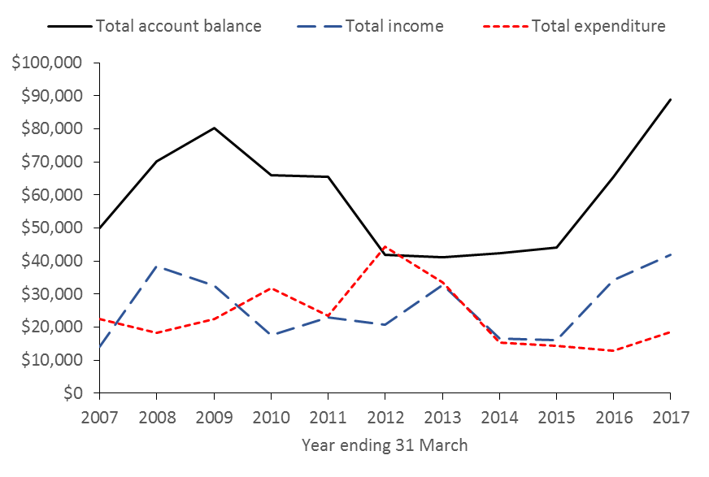
Figure 1: NZMSS total income, total expenditure and total account balance over time
Financial summary (2016/2017)
Table 2 shows income and expenditure for the 2016/2017 year and is prepared on a GST exclusive basis. However, note the Society pays around $5,000 in GST each year. The Society pays GST on memberships, conference registration and sponsorship, and can claim GST on some expenditure (e.g. website), but not on others (e.g. student awards).

Conference profit and loss is included in this summary to show that the Society is exposed to significant risk with this event due to the large amount of money that is received and spent (i.e. conference income and expenditure are nearly $200,000 each). The Society relies on conference organisers to demonstrate financial acumen and to aim to return a surplus of c. $10,000. Thank you to Kerry South and the conference organising committee for managing this so well for the 2016 conference. Note that income received from sponsorship at the 2016 conference totalled c. $70,000, which was particularly high. Figure 3 shows the conference surplus for 2016/2017 in the context of previous years.

Table 2: NZMSS income and expenditure for the year ended 31 March 2017
 | 2016/2017 (GST exc.)
Conference profit and loss
Conference income minus membership | 191,142
Conference expenditure | 160,048
Conference surplus after payment to AMSA | $26,928
NZMSS Income
Membership | 12,943
Conference surplus | 26,928
Interest | 878
Other income | 1105
Total income | $41,855
NZMSS Expenses
Audit fees | 1,250
Bank fees | 889
Council and general expenses | 1,998
NZMSS award sculpture | 700
John Morton Medal | 238
RSNZ affiliation fee | 1,304
First Overseas Conference Travel Award | 4,469
Student research award | 3,000
Student conference prizes | 1,000
Website maintenance | 468
Xero (accounting software) set-up | 2,875
Bookkeeping and Xero subscription fees | 340
Total expenditure | $18,531
Surplus income over expenditure for year | $23,324

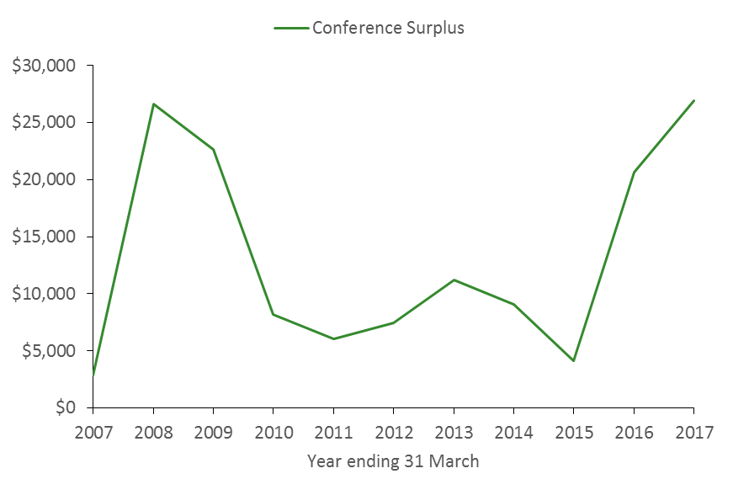
Figure 2: NZMSS conference surplus over time

Auditor’s Report (2015/2016)

The review 2016/2017 is still being processed (as at 16 June 2017). However, our Auditor has now completed the audit for the 2015/2016 year (provided below).

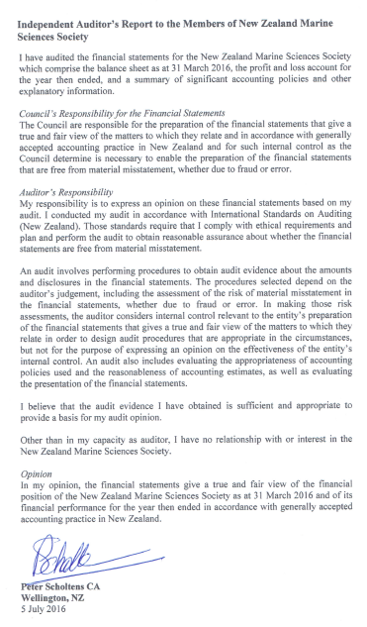

Appendix 4 - Proposed Budget (2017/18)

To ensure that the council follows the financial system (Figure 3), the proposed budget:

    - Aligns income received from the previous year’s conference to student awards that are awarded each financial year following the conference, to reflect the amount the Society can afford from known conference surplus,
    - Aims to increase capital as reasonable, thus reducing financial risk to the Society in the future,
    - Recommends that $5,000 is spent in 2017/2018 on a website re-design, which is required due to the outdated code and content of the current website. This spending was approved at last year’s AGM for 16/17 but has not been spent due to the RSNZ offer to create our website under their umbrella (see Agenda item on website).
    - Recommends that $8,000 is spent on casting 10 new NZMSS awards, as we have no more of these. The artist, Nick Dryden, has quoted $800 per piece, but we always purchase these in bulk.

The budget includes a mix of projected and actual income to reflect the amount of funds available for the 2017/2018 year. Projected income includes subscriptions and bank interest, and actual income is from the 2016 conference.

Note that the budget has been prepared on a GST exclusive basis to reflect the amount of money available, and to be consistent with the financial summary and auditor’s reports.

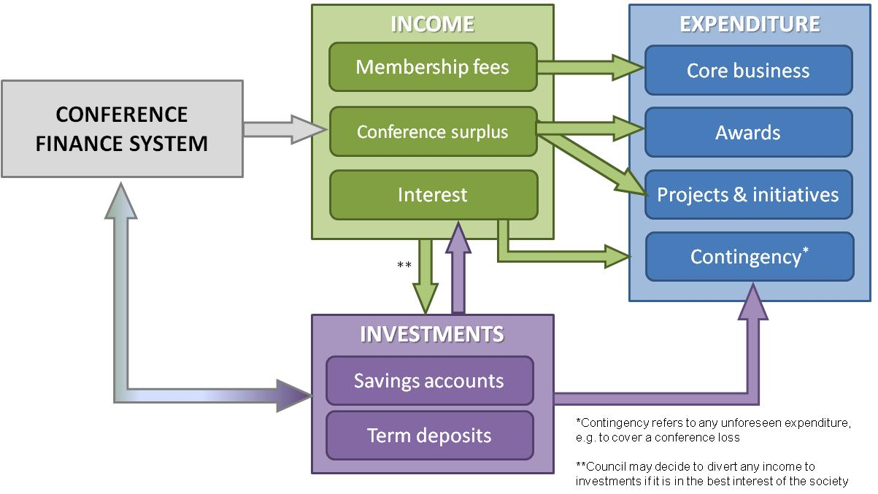
Figure 3: NZMSS generates income in three main ways: membership fees, conference surplus and interest from society investments. Society expenditure includes core business (the costs of running the society), projects and initiatives (e.g. website redesign) and awards (e.g. First Oversees Conference Travel Awards, student conference prizes). The conference finance system uses the society investments to outlay funds such as conference deposits, which should then be returned to the society investments after the conference. However, in the event of the conference running at a loss, or any other unforeseen expenses, the society requires sufficient investments to bear those expenses.

With these recommendations in mind the council proposes the following budget for 2017/18 financial year:

Table 3: Proposed budget for 2017/2018
 | 2017/2018 (exc. GST)
Projected and actual income
Projected income
Membership | 10,000
Interest received | 1,000
Actual income
Conference surplus (from 2016 conference) | 26,928
Total projected and actual income | $37,928
Budgeted expenditure
Core business
Audit fees | 1,000
Bank fees | 500
General council expenses (inc. current website maintenance) | 3,000
NZMSS review | 1,500
NZMSS award sculpture and John Morton Award | 900
Royal Society of NZ - affiliation fees | 1,000
Bookkeeping and Xero subscription | 2,000
Awards
First Overseas Conference Travel Awards | 4,500
Student research award | 3,000
Student awards at conference | 1,000
Projects and initiatives
Website re-design | 5,000
NZMSS award sculptures | 8,000
Other (for example event sponsorship) | 500
Total budgeted expenditure | $31,900
Projected surplus of income over expenditure | $6,028

Appendix 5 – Council Reports

1. Membership numbers

Membership type | 2010-11 | 2011-12 | 2012-13 | 2013-14 | 2014-15 | 2015-16 | 2016-17
Professional | 170 | 130 | 131 | 109 | 189 | 108 | 170
Life | 19 | 18 | 18 | 19 | 20 | 19 | 20
Retired/student | 114 | 98 | 76 | 90 | 86 | 121 | 113
Institutional | 9 | 8 | 7 | 7 | - | - | -
Total | 312 | 254 | 232 | 225 | 295 | 249 | 303

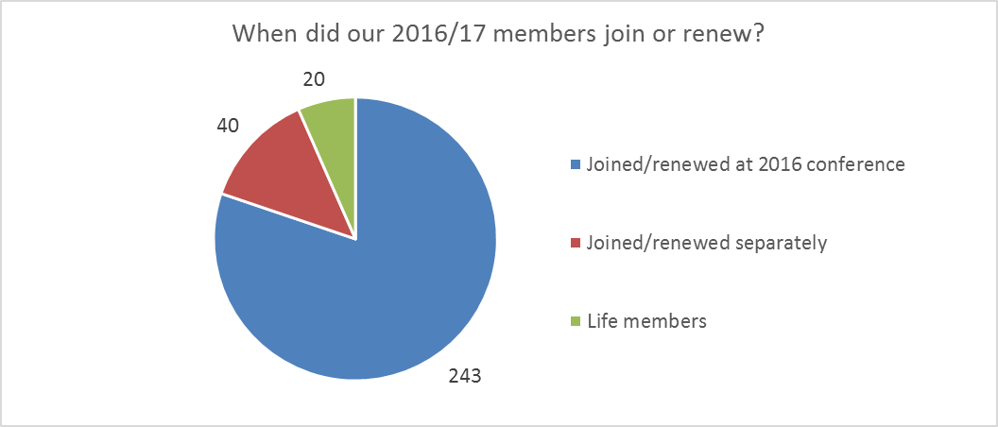
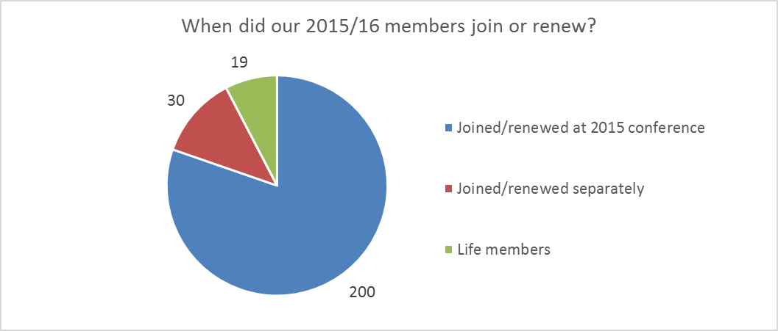
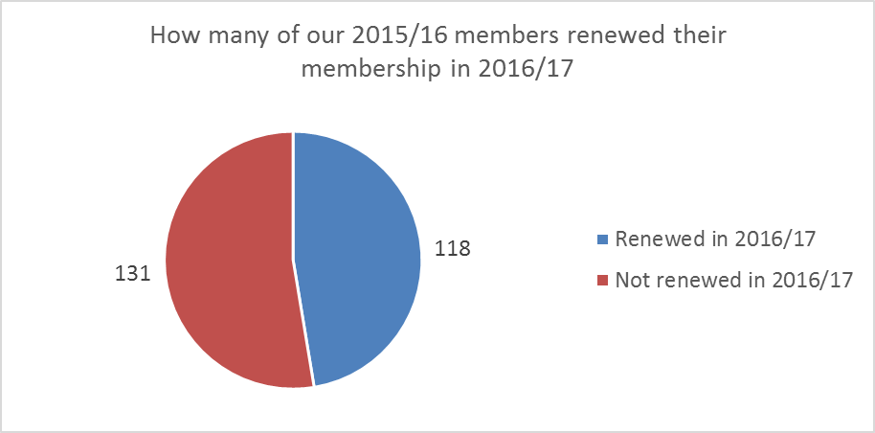
A full list of 2016-17 members is provided in Appendix 6
2. Council operational activities

Members
Council had 16 members (including four student reps). A list of 2016-17 members is provided in Appendix 7.

Meetings
There have been 11 meetings; ten via phone conference call and one face-to-face meeting in February 2017 in Wellington.

Monthly updates
At the February meeting it was decided that a monthly update to members would be a good way of communicating with our members throughout the year. The NZMSS Secretary is now sending out a short monthly update to members after each meeting.

3. Society rule changes
Changes to the society rules were presented at the 2016 AGM. Following feedback the rules were again updated and circulated to the 2016/17 members in November as a referendum to the society for comments or adoption. Twenty-five members voted to change the rules and no one voted against it.

Bob Hickman requested clarification on the auditing/review of accounts rule and did not vote. Clarification was provided and Bob was satisfied. Martin Cryer voted yes but requested Council look at the conflict of interest Rule again and double-check that it could deal with any eventuality. The rule was strengthened accordingly.

4. Submissions
Submissions prepared:
- Science roadmap (September 2016). Sent out a survey to the membership so we could incorporate feedback into the submission
- South East Marine Protection Forum (December 2016)
- Future of our Fisheries discussion and consultation document (Dec 2016)
- Managing microbeads in personal care products (February 2017). Advised membership that submissions were open but did not make a submission on behalf of the society
- Also submitted vote for RSNZ Constituent Organisations’ representative (May 2017)

You can view the NZMSS submissions on our website at http://nzmss.org/documents/documents-of-public-statement-or-release

5. Student awards
NZMSS supported four students to attend their first overseas conference
- Nuwan De Silva (University of Canterbury - $969)
- Becky Focht (Victoria University - $500)
- Alaric McCarthy (University of Auckland - $2000)
- Hua Zha (University of Auckland - $1000)

NZMSS supported Thao Van Nguyen (AUT) with a $3000 Student Research Award to contribute towards her research costs on ‘Development of a novel metabolomics approach to study summer mortalities in Pacific oysters’.
6. Clarification of student eligibility and marking criteria for First Overseas Conference Travel Fund (FOCTF)
The criteria for student eligibility and scoring for our FOCTF have been clarified. The website has been updated accordingly.

7. Website renewal
The NZMSS website rebuild was one of our priority projects in 2016/17. While Council was preparing a proposal to seek quotes for the website development, the Royal Society introduced a new website solution to all constituent organisations at their Constituent Organisation meeting on 30 November. The Royal Society offer is briefly described below:

From the Royal Society’s introductory brochure “Online presence branches and constituent organisations”:
Introduction
For some years now, the Royal Society of New Zealand has provided website hosting for some of our organisational members. In more recent times as technology has changed and demands have increased, it has become apparent that what has been provided is now inadequate for many of you. Quality has become poor and inconsistent which does not support a professional organisational image.
Prefer has developed a solution that will benefit you all and provide development opportunities for the future.
Hoppon
Hoppon is a solution which provides Constituent Organisations and Branches of The Royal Society of New Zealand the right features to support their online needs. This service, which is managed by Prefer on behalf of the Royal Society of New Zealand generates complete, feature packed websites.
The offer
The Royal Society of New Zealand will offer your organisation this service for free. You will get all the features described in attached leaflet of Hoppon and we will cover the ongoing costs.
Features available through the website include:
- Posts / News
- Pages
- Menu management
- Testimonials
- Lead campaigns
- Contact forms
- Mailchimp Integration
- Embedded Statistics
- Sliders
- Membership management including integration to a payment gateway

Council has carefully considered this offer and sought clarification from the Royal Society regarding IP of content and practical considerations should we decide to move away from the Royal Society offer in the future. All responses were positive and Council voted to accept the offer in March 2017.

Where are we at now?
Prefer have set up the NZMSS website. We chose the DIY option, which means that we are creating all website content ourselves. At the moment we do not have anybody on Council who is able to do this task. Depending on our new Council we may have to pay for this service. In 2016/17, $5,000 was budgeted for the website development. This is no longer required as the Royal Society offer was free of charge. We transferred this budget to the 2017/18 budget for website re-design cost. That will allow us to progress the website development in a timely manner and seek technical support as required.

8. Conference guidelines
Progress has been made on simplifying and clarifying the conference guidelines. The primary focus was the development of sponsorship guidelines (see agenda item 6). The conference guidelines will be finalised after this year’s conference reporting has been completed. The focus of the final stage of this process will be overall simplification and clarification of processes, roles of conference organising committee and Council and financial responsibilities.

9. Communication with our members and membership management
Council is aiming to clarify communication with members. Currently we communicate via the listserv and direct emails to current (i.e. paid) members. These discussions will be progressed as part of the website re-design project, which will include a new membership management system.

Appendix 6 – 2016-17 NZMSS Membership List (1 April 2016 to 31 March 2017)

Abraham, Edward | Carbines, Megan | Dunn, Matthew
Aich, Raj Sekhar | Carter, Lionel | Ebdon, Philippa
Allen, Hamish | Cassie-Cooper, Vivienne | Edwards, Charles
Anderson, Owen | Chapman, Lucy | Egan, Eimear
Annala, John | Chiswell, Stephen | Ellenberg, Ursula
Argyle, Phoebe | Choat, Howard | Eisert, Regina
Arlidge, William | Clark, Dana | Evans, Oliver
Armiger, Helena | Clark, Malcolm | Fenaughty, Jack
Asaad, Irawan | Clemente, Ken Joseph | Fettermann De Oliveira, Ticiana
Barker, Jeremy | Cole, Theresa | Field, Karen
Battershill, Chris | Connell, Amelia | Fischer, Johanne
Beets, Fena | Constantine, Rochelle | Float pass, DOC
Behrens, Erik | Conwell, Claire | Focht, Becky
Bell, Andrew | Cooper, Jeremy | Forcen-vazquez, Aitana
Bennet, Della | Cooper, Madeline | Ford, Rich
Berkenbusch, Katrin | Cope, Jane | Foster, Travis
Biggerstaff, Andrew | Crawshaw, Josie | Francis, Chris
Bird, Rebecca | Creese, Bob | Francis, Malcolm
Bishop, Suki | Cryer, Martin | Froude, Victoria
Bolton-Ritchie, Lesley | Currie, Kim | Gale, Samantha
Booth, John | Dane, Robert | Galland, Annie
Bowden, David | D'Archino, Roberta | Gardiner, Sarah
Bowmar, Peter | Davies, Christy-louise | Garrett, Sally
Brooke, Nathania | Dawson, Steve | Geange, Shane
Brough, Tom | De Hamel, Richard | Gerlletti, Annah
Brunton, Jen | de Kock, Willemien | Gerrity, Shawn
Cadwallader, Helen | De Silva, Nuwan | Giles, Hilke
Cahill, Patrick | Decima, Moira | Gillies, Chris
Caie, Phoebe | Del rio, Cintya | Gilmer, Greer
Caie, Stuart | Dempsey, Te Puea | Gilmer, Shane
Caiger, Paul | Dohner, Melanie | Gladstone-Gallagher, Rebecca
Campbell, Andy | Douglas, Emily | Glockner-Fagetti, Andrea
Campbell, Marnie | Drylie, Tarn | Goddard, Katrina
Canto, Robert Franklin | Duncan, Alison | Goetz, Kimberly
Carbines, Glen | Dunn, Alistair | Goodwin, Shannon

Gordon, Dennis | Kibele, Jared | Marsh, Craig
Graham, Brittany | Kincaid, Sophie | Matheson, Fleur
Grandiosa, Roffi | King, Staci | McCarthy, Alaric
Grange, Ken | Kinsey, Richard | Mc Cormack, Sam
Greenland, Adam | Knight, Ben | McCowan, Tom
Grieve, Janet | Kolodzey, Stina | Mccreedy, Erica
Growcott, Abraham | Kortet, Salme | McDowall, Chris
Guerra, Marta | Koverman, Ryan | McGregor, Vidette
Gutierrez-Rodriguez, Andres | Laferriere, Alix | McKenzie, Jan
Haggitt, Tim | Lagos, Paulo | McMullin, Rebecca
Hall, Julie | Lamarche, Geoffroy | McNaughtan, Daniel
Hannan, Danielle | Lange, Rolanda | Metcalfe, Isis
Happy, Samantha | Laroche, Oliver | Mills, Sadie
Harland, Hannah | Leunissen, Eva | Monahan, Bradley
Harrison, Ian | Libotte, Jennifer | Moraes, Carlos
Hayward, Bruce | Lin, Hsien-yung | Morais, Julia
Heath, Ron | Livingston, Mary | Morais, Zilda
Hewitt, Judi | Lohrer, Drew | Mormede, Sophie
Heyns, Karlien | Longson, Chris | Morrison, Mark
Hickford, Mike | Looker, Michael | Muncaster, Simon
Hickman, Bob | Lovett, Bailey | Murdoch, Judith
Hinton, Bethany | Luna-laurent, Emilie | Murdoch, Rob
Hunt, Stephen | Lundquist, Carolyn | Myers, Elisabeth
Huteau, Julien | Lydon, Greg | Neil, Helen
Ilyushkina, Irina | Lyon, Warrick | Neill, Kate
James, Mark | MacDiarmid, Alison | Nelson, Wendy
Jillett, John | Macdonald, Helen | Neubauer, Philipp
Jimenez Brito, Balam | Macdonald, Rachael | Newcombe, Emma
Johnston, David | Mace, Pamela | Nodder, Scott
Jones, Emma | Mackay, Kevin | Northern , Tyler
Jones, Hannah | Macpherson, Diana | O'Callaghan, Joe
Kane, Pamela | Madarasz-Smith, Anna | O'Driscoll, Richard
Kellett, Melissa | Malakhov, Yuriy | Oldach, Eliza
Kelly, Shane | Marquez, Melissa | Oliver, Megan
Kettles, Helen | Marsden, Islay | Olsen, Danette

Orchard, Shane | Schofield, Hilary | Urlich, Steve
Pande, Anjali | Schofield, Max | Valdes, Maria Jesus
Pantos, Olga | Shaffer, Megan | Van Nguyen, Thao
Parker, Steve | Shima, Jeff | Vandenberg Gracie, William
Parsons, Darren | ShortReay, Katherine | Vennell, Ross
Paul-Burke, Kura | Siciliano, Alfonso | Visconti, Valerio
Peart, Rachael | Singh, Bill Subir | Wade, Oliver
Phillips, Nicole | Sinner, Jim | Wallace, Catherine
Pilditch, Conrad | Slooten, Liz | Walls, Kathy
Pinkerton, Matt | Smith, Abby | Webber, Darcy
Pomarede, Marine | Smith, Rebecca | Webster, Trudi
Pook, Chris | Somerford, Tamlyn | Weeber, Barry
Powell, Sophie | Sorensen, Stine Tang | Weekes, Sally
Preuss, Maren | South, Paul | Wells, Susan
Pritchard, Daniel | Spillman, Claire | Wickman, Lindsay
Probert, Keith | Stevens, Craig | Williams, Mike
Putland, Rosalyn | Stewardson, Carolyn | Wilson, Oliver
Putri, Amanda | Stewart, Andrew | Wolf, Robert Paul
Qiu, Zhiguang | Stoute, Selina | Young, Tim
Ratana, Kelly | Struthers, Carl | Yungnickel, Mark
Rayment, William | Sutherland, Judy | Zha, Hua
Rickard, Graham | Swinburn, Jolyon | Zitoun, Rebecca
Riekkola, Leena | Tait, Leigh
Ritchie, Peter | Taumoepeau, Aleki
Roberts, Clive | Taylor, David
Robertson, Ben | Tellier, Pierre
Robinson, Nestor | Thomas, Sam
Rodriguez-Salinas, Paola | Thrush, Simon
Rosemary, Hurst | Torres, Joana
Ross, Phil | Torre-Williams, Laura
Roux, Marie-Julie | Townsend, Michael
Rovellini, Alberto | Tracey, Di
Rowden, Ashley | Tremlett, William
Sanjayasari, Dyahruri | Trnski, Tom
Schiel, David | Tyrrell, John

Appendix 7 – NZMSS Council Elected Membership (2016-2017)

President: | Hilke Giles | Wkto RC
Vice President: | Liz Slooten | U Otago
Secretary: | Dana Clark | Cawthron
Treasurer: | Hannah Jones | Wkto RC

Immediate Past President: | Helen Neil | NIWA

Council Members:
 | Chris Battershill | U Wkto
 | Kathy Walls | MPI
 | Islay Marsden | U Cant
 | Lesley Bolton-Ritchie | Cant RC
 | Nick Shears | U Auck
 | Will Rayment | U Otago
 | Emma Newcombe | Cawthron

Student Representatives:
 | Phoebe Argyle | U Cant
 | Tarn Drylie | U Wkto
 | Rebecca Zitoun | U Otago
 | Becky Focht | VuW

Conference Committee NZMSS 2017:
 | Islay Marsden | U Cant
 | Phoebe Argyle | U Cant
 | Lesley Bolton-Ritchie | Cant RC
 | Regina Eisert | U Cant
 | Sharyn Goldstein | U Cant
 | Jan McKenzie | U Cant
 | John Pirker | U Cant
 | Kimberley Seaward | NIWA

Appendix 8 – Draft Sponsorship Policy for discussion

Draft New Zealand Marine Sciences Society (NZMSS) Sponsorship Guidelines
Draft for discussion at 2017 NZMSS AGM and feedback from sponsors
Rationale
The NZMSS acknowledges that sponsorship provides funds and resources to help the society achieve its goals and objectives and thus enhance the value it provides to its members. Sponsorship may be provided by research institutes, government agencies and departments, trusts, foundations or commercial enterprises
Purpose of these guidelines
To reflect the fundamental principles that shape the NZMSS’s relationship with sponsors to ensure they generate mutual benefits.
To ensure that the NZMSS has a coordinated approach to sponsorship
To further develop positive working relationships with sponsors for the benefit of both parties
To ensure that the integrity of the NZMSS brand is actively managed and controlled by employing a practical and fair approval process
Guidelines
- All sponsorship arrangements must be specified in an agreement between the NZMSS and the sponsor. The agreement must outline all specific provisions as well as terms and conditions.
- The NZMSS should be open to discussing specific sponsor requirements and to work with sponsors on ways they can maximise the benefits of their investment in accordance with these guidelines.
- By entering into an agreement with a sponsor, the NZMSS does not imply endorsement of a company’s product or service and may not be represented by the sponsor or NZMSS as such.
- The NZMSS usually calls for sponsorship of its annual conference through a sponsorship proposal. Responses to this proposal are evaluated by the conference organising committee. The organising committee must follow these guidelines in their evaluation of sponsorship offers. The NZMSS Council retains responsibility for final approval of any sponsorship.
- Offers of sponsorship unrelated to the conference should be addressed to the NZMSS Council.
- The NZMSS prefers to have multiple sponsors for each event/activity.
- Conference programming is carried out by the Society and is always independent of the sponsor(s).
- Oral or poster conference presentations by people associated with the sponsors must not be used for promotional purposes. Abstracts from sponsors and other parties associated with sponsors will be subject to the same review and selection process as for any other conference presentation, and offers of sponsorship may not be contingent on selection of presentation abstracts.
- The NZMSS must clearly identify all sponsors at events/activities and in related communication material
- The sponsor must seek approval from the NZMSS for the use of the NZMSS name and/or logo.
- Sponsors must not to promote services or products that are in contradiction to the objectives of the society (viewable on the NZMSS website).

Other income comprises the donation of an NZMSS award sculpture ($700) and the refund of GST late payment penalties from IRD ($405)
Council recommends that all previous NZMSS reviews are collated (scanned if necessary) and made available online on the new NZMSS website.
As of the 2017 conference we have run out of NZMSS awards and need to buy some more. The sculptor has quoted $800 per piece (if 10 pieces are ordered). These should last the Society at least 10 years, and are retained in the accounts as an asset until they are awarded to a recipient.
Budgeted fund for projects and initiatives, such as supporting community or regional events, which align with the aims of the Society.
Projected surplus of income over expenditure for capital investment ~$6k.

