Minutes for 59th AGM of NZMSS

Napier Conference Centre, Napier, New Zealand
12.00 pm Wednesday 4th July 2018

Present: Hilke Giles, Dana Clark, Hannah Jones, Anna Madarasz-Smith, Liz Slooten, Nick Shears, Lizzy Myers, Anastasija Zaiko, Sam Thomas, Alice Rogers, Leena Riekkola, Pete Wilson, Kate Davies, Wendy Nelson, Cath Wallace, Olivia Johnston, Lesley Bolton-Ritchie, Roger Grace, Courtney Burn, Hannah Charan-Dixon, Robyn Dunmore, Genevieve Bennett, Jose Beya, Chris Cornelisen, Dan Crossett, Alex Hallwell, Yvan Papa, Megan Oliver, Ben Knight, Xavier Pochon, Phil Ross, Megan Carbines, Tim Young, Laura Biessy, Chris Battershill, Matt Pinkerton, Helen Neil, Mark Gall, Samantha Happy, Leigh Tait, Brett Beamsley, Shade Smith, Jason Schwartz, Matthew Bennion, Kaeden Leonard, Helen Cadwallader, Sam McCormack, Daniel Leduc, Simon Thrush, Emily Joy Frost, Ulla von Ammon, Sarah Brand, Sahar Izadi, Kush Jhugroo, Brenton Iurist, Leonardo Durante, Stina Kolodzey, Jess Waley, Erica Donlon, Aless Smith, Yusuf Hussain Qureshi, Emma Jones, Rob Christie, Esther Stuck, Mads Thomsen, Sophia Clark, Irene Middleton, June Loogie, Tamlyn Somerford, Rob Lewis, Steph Bennington, Scott Nodder, Chris Woods, Marta Guerra, Stephen Hunt, Will Rayment, Jeff Shima, David Schiel, Steph Mangan, Shane Kelly, Stefano Schenone, Benn Hanns, Hazel Needham, Michael Townsend, Tarn Drylie, Rebecca Gladstone-Gallagher, Grady Petersen, Vera Rullens, Georgina Flowers, Conrad Pilditch, Emily Douglas, Bob Hickman, Islay Marsden, Drew Lohrer, Richard Bulmer, Martin Cryer, Judi Hewitt, Andrew Bell, Pamela Mace, Kathy Walls, Kura Paul-Burke, Tommaso Alestra.

- Apologies received: Holly Bennett, Rob Major, Ani Murchie, Emma Newcombe, Bailey Lovett.

- Voting for president

- Voting procedure explained and voting forms handed out.

- Minutes of the 2017 AGM

- The minutes were approved via email (sent 8 August 2017, responses due by 18 August 2017). No objections were raised to finalising the circulated draft minutes.

- Matters arising from 2017 AGM

Minute | Action | Status
3) | Finalise conference guidelines, including sponsorship guidelines | Sponsorship guidelines completed, conference guidelines to be completed after 2018 conference to incorporate changes resulting from working with new conference organisers. See Appendix 8
4) b) | Dana to circulate the AGM minutes to members before the end of the month | Completed

- Reports tabled to the AGM 2018

  - President – Hilke Giles (Appendix 1) - moved by Helen Neil, seconded by Pete Wilson.

- No questions raised.

  - Treasurer - Hannah Jones (Appendix 2) - moved by Judi Hewitt, seconded by Nick Shears.

- Question on rationale for keeping the membership payments going through the conference. Hannah explained that we are cautious about removing it from conference registration because people may not voluntary renew their membership and we could lose a lot of money. Also results in time chasing people up. David Schiel showed support for keeping membership joint with conference registration based on his experience with other societies.

- Suggestion was made that people should be able to have the option of opting out of being a member of NZMSS because it is not democratic to force membership onto people just because they want to attend the conference. There could be a penalty for opting out to discourage it.

- Suggestion of a multi-year membership. Potential issue with rectifying the finances but is an option that we will consider.

- Suggestion of providing automatic emails to past members to encourage them to renew. This will be incorporated into the new membership system.

  - Proposed Budget – Hannah Jones (Appendix 3) - moved by Judi Hewitt, seconded by Nick Shears.

  - Auditor - Hannah Jones (Appendix 4) - moved by Judi Hewitt, seconded by Nick Shears.

  - Other Council reports – Hilke Giles (Appendix 5) - moved by Kathy Walls, seconded by Anna Madarasz-Smith.

- Sam Thomas gave an overview of the new website and requested that people that who would like to contribute photos to contact the secretary. Hoping to launch in early August.

- Hilke gave an overview of the new membership system.

- Question on security of the membership details. Hilke said the website comes with standard privacy requirements and it is password protected. Any specific requests can be passed onto Prefer.

- Hilke thanked Kerry South for her work organising past NZMSS conferences. Unfortunately, she moved to a new company and the quote for organising the conference was significantly more expensive than it has cost us to run the conference in the past so we decided to go with OnCue.

- Suggestion to have face-to-face meeting day after or day before the conference. Issue is that it would be either an outgoing council or incoming council so it may not be very productive. Will consider how we can incorporate a face-to-face meeting in the future.

- Election of Officers and other Council members for 2018-19
Nominations received and vacancies as of 16 June 2018 are listed below. Further nominations may be made before or at the AGM. 2017/18 Council members are listed in Appendix 7.
Officers
  - President (see statements from Nick and Liz below)
Nick Shears is willing to stand.
      - Nominated by Hilke Giles, seconded by Craig Radford.
Liz Slooten is willing to stand.
      - Nominated by Steve Dawson, seconded by Will Rayment.
- Voting results: Nick Shears voted by membership to be NZMSS President in 2018/19.
  - Vice-president
Kathy Walls is willing to stand.
      - Nominated by Nick Shears, seconded by Pamela Mace.
  - Secretary
Dana Clark is willing to re-stand.
      - Nominated by Emma Newcombe, seconded by Ben Knight.
  - Treasurer
Hannah Jones is willing to re-stand.
      - Nominated by Hilke Giles, seconded by Pete Wilson.
  - Immediate Past President (non-elected) – Hilke Giles

Other roles
  - Secretary “in training”
Holly Bennet is willing to stand.
      - Nominated by Dana Clark, seconded by Deanna Elvines.
  - Treasurer “in training”
Rob Major is willing to stand.
      - Nominated by Emma Newcombe, seconded by Sam Thomas.
  - Website coordinator and student rep
Sam Thomas (Otago University) is willing to re-stand
      - Nominated by Josie Crawshaw, seconded by Hilke Giles.
  - Membership secretary and student rep
Vera Rullens (University of Waikato) is willing to stand
      - Nominated by Conrad Pilditch, seconded by Tarn Drylie.
General council members
  - Will Rayment is willing to re-stand.
      - Nominated by Dana Clark, seconded by Marta Guerra.
  - Emma Newcombe is willing to re-stand.
      - Nominated by Robyn Dunmore, seconded by Daniel Crossett.
  - Anna Madarasz-Smith is willing to re-stand. (conference organising transition)
      - Nominated by Hannah Jones, seconded by Carolyn Lundquist.
  - Liz Slooten is willing to stand.
      - Nominated by Steve Dawson, seconded by Will Rayment.

Student Reps (at least 2)
  - Leena Riekkola (University of Auckland) is willing to re-stand
      - Nominated by Rochelle Constantine, seconded by Carolyn Lundquist.
  - Sam Thomas (above)

  - Vera Rullens (above)

General nominations
  - Ani Murchie is willing to stand.
      - Nominated by Dana Clark, seconded by Carolyn Lundquist.

New position: Membership Liaison
For the first year this will not be a designated role and will be shared by Anna Madarasz-Smith, Hannah Jones and Hilke Giles.

- One additional nomination during the AGM: Islay Marsden
Nominated by Cath Wallace and seconded by Lesley Bolton-Ritchie

- Decision to accept all nominations moved by Judi Hewitt and seconded by Megan Carbines. All in favour.

Statements from President candidates

Liz Slooten
Liz Slooten's research in ecology and risk analysis has provided the scientific underpinning for better protection of marine mammals - from fisheries mortality, marine mining and other threats. As a Professor at Otago University she is actively involved in organising the 2019 NZMSS Conference in Dunedin. Held on a university campus the conference aims to reduce registration costs, to allow the widest possible range of people to participate and to reduce NZMSS's dependence on commercial sponsorship. Keeping conference costs under control also reduces the risk of NZMSS losing money, in years when the number of registrations or the amount of sponsorship are insufficient to cover the full cost of running the conference. Liz believes in open, transparent communication and decision making, within NZMSS, in marine science in general and in marine management. She would love to hear from other NZMSS members and other marine scientists about what they think are the biggest threats and opportunities for marine science and the marine environment right now. In particular, what do people think NZMSS can do in the next couple of years to help reduce the threats and make the most effective use of the opportunities?

Nick Shears
I am a marine ecologist at the University of Auckland and have been on the NZMSS Council since 2012. My students and I regularly attend the NZMSS annual conference, and I believe attending the NZMSS conference should be a rite of passage for future marine scientists in NZ. However, an ongoing challenge for NZMSS is ensuring the annual conference remains relevant and is attractive to the full spectrum of marine scientists in NZ.

Over the last five years, NZMSS has made great progress in developing new operational procedures and financial systems that allow the Council to run more smoothly and effectively and be financially sound. I believe the focus now is for NZMSS to reconnect with its membership and the wider Marine Science community and re-establish and strengthen its role as an independent voice that represents the views of marine scientists across NZ. The need for change in the management of marine ecosystems is increasingly being recognised, and believe it or not, the role of science in decision-making is increasing. Consequently, I believe NZMSS has an increasingly important role to play in the future of both marine science and the management of marine ecosystems in NZ.

- Sponsorship Guidelines
Following discussions at the 2016 and 2017 AGMs, the NZMSS sponsorship policy was finalised by council (see Appendix 8).

- General Business
  - Applications for the 2018 NZMSS Award and 2018 John Morton Medal have been evaluated and the awards will be presented at the NZMSS 2018 conference dinner. The 2018 NZMSS Award recipient will be announced on Thursday, 5 July, at 4:30pm and the recipient will give a plenary speech before the closing session.

  - Future NZMSS Conferences
Conference for 2019 will be held in Otago (3-5 July)
Conference for 2020 will be a join NZMSS/AMSA conference in Australia
Conference for 2021 will be a North Island conference (location to be confirmed).

- We have been approached by the Freshwater Society Conference to have a joint conference. Chris Battershill put forward Tauranga as an option for 2021. The Freshwater Society usually has their conference at the end of the year so will need to discuss when will suit both societies to hold the conference. Previously when we had a joint conference with the Freshwater Society, it was held in August.

- Any Other Business

  - Scott Nodder congratulated the council on getting the society back on track. Hilke acknowledged Helen Neil’s (Past President) contribution towards this.

Close of meeting at 1:15 pm
Appendix 1 – President’s Report 2017/18

In 2017/18, we continued our initiatives aimed at responsible management of the society and improved value proposition to our membership. For a comprehensive overview of Council activities please see Appendix 5.

Following the progress made in 2016/17 on core operational aspects (including the change of our society rules, setting up our finances in Xero and clarifying financial reporting requirements), in 2017/18 we focussed on more visible initiatives that will modernise the society and add value to the membership. Our biggest project is our new website development, which will include a new membership system. Other achievements are the completion of the NZMSS Sponsorship Policy and the circulation of monthly updates to the membership sharing the highlights of the NZMSS council conference calls.

Thank you to all of you who responded to the surveys sent out after the 2017 conference. This year we surveyed conference attendees as well as members who did not attend our conference. This provided valuable information on not only what people liked about the conference and where we can improve but also why people chose not to attend. We will continue improving our surveys to ensure that we make decisions based on robust information. The survey results are provided in Appendix 9.

To further strengthen our understanding of and add value to the membership, we have created a new role on council titled ‘Membership liaison’. We decided that it is valuable to have one person primarily focussed on the link between the council and the membership and to feed their understanding of the views and priorities of the membership into the various council activities.

One of the most rewarding aspects of the society is the presentation of our student awards. Congratulations to the four successful students who received the First Overseas Conference Travel Fund (Tarn Drylie, Lindsay Wickman, Dyahruri Sanjayasari and Suong Nguyen) and to Irene Middleton who received our Student Research Award.

Many thanks to the 2017/18 council members who supported the society despite everybody’s high workloads in their day jobs. I like to particularly acknowledge Dana and Hannah who both have continued to provide invaluable support to the society in their roles as Secretary and Treasurer, respectively.

Special thanks also to our 2018 conference organising committee and our new conference organising team from OnCue for their hard work and enthusiasm.

As outgoing President, I like to thank everybody who has worked, debated, exchanged emails, laughed and torn their hair out with me during these two years. It has been a pleasure.

Hilke Giles
President NZMSS, June 2018

Appendix 2 – Treasurer’s Report 2017/18

1. Society accounts
As of 31 March 2018 there was a total of $90,775 in the Society’s accounts (Table 1). The Society generated a surplus of income over expenditure in 2017/2018 of $2,045. The 2017 conference generated a surplus of nearly $7,000. This year, we awarded the Student research award to one student ($3,000), First Overseas Conference Travel Awards to four students (totalling $4,500), as well as the usual student conference prizes ($950). Figure 1 shows the 2017/2018 year in the context of previous years. The Society’s funds had mostly been decreasing since 2009, but the past few years have reversed that trend and increased funds significantly. This puts the Society in a much stronger position financially in the years to come.

An online accounting system (Xero) has significantly improved our record keeping and allows us to track the Society’s income and expenses more effectively, and more easily file accurate and timely GST returns. Our intention for the past year was to ensure that we were maximising our investment returns and minimising bank fees. To this end we transferred some funds into term deposits and an online saver account, and also questioned our payment of monthly bank fees with Westpac. Westpac found that we has been paying bank fees in error since 2009 and issued a refund to the society of $955.20. We are also in the process of switching over our website, which will make the online credit card payment facility redundant and this should result in a further saving of c. $50 per month.

As per our budget, this year we purchased 10 new NZMSS awards from the sculptor Nick Dryden. We also had budgeted $5,000 for a website re-design this year, but spent far less than the budgeted amount as the RSNZ has enabled consistent organisations to create websites under their umbrella for very little cost.

As for last year, we will need to update the signatories on our Westpac accounts to include any new Officers of the Society after this AGM, and so will need to circulate and approve our minutes (by email) within one month of this meeting.

Table 1: NZMSS Balance Sheet
 | 2017-18 | 2016-17
NZMSS Funds
Balance 1 April | $88,730 | $65,407
Surplus income over expenditure for year | 2,045 | 23,323
Cheque accounts | 34,686 | 52,814
Savings accounts | 17,966 | 2,844
Sculptures on hand | 8,000 | 700
Accounts receivable/prepayments | 1,739 | 12,424
Westpac term investments | 30,961 | 20,289
Less Accounts payable | 2,578 | 340
Balance as of 31 March | $90,775 | $88,730

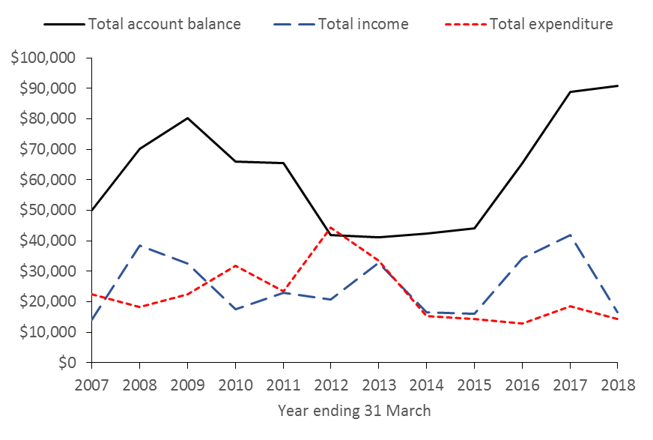
Figure 1: NZMSS total income, total expenditure and total account balance over time

2. Financial summary (2017/2018)
Table 2 shows income and expenditure for the 2017/2018 year and is prepared on a GST exclusive basis. However, note the Society usually pays a GST bill of several thousand dollars each year. The Society pays GST on memberships, conference registration and sponsorship, and can claim GST on some expenditure (e.g. website), but not on others (e.g. student awards).

Conference profit and loss is included in this summary to show that the Society is exposed to significant risk with this event due to the large amount of money that is received and spent (i.e. conference income and expenditure in 2017 were around $100,000 each and have been nearly double this amount in previous years). The Society relies on conference organisers to demonstrate financial acumen and to aim to return a surplus of c. $10,000. Thank you to Kerry South and the conference organising committee for managing to return a $7,000 surplus for the 2017 conference. Note that income received from sponsorship at the 2017 conference totalled c. $44,000, which is a substantial amount and demonstrates the degree to which the Society relies on sponsorship for conferences to break-even or return a surplus. Figure 3 shows the conference surplus and membership income for 2017/2018 in the context of previous years. Note that conference surplus varies considerably from year to year, but has averaged around $12,000 over the past 10 years. Membership also varies quite a bit from year to year, and has averaged around $9,000 over the past 10 years. Note that, at times, membership income seems to be significantly affected by the number of people attending the conferences, as membership is included in conference registration and it seems that many people may not renew their membership if they do not attend a conference in a particular year. Note the degree to which the Society relies on these two streams of income, both of which can fluctuate greatly from year to year.

Table 2: NZMSS income and expenditure for the year ended 31 March 2018
 | 2017/2018 (GST exc.)
Conference profit and loss
Conference income | 101,651
Conference expenditure | 94,757
Conference surplus | $6,894
NZMSS Income
Membership | 7,704
Conference surplus | 6,894
Interest | 886
Other income | 1042
Total income | $16,526
NZMSS Expenses
Audit fees | 950
Bank fees | 616
Council and general expenses | 1,372
NZMSS award sculpture | 700
John Morton Medal | 126
RSNZ affiliation fee | -
First Overseas Conference Travel Award | 4,500
Student research award | 3,000
Student conference prizes | 950
RSNZ - sponsorship | 500
Bookkeeping and Xero subscription fees | 705
Website (hosting) | 468
Website (re-design) | 594
Total expenditure | $14,481
Surplus income over expenditure for year | $2,045

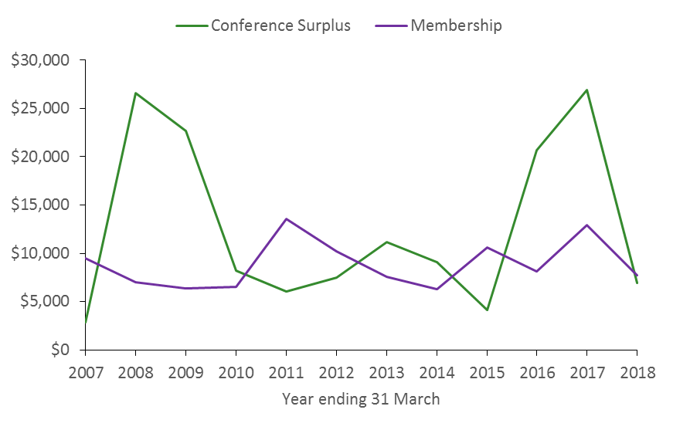
Figure 2: NZMSS conference surplus and membership income from 2007 to 2018

3. NZMSS finance system

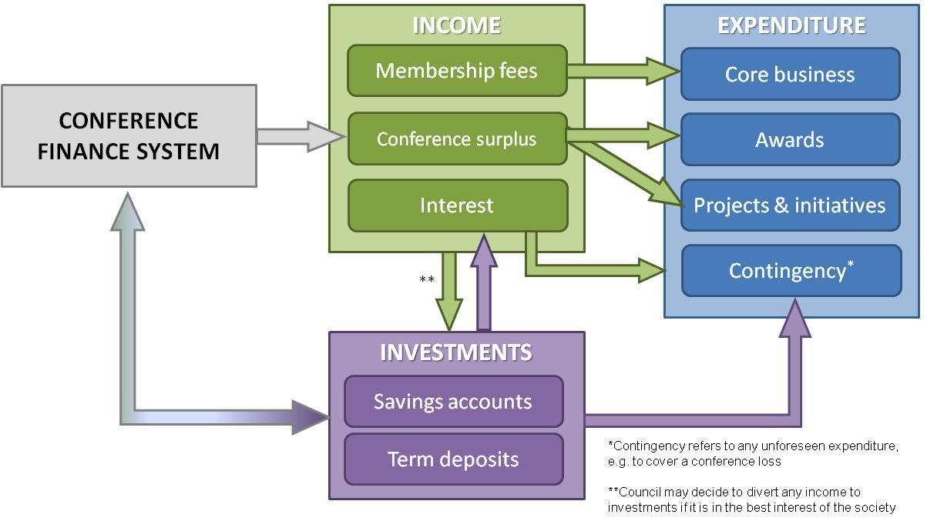
Figure 3: NZMSS generates income in three main ways: membership fees, conference surplus and interest from society investments. Society expenditure includes core business (the costs of running the society), projects and initiatives (e.g. website redesign) and awards (e.g. First Oversees Conference Travel Awards, student conference prizes). The conference finance system uses the society investments to outlay funds such as conference deposits, which should then be returned to the society investments after the conference. However, in the event of the conference running at a loss, or any other unforeseen expenses, the society requires sufficient investments to bear those expenses.

Appendix 3 – Proposed Budget 2018/19
To ensure that the council follows the financial system as outlined in Appendix 2, the proposed budget:

    - Aligns income received from the previous year’s conference to expenditure in the financial year following the conference, to reflect the amount the Society can afford from known conference surplus,
    - Aims to keep student awards (FOCTA and Student Research award) as for last year so that students know how much is available and awards are consistent from year to year,
    - Recommends $2,000 be budgeted to pay for continued work on the new website to transfer current content over to the new platform, ensure content is up to date and that facilities (e.g. membership log on and payment pages) work as intended.

The budget includes a mix of projected and actual income to reflect the amount of funds available for the 2018/2019 year. Projected income includes membership subscriptions and bank interest, and actual income is from the 2017 conference. Note that the budget has been prepared on a GST exclusive basis to reflect the amount of money available, and to be consistent with the financial summary and auditor’s reports. With these recommendations in mind the council proposes the following budget for 2018/19 financial year:

Table 3: Proposed budget for 2018/2019
 | 2018/2019 (exc. GST)
Projected and actual income
Projected income
Membership | 8,000
Interest received | 1,000
Auckland Museum NZMSS award sponsorship | 1,000
Actual income
Conference surplus (from 2017 conference) | 6,894
Total projected and actual income | $16,894
Budgeted expenditure
Core business
Audit fees | 1,000
Bank fees | 500
General council expenses | 2,000
Website hosting | 500
Potential event sponsorship | 0
NZMSS review | 0
NZMSS award sculpture and John Morton Award | 1,000
Royal Society of NZ - affiliation fees | 1,000
Xero monthly subscription | 700
Awards
First Overseas Conference Travel Awards | 4,500
Student research award | 3,000
Student awards at conference | 1,000
Projects and initiatives
Website re-design (continued work) | 2,000
Total budgeted expenditure | $17,200
Projected surplus of income over expenditure | -$306

Appendix 4 – Auditor’s Report (2016/2017)

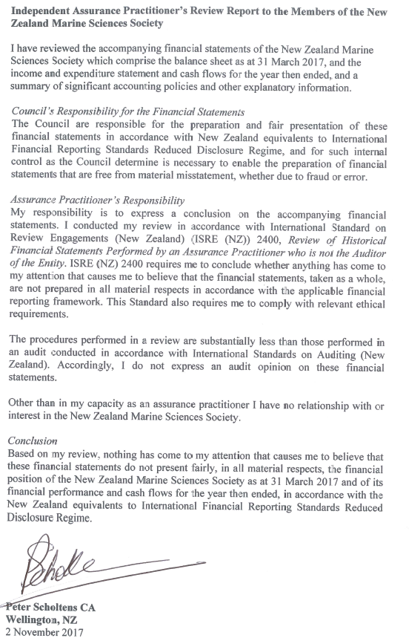

Appendix 5 – Council Reports 2017/18

1. Membership numbers

Membership type | 2010-11 | 2011-12 | 2012-13 | 2013-14 | 2014-15 | 2015-16 | 2016-17 | 2017-18
Professional | 170 | 130 | 131 | 109 | 189 | 108 | 170 | 120
Life | 19 | 18 | 18 | 19 | 20 | 19 | 20 | 23
Retired/student | 114 | 98 | 76 | 90 | 86 | 121 | 113
Retired |  |  |  |  |  |  |  | 0
Student |  |  |  |  |  |  |  | 91
Institutional | 9 | 8 | 7 | 7 | - | - | - | -
Total | 312 | 254 | 232 | 225 | 295 | 249 | 303 | 235

A full list of 2017-18 members is provided in Appendix 6.

2. Council operational activities

Members
Council had 18 members (including seven student reps). A list of 2017-18 members is provided in Appendix 7.

Meetings
There have been 11 meetings; all via phone conference call.

No face-to-face meeting was held in 2017/18 because the travel support requested by council members was greater than the amount budgeted for this meeting.

Royal Society Constituent Organisation Forum meetings
Hilke Giles attended both Royal Society Constituent Organisation Forum meetings organised during the year (July 2017, Dec 2017)

3. Submissions
Submissions prepared:
- Proposed national environmental standards for marine aquaculture (August 2017).
- Review of sustainability measures for four rock lobster stocks, two sea cucumber stocks and one southern blue whiting stock for the 2019/19 fishing year (February 2018). Advised membership that submissions were open but did not make a submission on behalf of the society.
- Proposals for an in-season increase to the total allowable catch for southern bluefin tuna (February 2018). Advised membership that submissions were open but did not make a submission on behalf of the society.
- Sustainable Seas Science Strategy 2019-2024 consultation document (April 2018). Advised membership that submissions were open but did not make a submission on behalf of the society.
- Draft Chatham Islands (PAU4) Fisheries plan (June 2018). Advised membership that submissions were open but did not make a submission on behalf of the society.
- Temporary closure of the Southern Scallop (SCA 7) fishery. Advised membership that submissions were open but did not make a submission on behalf of the society.

You can view the NZMSS submissions on our website at http://nzmss.org/documents/documents-of-public-statement-or-release

4. Student awards
NZMSS supported four students to attend their first overseas conference
- Tarn Drylie (University of Waikato - $1050)
- Lindsay Wickman (University of Otago - $1050)
- Dyahruri Sanjayasari (University of Auckland - $1100)
- Suong Nguyen (University of Auckland - $1300

NZMSS supported Irene Middleton with a $3000 Student Research Award to contribute towards her research costs on ‘Marine debris: an underappreciated habitat for juvenile fishes in New Zealand’s pelagic environment’.

5. Website renewal
The NZMSS website rebuild has been a priority project since 2016/17. During this time the Royal Society made the following offer to all constituent organisations:
Introduction
For some years now, the Royal Society of New Zealand has provided website hosting for some of our organisational members. In more recent times as technology has changed and demands have increased, it has become apparent that what has been provided is now inadequate for many of you. Quality has become poor and inconsistent which does not support a professional organisational image.
Prefer has developed a solution that will benefit you all and provide development opportunities for the future.
Hoppon
Hoppon is a solution which provides Constituent Organisations and Branches of The Royal Society of New Zealand the right features to support their online needs. This service, which is managed by Prefer on behalf of the Royal Society of New Zealand generates complete, feature packed websites.
The offer
The Royal Society of New Zealand will offer your organisation this service for free. You will get all the features described in attached leaflet of Hoppon and we will cover the ongoing costs.
We accepted this offer and are in the process of finalising the new NZMSS website.
Update on website development
A subcommittee was formed to lead the redevelopment of the NZMSS website. We are taking a staged approach with an initial focus on the transfer of existing material to the new website, with some editing of content and structure. The subcommittee reviewed the content on the existing website, considering readability, accuracy, and relevance. Highest-priority material was restructured or edited as required, in preparation for creation of a new website. Once the new website has been populated with basic content, the website will go live. This is planned for early August 2018.
Our next steps will include development of a news feed and an improved social media presence.
Update on membership management system
We have a new membership management system (MemberPress) that is integrated in the new WordPress website. Each member will have a login and the ability to update contact details and renew their membership online. The system includes secure credit card facilities.
We will also use this system for communication with the membership and slowly phase out the listserv. More information will be provided before we commence this transition.
All 2017/18 members have already been imported into the new system. After the conference, the system will be updated with 2018/19 renewals and new members. Emails will be sent out to everybody providing information on how to access the system. Expect to receive an email early August.
We will ask you to check and, if necessary, update your contact details and would appreciate if you could keep your details up-to-date to ensure you receive our emails and notifications.
6. Conference surveys
After the 2017 conference we surveyed conference attendees as well as members who did not attend our conference. This provided valuable information on not only what people liked about the conference but also why people chose not to attend. We will continue improving our surveys to ensure that we make decisions based on robust information. The survey results are provided in Appendix 9.

7. Conference guidelines
As described in the Treasurer’s report, our society is exposed to significant risk due to the large amount of money that is received and spent in relation to our annual conference. The Society relies on conference organisers to demonstrate financial acumen and to return a surplus (aim c. $10,000) to provide the funds for student support and other expenditure items (see finance diagram in Treasurer’s report). Membership numbers also vary from year to year and are largely a reflection of the number of conference attendees.

To support the conference organising committee to meet these expectations, we have been working on conference guidelines for some time. These guidelines were meant to be completed in 2017/18.
During the 2017/18 year, Kerry South informed us that she has changed positions and can no longer organise our conference in the previous format. Following a thorough comparison of conference organising services, we contracted OnCue to organise our 2018 conference. Kerry has provided conference organising services to the NZMSS for a very competitive rate and the change in service provider resulted in an increased cost to NZMSS. At the same time, OnCue are providing new opportunities that we are benefitting from. We decided to delay the completion of the conference guidelines to 2018/19 so that we can incorporate the changes resulting from the change in conference organising services.

Appendix 6 – 2017/18 NZMSS Membership List (as of 31 March 2018)

Aguirre, David | Dean, Matthew | Heath, Ron
Alestra, Tommaso | Decima, Moira | Hendriks, Hannah
Allen, Ro | Dencer-Brown, Amrit | Hewitt, Judi
Allison, Andrew | Dickson, Toby | Hickey, Chris
Austin, Trevor | Douglas, Emily | Hickford, Mike
Babuder, Mareike | Drylie, Tarn | Hickman, Bob
Barker, Jeremy | Dudley, Jade | Hillman, Jenny
Barriball, Leana | Dunmore, Robyn | Hoffmann, Linn
Bates, Tracey | Ebdon, Philippa | Holmes, Monique
Beamsley, Brett | Edwards, Mark | Hupman, Krista
Beaumont, Jennifer | Ellenberg, Ursula | Inglis, Graeme
Beets, Fenna | Eme, David | Jackson, Susan
Bell, Jacqui | Espinel, Nadjejda | James, Mark
Berthelsen, Anna | Fletcher, Lauren | James, Kate
Betty, Emma | Floerl, Oliver | Jennings, Jessica
Blain, Caitlin | Flood, Ashley | Jillett, John
Blessy, Laura | Foergill, Nicola | Jones, Doug
Bollen, Michael | Foley, Melissa | Jones, Hannah
Bolton-Ritchie, Lesley | Ford, Rich | Murchie (nee Kainamu), Ani
Booth, John | Francis, Chris | Kearney, Emma
Bowden, David | Francis, Malcolm | Kellett, Melissa
Brough, Tom | Gammon, Malindi | Knight, Ben
Bulmer, Richard | Gentry, Rebecca | Kovacs-Wilks, Kimberley
Cadwallander, Helen | Gerrity, Shawn | Koverman, Ryan
Cameron, Tania | Geytenbeek, Mark | Lambie, Joanna
Camlek, Florjan | Gheitanchi Mashini, Amirhossein | Leunissen, Eva
Carbines, Megan | Giles, Hilke | Lewis, Robert
Carmona-Noklegaard, Tone | Gillies, Tasman | Li, Moyang
Carter, Lionel | Gladstone-Gallagher, Rebecca | Lischka, Alexandra
Cassie-Cooper, Vivienne | Glockner-Fagetti, Andrea | Lohrer, Drew
Choat, Howard | Godoy, Daniel | Lovett, Bailey
Clark, Dana | Goldstien, Sharyn | Loy, Candace
Clark, Kate | Gordon, Dennis | Lundquist, Carolyn
Clark, Malcolm | Gorman, Lucy Mae | Lust, Bobby
Clark, Sophia | Grandiosa, Roffi | Lydon, Greg
Clemente, Ken Joseph | Gray, Fiona | MacDiarmid, Alison
Cope, Jane | Grieve, Janet | Mace, Emily
Corne, Chloe | Guerra, Marta | Mace, Pamela
Costello, Mark | Guo, Xiangzhao | Mackay, Kevin
Crawshaw, Josie | Gutierrez Rodriguez, Andres | Madarasz-Smith, Anna
Creese, Bob | Hailes, Sarah | Madi Salloum, Priscila
Cressey, Peter | Happy, Samantha | Markic, Ana
Cunningham, Shaun | Harbron, Amy | Marsden, Islay
Dawes, Sarahlee | Hawes, Nicola | Maryag, Lara
Dawson, Steve | Hayward, Bruce | Masi, Michelle
Masoomi Dezfooli, Seyedehsara | Sanjayasari, Dyahruri | Zha, Hua
Matheson, Fleur | Schenone, Stefano | Zhang, Jingjing
Maxwell, Kimberley | Schiel, David | Zintzen, Vincent
Mc Cormack, Sam | Seaward, Kimberley | Zitoun, Rebecca
Mccartain, Lisa | Seneviratna, Deepani
McComb, Peter | Seyfoddin, Ali
McCowan, Tom | Sharp, Ben
Middleton, Irene | Shears, Nick
Milne, Juliet | Slooten, Liz
Monahan, Bradley | Smith, Aless
Murdoch, Rob | Spreitzenbarth, Stefan
Myers, Elisabeth | Stephenson, Fabrice
Neil, Helen | Stevens, Craig
Neilson, Conor | Stockin, Karen
Nelson, Wendy | Tait, Leigh
Newcombe, Emma | Taylor, Rikki
Nguyen, Suong | Tellier, Pierre
Nguyen, Thao | Thomas, Sam
Nodder, Scott | Thomsen, Mads
Norrie, Craig | Thrush, Simon
Nutsford, Constance | Townsend, Michael
O'Carroll, Jack | Trembath, Caroline
O'Meara, Teri | Turner, Tracey
Oosting, Tom | Udy, Jacquetta
Palfi, Orsolya | Urlich, Steve
Pantos, Olga | Valdes, Maria Jesus
Parry, Bethan | van der Krogt, Rebecca
Patiño Perez, Jessica | Van Der Reis, Aimee
Paul-Burke, Kura | von Ammon, Ulla
Peebles, Bryce | Wakelin, Laura
Peters, Catherine | Walls, Kathy
Pilditch, Conrad | Wang, Juan
Pinkerton, Matt | Wang, Li
Pook, Chris | Webb, Samantha
Pritchard, Daniel | Wells, Susan
Probert, Keith | White, Sophie
Pryor Rodgers, Rata | Whitehead, Amy
Putland, Rosalyn | Wickman, Lindsay
Rayment, William | Wietheger, Anne
Riding, Tim | Williams, Uru-Manuka
Riekkola, Leena | Wilson, Pete
Roberts, Jim | Wilson, Shaun
Robinson, Esme | Wood, Susie
Robinson, Nestor | Woods, Chris
Ross, Phil | Wright, Andrew
Ruffell, Helena | Yan, Ruojin
Russell, Pete | Zabarte Maeztu, Inigo
Safi, Karl | Zeldis, John
Appendix 7 – NZMSS Council Elected Membership (2017/18)

President: | Hilke Giles | Waikato Regional Council/  Pisces Consulting
Vice President: | Liz Slooten | University of Otago
Secretary: | Dana Clark | Cawthron
Treasurer: | Hannah Jones | Waikato Regional Council

Immediate Past President: | Helen Neil | NIWA

Council Members: | Anna Madarasz-Smith | Hawkes Bay Regional Council
 | Kathy Walls | MPI
 | Islay Marsden | University of Canterbury
 | Nick Shears | University of Auckland
 | Will Rayment | University of Otago
 | Emma Newcombe | Cawthron

Student Representatives: | Sam Thomas | University of Otago
 | Phoebe Argyle | University of Canterbury
 | Tarn Drylie | University of Waikato
 | Leena Riekkola | University of Auckland
 | Bailey Lovett | University of Auckland
 | Lizzy Myers | Massey University
 | Monique Holmes | Victoria University

Conference Committee NZMSS 2018:
 | Anna Madarasz-Smith | Hawkes Bay Regional Council
 | Phil Ross | University of Waikato
 | Megan Carbines | Auckland Council
 | Carolyn Lundquist | NIWA
 | Leena Riekkola | University of Auckland
 | Conrad Pilditch | University of Waikato
 | Oliver Wade | Hawkes Bay Regional Council
 | Pete Wilson | Waikato Regional Council
 | Hannah Jones | Waikato Regional Council
 | Lizzy Myers | Massey University
 | Shade Smith | Triplefin Consulting

Appendix 8 – NZMSS Sponsorship Policy

New Zealand Marine Sciences Society Sponsorship Policy
Rationale
The New Zealand Marine Sciences Society (NZMSS) acknowledges that sponsorship provides funds and resources to help the society achieve its goals and objectives and thus enhance the value it provides to its members. Sponsorship may be provided by research institutes, government agencies and departments, trusts, foundations or commercial enterprises
Purpose of this policy
The objectives of this policy are to:
- Reflect the fundamental principles that shape the NZMSS’s relationship with sponsors to ensure they generate mutual benefits.
- Ensure that the NZMSS has a coordinated approach to sponsorship
- Further develop positive working relationships with sponsors for the benefit of both parties
- Ensure that the integrity of the NZMSS brand is actively managed and controlled by employing a practical and fair approval process
Policy
- All sponsorship arrangements must be specified in an agreement between the NZMSS and the sponsor. The agreement must outline all specific provisions as well as terms and conditions.
- The NZMSS should be open to discussing specific sponsor requirements and to work with sponsors on ways they can maximise the benefits of their investment in accordance with these guidelines.
- By entering into an agreement with a sponsor, the NZMSS does not imply endorsement of a company’s product or service and may not be represented by the sponsor or NZMSS as such.
- The NZMSS usually calls for sponsorship of its annual conference through a sponsorship proposal. Responses to this proposal are evaluated by the conference organising committee. The organising committee must follow these guidelines in their evaluation of sponsorship offers. The NZMSS Council retains responsibility for final approval of any sponsorship.
- Offers of sponsorship unrelated to the conference should be addressed to the NZMSS Council.
- The NZMSS prefers to have multiple sponsors for each event/activity.
- Conference programming is carried out by the Society and is always independent of the sponsor(s).
- Oral or poster conference presentations by people associated with the sponsors must not be used for promotional purposes. Abstracts from sponsors and other parties associated with sponsors will be subject to the same review and selection process as for any other conference presentation, and offers of sponsorship may not be contingent on selection of presentation abstracts.
- The NZMSS must clearly identify all sponsors at events/activities and in related communication material
- The sponsor must seek approval from the NZMSS for the use of the NZMSS name and/or logo.
- Sponsors must not to promote services or products that are in contradiction to the objectives of the society (viewable on the NZMSS website).

Appendix 9 – Results of 2017 conference survey

Survey 1: Conference attendees
Results are only categorised by membership type (student, professional member). Response data also provide the ability to categorise based on answers to the questions:
- Where did you travel from?
- Did you attend one day or whole conference?
- Did you give an oral presentation?
- Did you present a poster?

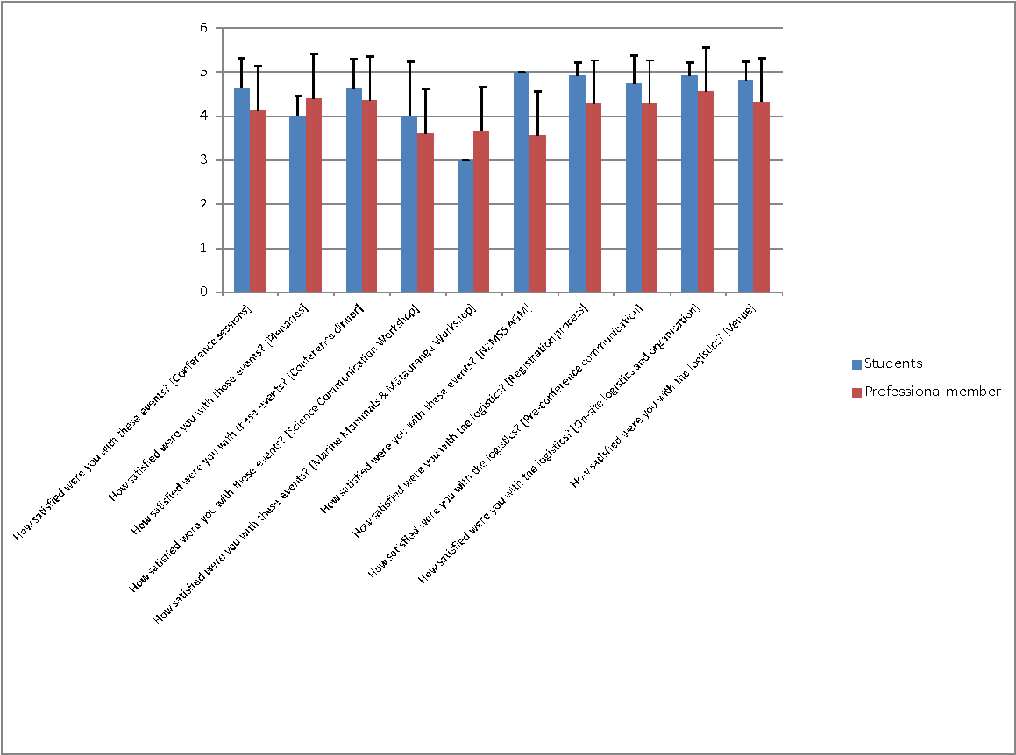
Figure: Average of ratings (scale 1-5) with standard deviation.

Do you have any comments about conference events?
- Students
- I really enjoyed Vonda Cumming's plenary but the other plenaries were not of interest to me
- My score for the conference sessions and plenaries comes simply from the fact that the broad topics which were covered were not as much in my area of interest as the year before's conference. The sessions themselves were run very well and there were a lot of great talks.
- Dinner took a long time to come out. But it was absolutely delicious and the venue and entertainment fantastic.
- A brilliant line-up of talks. it was difficult to prioritise which ones to attend!
- Dinner and evening functions were great - awesome catering and wine supply

- Professional members
- conference sessions overlapped a lot in similar themes
- "Planaries" ? (Sp. mistake)
- Great venue for conference and dinner- all very well organised
- Dinner was good but venue too noisy and hard to have a conversation.
- Prefer not to have plenaries right before a session without break as this makes it difficult for the following session chair
- Prefer not to have plenaries right before a session without break as this makes it difficult for the following session chair
- The conference dinner venue and food were amazing.
- Would have loved to attend Genetics and aquaculture as they are often closely related and i work in aquaculture but they were on at the same time!
- It was great having the workshops. The conference dinner was really nice and the venue for the conference was perfect.
- Sessions included too many presentations on intrim results. A number also presented on results based on poor experimental design and set-up, and non-statistically significant results. Several also presented their results as if these were new findings, while if fact the same have previously been found by other NZ insittutions or reported overseas.
- Field trips would be very beneficial
- Social events were excellent.

Do you have any comments about the conference logistics?
- Students
- Received multiple emails about fees being unpaid when they had been. Each time proof had to be sent.
- They were fantastic
- I am curious what happens to left over food/food waste. Is this composted? I appreciated the lack of single use plastic, thank you!
- Professional members
- It would be great have have coffee when we arrive on the first morning!
- Only confusion was around the campus layout, almost no maps and the ones that were there were vague! Very hard to orient for someone who has never been there before.
- went very well
- Lovely organiser! :)

Did you know you were eligible for student prizes and what they were? (students only)
No: 2
Yes: 5

Do you have suggestions on how we could improve our processes related to student prizes? (students only)
- As a student giving a speed talk, I was aware I was eligible for prizes but I did not realize there was no specific prize for speed talks. I believe there should be a different category for speed-talks vs. full-length talks. It is very difficult to convey the same amount of information and make the same impact on the audience in a speed talk vs. a full length talk (as you can barely explain anything in depth in 5 minutes), so they should be considered differently when it comes to prizes.
- Have a students choice award.
- I did not present a talk although if I had I would've loved to have access to the marking scheme and/or feedback given after the talks
- I knew I was eligible but I did not know what they were. I didn't know the marking criteria and I would have liked some guidelines and feedback. I don't know how I can improve or what my strengths might have been.

How do you rate the process of assessing student presentations and/or posters at this conference? (professional members who were scoring only)
3.5 +/- 1.1

Do you have any suggestions for improvement of the student marking process (to make it easier for you and possibly more consistent among assessors)? (professional members who were scoring only)
- Requires some moderation of scores
- Consistency across markers is key. We probably need to discuss this more extensively.
- Not make the scoring out of 100. I suggest out of 30.
- It went quite well really - it would be great to have more than 2 for each talk and some overlap. Would like to see a prize for estuarine work because there were a lot of student papers

Do you have any additional comments about the 2017 conference?
- A lot of people commented that it was expensive. I'm not sure how it compares to other conferences. I thought the student fees were very reasonable and the conference dinner was really nice.
- Some of the prizes were given to students even though the prize had nothing to do with what they were doing.
- Great event! Loved the location of the mingle session on the Monday night!
- It was great.
- Great conference! Just one comment about the conference catering, I feel very strongly that an effort could have been made to encourage the contracted company to reduce the over-use of plastic wrapping and plastic water bottles to service our dietary needs. I know from my experience in catering that it is not necessary to individually wrap sandwiches, 'wraps' or filled buns in glad wrap before serving. A vast amount of plastic waste was generated from catering, including the hundreds of plastic packaged individual butter and jam servings! In light of the environmental damage this is known to cause, I feel this in not in-line with our efforts to protect and care for our environment. Para kore Aotearoa!
- Conference dinner was awesome, as were social events

Do you think you will attend the 2018 conference in Napier?
Yes: 21
No: 2
Not sure yet: 11

Do you have any suggestions for the 2018 conference?
- More activities for networking between students
- I would challenge you to try and make this a zero waste conference :-)
- It would be great if any meat and animal products served were sustainably sourced and cruelty free (i.e. free range chicken and pork etc.), thanks.
- Bring the reg fee down. At present it costs same to go to NZMSS as an international more specialist conference. This may not matter to NIWA staff who are funded by national projects, or students who are sponored, but the high reg fee may explain the low attendance of academics and post-docs from universities.
- Keep doing what you're doing!
- Before and after conference activities are available, eg a trip to the gannet colony or a winery or two.
- Focus on quality. There should be a higher bar for getting abstracts accepted.
- It should look to address Natural capital/ecosystem services/investment approaches and Ecosystem based management
- Field trips! And please retain the biosecurity session that was great. I'm happy to assist in organising this and a biosecurity field trip?
- I'm a bit of a broken record here. There are big chunks of the marine science community not attending the conference. This is mainly university groups. It would be good to understand the reason these people don't bother attending and address the issue if possible.
- The programme is one of the most difficult aspects to sort out. We were hampered a bit by not knowing where students were from and at times who the other authors were. Why were there fewer posters than usual?
- Lots of social events, networking chances
- Absolutely loved it and wish i could have stayed for longer
- very enjoyable
- "A two day conference with a focus on quality rather than quantity in terms of presentations would have been preferred.
- A higher level of industry involvement would also have been benificial. "
- Plenary speakers were exceptional!
- Great conference, well done. I thought the number of attendees was a bit light this year, I wonder if there needs to be a push to get more people attending.
- Some sessions of similar themes ran in parallel which meant I had to miss some good content.

Survey 2: People who did not attend the conference
Results are not categorised. Response data provide the ability to categorise based on answers to the question:
- Are you a student or professional member?
- Where did you travel from?

What were your reasons for not attending the 2017 conference in Christchurch?
- I had another commitment at that time (e.g. overseas trip, teaching)
- I had another commitment at that time (e.g. overseas trip, teaching)
- I had another commitment at that time (e.g. overseas trip, teaching)
- I had another commitment at that time (e.g. overseas trip, teaching), Programme was not of interest/relevant to me, Registration cost
- Registration cost, Travel and accommodation cost
- I attended another conference (other conferences) in 2017 that were higher priority
- I attended another conference (other conferences) in 2017 that were higher priority
- I was finishing up my PhD thesis
- I did attend!
- I had another commitment at that time (e.g. overseas trip, teaching)
- I had another commitment at that time (e.g. overseas trip, teaching), Travel and accommodation cost, No longer in the country
- I attended another conference (other conferences) in 2017 that were higher priority, Registration cost, Travel and accommodation cost
- I had another commitment at that time (e.g. overseas trip, teaching), previous conference experience
- Did attend the conference
- I had another commitment at that time (e.g. overseas trip, teaching)
- I had another commitment at that time (e.g. overseas trip, teaching)
- Had nothing ready to present at this time
- Registration cost, Travel and accommodation cost
- I had another commitment at that time (e.g. overseas trip, teaching)
- working overseas
- I had another commitment at that time (e.g. overseas trip, teaching)
- Time of the year, Programme was not of interest/relevant to me, Travel and accommodation cost
- Programme was not of interest/relevant to me
- I had another commitment at that time (e.g. overseas trip, teaching), I attended another conference (other conferences) in 2017 that were higher priority, Programme was not of interest/relevant to me, Registration cost
- Time of the year, I attended another conference (other conferences) in 2017 that were higher priority, Only limited number of people from my organisation could attend and it was more important for others to go (e.g. students)
- Too much work on
- Registration cost, Travel and accommodation cost
- I had another commitment at that time (e.g. overseas trip, teaching)
- Only limited number of people from my organisation could attend and it was more important for others to go (e.g. students)
- I had another commitment at that time (e.g. overseas trip, teaching)
- I attended another conference (other conferences) in 2017 that were higher priority, I had long service leave this year, and so could not spare work time for conferences.
- I attended another conference (other conferences) in 2017 that were higher priority, Programme was not of interest/relevant to me, Only limited number of people from my organisation could attend and it was more important for others to go (e.g. students)
- I had another commitment at that time (e.g. overseas trip, teaching), Programme was not of interest/relevant to me
- Travel and accommodation cost
- I had another commitment at that time (e.g. overseas trip, teaching)
- I had another commitment at that time (e.g. overseas trip, teaching)
- Only limited number of people from my organisation could attend and it was more important for others to go (e.g. students)
- I had another commitment at that time (e.g. overseas trip, teaching)
- I was on maternity leave
- I attended another conference (other conferences) in 2017 that were higher priority, I am in the field in AUstralia
- Only limited number of people from my organisation could attend and it was more important for others to go (e.g. students)
- I had another commitment at that time (e.g. overseas trip, teaching)
- Programme was not of interest/relevant to me, Only limited number of people from my organisation could attend and it was more important for others to go (e.g. students)
- I had another commitment at that time (e.g. overseas trip, teaching)
- I had another commitment at that time (e.g. overseas trip, teaching), I attended another conference (other conferences) in 2017 that were higher priority, Programme was not of interest/relevant to me, Only limited number of people from my organisation could attend and it was more important for others to go (e.g. students)
- I had another commitment at that time (e.g. overseas trip, teaching)
- I attended previously as a student. At the moment I am employed in a different profession, and saw no good reason to attend.
- Registration cost, Travel and accommodation cost
- Only limited number of people from my organisation could attend and it was more important for others to go (e.g. students)
- I had another commitment at that time (e.g. overseas trip, teaching), Registration cost, Travel and accommodation cost
- Travel and accommodation cost
- Registration cost, Retired
- I had another commitment at that time (e.g. overseas trip, teaching)
- I had another commitment at that time (e.g. overseas trip, teaching)
- I had another commitment at that time (e.g. overseas trip, teaching)

Please provide detailed explanations of your selections in the previous question.
- I had uni classes on at the time
- I went to the Czech Republic for my sister in laws wedding, so was away in Europe for the time of the conference.
- FIeldwork season in Indonesia
- Not working, low on funds.
- As PhD student I needed to attend an international conference, and unfortunately it happens in the same week of NZMSS conference 2017
- I presented in America one month prior at a more targeted conference
- I attended and presented a 15 minute talk on ship strike mitigation at the conference. So you might want to check your records!
- I was in Europe to visit family
- I attended another conference overseas, and although I would have liked to attend the NZMSS conference as well, I did not have a budget for this.
- Previous conference speaking slot was reduced from 15 mins (allocated) to 10 mins (actual) due to timing + chairing issues. It is hard enough to deliver research findings in 15 mins. Considering the investment in preparing the presentation, travel, and conference fee this was a terrible experience.
- Did attend the conference
- See above
- "This needs an 'other' option above, because it won't let me carry on without choosing an option. The one I chose isn't really the case.
- Time away from work, and preparation time of a talk, is too much every year also I didn't have anything I felt I really needed to present"
- doing a post-doc in the USA
- I was a Keynote speakers at the AMSA conference which was the same week.
- Unless there is a directly relevant purpose for me to attend, i.e., I have a talk or poster to present, or there is a theme or talk session that relates directly to my role at work then I cannot justify the cost of travel and accommodation and registration to my employer.
- I am a physical oceanographer
- Many of the international conferences that I attend have much more affordable registration fees, particularly for students. I supervise a large group of students who would benefit from conferences such as NZMSS--and some years I cover their costs to attend--but its difficult for me to justify collective costs of 10K+ for student conference costs on an annual basis. Increasingly, I've become somewhat disenchanted with NZMSS conference content--which seems to me to be incorporating much more policy/outreach and science challenge propaganda, and less actual science of the sort that would be of benefit and interest to me and my students.
- My current employment would not have paid the costs.
- I was overseas, so unable to attend
- The NZMSS conferences are not as inspiring as some other NZ conferences. The theme and sessions seem loosely related and the same people attend.
- I was pretty busy. The content in these conferences is OK but does not overlap with what I do a whole lot. I generally go for social reasons.
- Conference attendance is limited (1 every 2-3 years), so have to be chosen carefully. Unless the programme is completely aligned, and there are speakers we might not otherwise get to hear or communicate with, then it's hard to justify the NZMSS.
- I attended the conference last year, didn't have anything to present this year and we had some new staff in our team. Our manager prefered to give priority to the new staff and those presenting.
- Family commitments, children to look after.
- Unfortunately the conference was to occur a few weeks out from a six week vessel-based expedition that i was leading. I couldn't afford the time to attend the conference this year.
- I joined to attend the 2016 conference but marine science is not my main interest.
- Just getting back from an overseas conference the day before.
- It was during teaching so hard to get away. Saving funds for an international conference. Session related to my area was not innovative and some talks repeated from previous years so not novel.
- on maternity leave and working limited hours
- While I am technically self-employed I have been overseas and then ill and so have earned little recently. The costs of attendance are high given I am not paid to attend. The winter date is difficult when I need to stay far away from the venue in cheaper accommodation and need to walk to and from the venue in the dark on my own.
- I was originally going to attend, and registered. However, one of my team was keen to attend, and it was more valuable and better use of funds for them to replace me.
- I'm retired so have to cover all costs myself, which is a major consideration. However, in this case I was overseas at the time anyway.
- As a pensioner, and not having my own vehicle there (I live in the north of the NI), comfortable yet reasonably inexpensive accommodation was an issue.
- Still interested in science but now focused on my specialty area.
- At announced first I was planning to go overseas, then my nice announced that she was going to have a baby at the time of the conference, so I stayed back in NZ but still could not get to the NZMSS. I really liked the conference theme and was very sorry not to be able to attend.
- Enjoying Spanish/Portuguese heat rather than Christchurch cold!

Do you think you will attend the 2018 conference in Napier?
- Yes: 19
- No: 5
- Not sure yet: 31

Do you have any suggestions for the 2018 conference?
- Not at this time.
- No
- 20 minute time slots are a lot better for the quality of presentations
- no
- I would like to have a session on the research being conducted by the Sustainable Seas National Science Challenge
- To encourage the physical oceanographic community and the wave community to attend.
- I think the use of professional conference organisers adds significantly (and unnecessarily) to the costs of these events for students. Conferences such as the Western Society of Naturalists is comparable in size and scope. Student membership fees are $5 and conference registration fees are typically on the order of $100. The organisation of the conferences is managed by the local hosts (with much of the organisation and legwork achieved by students at the local host institution).
- Have more specialised sessions around a topical theme and invite people to present. More time for questions and debate.
- Keynotes are important.
- Lunch and Dinner included in registration fee would be best.
- Ensure that the tāngata whenua are involved in the conference and if they were interested provide them the ability to contribute meaningfully and participate throughout the whole conference to hear about what is going on in this space.
- marine biosecurity to be a focus and encourage regional councils and MPI to do presentations
- Cheaper options for registration - e.g. no conference dinner option
- Ecosystem-based management of activities and impacts of the marine environment; Spatial management; NZ's responsibilities to the marine environment under international law - how far are we meeting these?
- More of the same

Is there anything else you like to tell us?
- I was disappointed for not getting the NZMSS First Overseas Conference Travel Fund after presenting my PhD project outcome two years in a row at NZMSS conferences
- Are you sending out a reminder email for people that want to be members, but couldn't attend the conference?
- NO
- I miss NZ and nzmss. Would love to come every year if I could.
- Keep up the good work
- NZMSS was a good conference the two times I attended, and if I ever find myself involved in marine science again I'll be back...
- Maybe there could be a registration option for community group members as that is where I do much of my work at present (as pro bono or heavily discounted rates). This option could exclude the conference dinner. Venues closer to cheaper (e.g. backpacker accommodation) would be helpful (e.g. Claudelands used for NZ Ecological Society Conference in November 2016)
- No
- Nope, just sorry I missed this year's conference

Other income comprises the refund of Westpac bank fees ($955) and the reimbursement from RSNZ for expenses associated with NZMSS attendance at a RSNZ constituent’s meeting in Wellington ($87).
The Auckland Museum has previously provided sponsorship for the NZMSS Award but this has previously been included in conference income. It has been separated out here to clarify that it is not actually conference sponsorship.
There is no money available to budget for this item in the 2018/19 year.
All previous NZMSS reviews still need to be collated and made available online on the new NZMSS website. However, there is no money available to budget for this item in the 2018/19 year.

