Draft minutes for 60th AGM of NZMSS

Castle 1 lecture theatre, University of Otago, Dunedin, New Zealand
11.30 am Thursday 4th July 2019

Present: Dana Clark, Nick Shears, Vera Rullens, Bridie Allan, Rob Major, Hannah Jones, Anna Madarasz-Smith, Liz Slooten, Catherine Meyer, Shaun Ogilvie, Amandine Sabadel, Kat Bolstad, Tristan Strange, Samantha Patterson, Libby Liggins, Steph Bennington, Toby Dickson, Hazel Needham, Rebecca Gladstone-Gallagher, Steph Mangan, Harry Allard, Thomas Morris, Emily Douglas, Nuwan De Silva, Tom Brough, Marta Guerra, Gaya Gnanalingham, Leigh Tait, Bailey Lovett, Jenny Hillman, Caitlin Blain, Benn Hanns, Al Alder, Brendon Dunphy, Josh Van Lier, Daniel Pritchard, Craig Norrie, Stephen Hunt, Pete Wilson, Tim Young, Andrew Bell, Becky Focht, Phil Ross, Kura Paul-Burke, Robyn Dunmore, Lily Pryor Rodgers, Ani Kainamu-Murchie, Chris Battershill, Steve Wing, Ohad Peleg, Bob Hickman, Kim Currie, Mary Livingston, Islay Marsden, Chanelle Seabrook, Sven Tobias-Hunefeldt, Thuy Nguyen Thi, Dave Lundquist, Trudi Webster, Rochelle Constantine, Will Rayment, Aimee van der Reis, Sarah Brand, Mimi Tzeng, Rachael Peart, Kareen Schnabel, Hanneloor Heynderickx, Morgan Meyers, Duong Le, Clara Schlieman, Courtney Burn, Dan Crossett, Maria Charry, Tommaso Alestra, Kathy Walls, Samantha Happy.

- Apologies received: Leena Riekkola

- Minutes of the 2018 AGM

The minutes were approved via email (sent 20 July 2018, responses due by 3 August 2018). No objections were raised to finalising the circulated draft minutes.

- Matters arising from 2018 AGM

No matters arising

- Reports tabled to the AGM 2019

  - President – Nick Shears (Appendix 1)
- Nick gave recognition to Bob Hickman, who has attended 43 NZMSS conferences
- He congratulated Hilke and others for their work getting the new website up and running and Becky Focht for her continued work updating the old website
- Mention was made of the membership liaison role, which will be filled by Anna Madarasz-Smith. The council will be sending out a post-conference survey and will be looking for input on how members can get the most out of the society.
- The council has become more active in the submission space over the past year and would value input from our members, to share the workload and ensure all voices are being heard
- Nick thanked the council members who are stepping down this year

  - Treasurer - Hannah Jones (Appendix 2)
- Society accounts are doing well and the 2018 conference generated a good surplus to allow us to fund our student awards
- We have continued to increase our savings over the last four years
- We now keep our records in an online accounting system which makes things more efficient and transparent
- Conferences pose a lot of financial risk and we rely heavily on sponsorship in order to break even and generate a surplus

  - Proposed Budget – Hannah Jones (Appendix 3)
- The proposed budget was set to align income from the previous year’s conference to expenditure, so we avoid spending money before we have it
- We think it is important to keep the student awards running so that students have consistency year-to-year
- We have budgeted some money towards keeping the website running
- Next year’s conferences is joint with AMSA and we tend not to generate much surplus from those conferences so we have tried to set the budget to ensure a good surplus
- Liz Slooten asked which conferences did not generate much income. Dana Clark will check this and let her know.

  - Auditor - Hannah Jones (Appendix 4)

  - Other Council reports – Nick Shears (Appendix 5)
- Membership is stable, we have made quite a few submissions this year and are continuing to fund the student awards

  - Decision to accept all reports moved by Chris Battershill and seconded by Phil Ross.

- Election of Officers and other Council members for 2019-20
Nominations received and vacancies as of 4 June 2019 are listed below. Further nominations may be made before or at the AGM. 2018/19 Council members are listed in Appendix 7.
Officers
  - President
Nick Shears is willing to re-stand.
      - Nominated by Hilke Giles, seconded by Craig Radford.
  - Vice-president
Kathy Walls is willing to re-stand.
      - Nominated by Nick Shears, seconded by Andrew Bell.
  - Secretary and student rep
Dana Clark is willing to re-stand.
      - Nominated by Will Rayment, seconded by Dan Crossett.
  - Treasurer (Hannah Jones is standing down from this role)
Rob Major is willing to stand.
      - Nominated by Ben Knight, seconded by Sam Thomas.
  - Immediate Past President (non-elected) – Hilke Giles

Other roles
  - Website coordinator and student rep
Sam Thomas is willing to re-stand
      - Nominated by Tom McCowan, seconded by Rob Major.
  - Secretary “in training”
Emily McGrath is willing to stand.
      - Nominated by Dana Clark, seconded by Dan Crossett.
  - Membership secretary and student rep
Steph Mangan is willing to stand
      - Nominated by Rebecca Gladstone-Gallagher, seconded by Dana Clark
  - Membership Liaison
Anna Madarasz-Smith is willing to re-stand.
      - Nominated by Hannah Jones, seconded by Shade Smith.

General council members
  - Will Rayment is willing to re-stand.
      - Nominated by Dana Clark, seconded by Marta Guerra.
  - Hannah Jones is willing to re-stand.
      - Nominated by Anna Madarasz-Smith, seconded by Steve Hunt.
  - Islay Marsden is willing to re-stand.
      - Nominated by Mads Thomsen, seconded by Nick Shears.
  - Liz Slooten is willing to re-stand.
      - Nominated by Steve Dawson, seconded by Will Rayment.

Student Reps (at least 2)
  - Sam Thomas – Otago University (above)
  - Dana Clark – Waikato University/Cawthron Institute (above)
  - Steph Mangan - Waikato University (above)

Additional nominations at the AGM
- Samantha Happy, nominated by Kathy Walls and seconded by Chris Battershill
- Ani Kainamu-Murchie, nominated by Islay Marsden and seconded by Nick Shears
- Bridie Allan, nominated Will Rayment and seconded by Dana Clark
- Marieke Babuder, nominated by Islay Marsden and seconded by Mike Hickford

  - Decision to accept all nominations moved by Chris Battershill and seconded by Becky Focht.

- General Business
  - Applications for the 2019 NZMSS Award and 2019 John Morton Medal have been evaluated and the awards will be presented at the NZMSS 2019 conference.

  - Future NZMSS Conferences
- Conference for 2020 will be a join NZMSS/AMSA conference in Sydney, Australia. The conference will be held at Macquarie University from 5-9 July 2020.
- The University of Waikato and the Bay of Plenty Regional Council have volunteered to host the 2021 conference, led by Chris Battershill.
- Option to have a joint conference with the Crustacean Society in 2022, with Kareen Schnabel as the contact.
- Conference for 2022 would normally be a South Island conference

Past conference locations:
2019 Dunedin
2018 Napier
2017 Christchurch
2016 Wellington
2015 Auckland
2014 Nelson
2013 Hamilton
2012 Hobart
2011 Stewart Island
2010 Wellington

- Any Other Business

- Floor was opened to general questions and comments but no questions were raised.

Close of meeting at 12.15 pm
Appendix 1 – President’s Report 2018/19

In 2018/19, NZMSS has benefitted from the hard work put in over recent years on initiatives aimed at responsible management of the society and improving core operational aspects. NZMSS now has more robust processes and is in a stronger financial position which has meant we have been able to be more active in other areas such as improving the value proposition to our membership and providing an independent voice for the marine science community on key issues.

The new NZMSS website has now gone live and I would like to acknowledge all of those involved in this project for their contribution. This has been a long process and quite an effort spearheaded by Hilke so it is great to see this come to fruition. A special thank you also to Becky Focht for her great work on continuing to update the old website and manage the listserv. Becky offered to continue doing this when she left the Council in 2017 while we got the new website up and running - none of us expected it would take so long, so much appreciated Becky!

An ongoing goal for the Council is to further strengthen our understanding of, and add value to, the membership. In 2018 we created a new ‘Membership liaison’ role primarily focussed on better understanding the link between the council and the membership. This year we have decided to also ask the membership for specific feedback in the post-conference survey on ways of improving links with the membership, and then review this information as a Council.

Over the last year the Council has been more active in its role as a voice for marine science and written numerous letters and submissions on a range of issues, including the Te Papa restructure, global targets for the Convention on Biological Diversity, the new NZ Biodiversity Strategy, and management of fisheries and invasive species in NZ. Making submissions on behalf of the marine science community is an important role of NZMSS and we would welcome more involvement and input from the membership on upcoming submissions. We will continue to share information on upcoming submissions via the listserv to keep the membership informed, but also to provide an opportunity for non-Council members to comment, share expertise and lead submissions. We have also developed the role of “Submissions coordinator” (Kathy) to keep track of upcoming submissions, identify people to lead these, and ensure submissions are prepared in a timely manner.

A key role of NZMSS is also supporting student research and travel to international conferences. Congratulations to the four successful students who received the First Overseas Conference Travel Fund (Marta Guerra, Laura Biessy, Vera Rullens and Stephanie Mangan) and to Matthew Bennion who received our Student Research Award. These awards are funded by our annual conferences and therefore largely dependent on the generous support of our conference sponsors. So, well done to the Napier Conference 2018 organising committee and thank you again to the sponsors!

Many thanks to the 2018/19 council members for their efforts despite everybody’s high workloads. I would like to thank Emma, Holly, Vera, Leena and Ani who are leaving the Council for their contribution. Special thanks to Hannah Jones and Dana Clark who have both continued to provide invaluable support to the Society. Hannah is stepping down from 4 years as Treasurer where she has made an incredible contribution and brought the Society’s financial systems into order. Dana has been Secretary for the past 3 years and done an outstanding job. Thankfully, she has agreed to continue on an interim basis while Emily is trained in this role. Thanks also to Cawthron for supporting both Dana and Emily in this role.

Finally, thanks to our 2019 conference organising committee and the conference organising team from OnCue for their hard work and enthusiasm.

Nick Shears
President NZMSS, June 2019
Appendix 2 - Treasurer’s Report (2018/2019)

Society accounts
As of 31 March 2019, there was a total of $102,335 in the Society’s accounts (Table A2.1). The Society generated a surplus of income over expenditure in 2018/2019 of $11,559. The 2018 conference generated a surplus of $14,855. This year we awarded the Student Research Award to one student ($3,000), and the First Overseas Conference Travel Awards to four students (totalling $4,500), as well as the usual student conference prizes ($1,000). Figure A2.1 shows the 2018/2019 year in the context of previous years. As mentioned in the Treasurer’s report last year, the Society’s funds had mostly been decreasing since 2009, but the past few years have increased funds significantly. This puts the Society in a much stronger position financially and allows for greater consistency with regards to student awards.

We have continued to keep records in an online accounting system (Xero), maximise investment returns and reduce bank fees. Our website re-design has been on budget ($2,000) and is now live.

As for last year, we will need to update the signatories on our Westpac accounts to include any new Officers of the Society after this AGM, and so will need to circulate and approve our minutes (by email) within one month of this meeting.

Table A2.1: NZMSS Balance Sheet
 | 2018-19 | 2017-18
NZMSS Funds
Balance 1 April | $90,775 | $88,730
Surplus income over expenditure for year | 11,559 | 2,045
Cheque accounts | 29,979 | 34,686
Savings accounts | 33,393 | 17,966
Sculptures on hand | 7,200 | 8,000
Accounts receivable/prepayments | 2,400 | 1,739
Westpac term investments | 32,118 | 30,961
Less Accounts payable | 2,755 | 2,578
Balance as of 31 March | 102,335 | $90,775

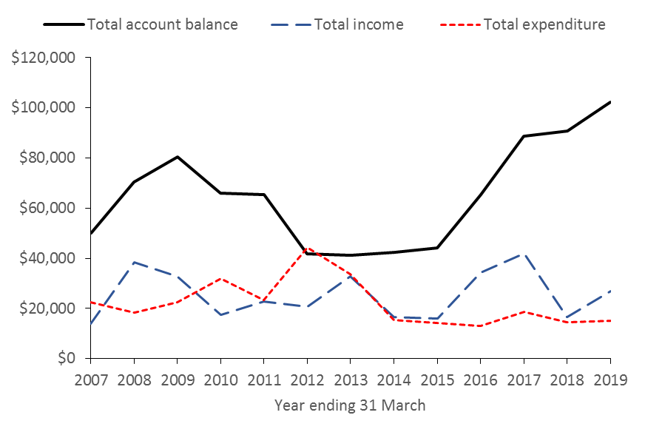
Figure A2.1: NZMSS total income, total expenditure and total account balance from 2007 to 2019

Financial summary (2018/2019)
Table A2.2 shows income and expenditure for the 2018/2019 year and is prepared on a GST exclusive basis. However, note the Society usually pays a GST bill of several thousand dollars each year. The Society pays GST on memberships, conference registration and sponsorship, and can claim GST on some expenditure (e.g. website), but not on others (e.g. student awards).

The Society relies on conference organisers to demonstrate financial acumen and to aim to return a surplus of c. $10,000. Thank you to On Cue and the conference organising committee for returning a surplus of nearly $15,000 for the 2018 conference in Napier. Income received from sponsorship at the 2018 conference totalled c. $75,000, which is a substantial amount and demonstrates the degree to which the Society relies on sponsorship for conferences to break-even or return a surplus. Note that conference income was c. $143,000 and expenditure was c. $128,000. These figures also highlight the increasing costs of running NZMSS conferences. To date we have managed to cover growing costs through greater efforts to secure sponsorship, rather than increasing registration fees.

Figure A2.2 shows the conference surplus and membership income for 2018/2019 in the context of previous years. Conference surplus varies considerably from year to year but has averaged around $12,000 over the past 10 years. Membership also varies quite a bit from year to year and has averaged around $9,000 over the past 10 years. We have previously noted that membership income appears to be significantly affected by the number of people attending the conference. (So, please pay your membership fees even if you don’t go to the conference!)

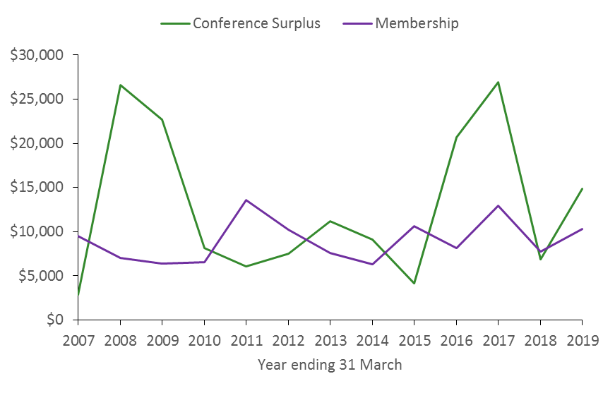
Figure A2.2: NZMSS conference surplus and membership income from 2007 to 2019

Table A2.2: NZMSS income and expenditure (GST exc.) for the year ended 31 March 2019
 | 2018/2019 Actual
NZMSS Income
Membership | 10,287
Conference surplus | 14,855
Interest | 1,609
Total income | $26,751
NZMSS Expenses
Audit fees | 650
Bank fees | 231
Council and general expenses | 753
NZMSS award sculpture | 800
John Morton Medal | 130
RSNZ affiliation fee | 870
First Overseas Conference Travel Award | 4,500
Student research award | 3,000
Student conference prizes | 1,000
Xero subscription fees | 685
Website (hosting) | 538
Website (re-design) | 2,033
Total expenditure | $15,191
Surplus income over expenditure for year | $11,559

Appendix 3 - Proposed Budget (2019/20)

To ensure that the council follows the financial system as outlined in Figure A3.1, the proposed budget:

    - Aligns income received from the previous year’s conference to expenditure in the financial year following the conference, to reflect the amount the Society can afford from known conference surplus,
    - Aims to keep student awards (FOCTA and Student Research award) as for last year so that students know how much is available and awards are consistent from year to year,
    - Recommends $1,000 be budgeted to pay for on-going website hosting and maintenance to ensure content is up to date and that facilities work as intended,
    - Aims for a projected surplus of income over expenditure of c. $9,000 (to fund student awards the following year) as the joint conference with AMSA in Australia in 2020 is not expected to generate much surplus for NZMSS.

The budget includes a mix of projected and actual income to reflect the amount of funds available for the 2019/2020 year. Projected income includes membership subscriptions and bank interest, and actual income is from the 2018 conference. Note that the budget has been prepared on a GST exclusive basis to reflect the amount of money available, and to be consistent with the financial summary and auditor’s reports. With these recommendations in mind the council proposes the following budget for 2019/20 financial year:

Table 3: Proposed budget for 2019/2020
Income/expenditure | 2019/2020 (exc. GST)
Projected and actual income
Projected income
Membership | 9,000
Interest received | 1,500
Actual income
Conference surplus (from 2018 conference) | 14,855
Total projected and actual income | $25,355
Budgeted expenditure
Core business
Audit fees | 2,000
Bank fees | 0
General council expenses | 2,000
Website hosting & maintenance | 1,000
NZMSS award sculpture and John Morton Award | 1,000
Royal Society of NZ - affiliation fees | 1,000
Xero monthly subscription | 700
Awards
First Overseas Conference Travel Awards | 4,500
Student research award | 3,000
Student awards at conference | 1,000
Special projects and initiatives | 0
Total budgeted expenditure | $16,200
Projected surplus of income over expenditure | $9,155

NZMSS finance system

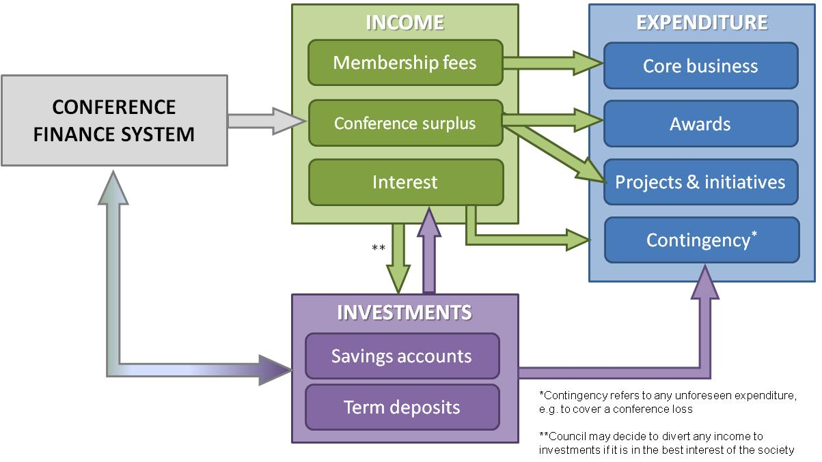
Figure A3.1: NZMSS generates income in three main ways: membership fees, conference surplus and interest from society investments. Society expenditure includes core business (the costs of running the society), projects and initiatives (e.g. website redesign) and awards (e.g. First Oversees Conference Travel Awards, student conference prizes). The conference finance system uses the society investments to outlay funds such as conference deposits, which should then be returned to the society investments after the conference. However, in the event of the conference running at a loss, or any other unforeseen expenses, the society requires sufficient investments to bear those expenses.

Appendix 4 - Auditor’s Report (2017/2018)

Appendix 5 – Council Reports 2018/19

1. Membership numbers

Membership type | 2010-11 | 2011-12 | 2012-13 | 2013-14 | 2014-15 | 2015-16 | 2016-17 | 2017-18 | 2018-19
Professional | 170 | 130 | 131 | 109 | 189 | 108 | 170 | 120 | 136
Life | 19 | 18 | 18 | 19 | 20 | 19 | 20 | 23 | 20
Retired/student | 114 | 98 | 76 | 90 | 86 | 121 | 113
Retired |  |  |  |  |  |  |  | 0 | 1
Student |  |  |  |  |  |  |  | 91 | 66
Institutional | 9 | 8 | 7 | 7 | - | - | - | - | -
Total | 312 | 254 | 232 | 225 | 295 | 249 | 303 | 235 | 223

A full list of 2018-19 members is provided in Appendix 6.

2. Council operational activities

Members
Council had 16 members (including three student reps). A list of 2018-19 members is provided in Appendix 7.

Meetings
There have been 11 meetings; all via phone conference call.

No face-to-face meeting was held in 2018/19 because the travel support required by Council members is quite large and the Council felt as though things were running effectively. It was decided that face-to-face meetings should be scheduled when there are big items to discuss rather than having them as a matter of course.

Royal Society Constituent Organisation Forum meetings
Nick Shears attended the Royal Society Constituent Organisation Forum meeting organised during the year (February 2019).

3. Submissions
Submissions prepared:
- Concern of the NZMSS over potential impacts of restructuring on natural environment collections (August 2018)
- Draft convention on biological diversity national report (November 2018)
- Proposed review of the CRA2 rock lobster fishery (December 2018)
- Development of a new NZ Biodiversity Strategy (February 2019)
- Initial views on new global targets for the Convention on Biological Diversity (March 2019)
- New Zealand museums require a radical rethink (March 2019)
- Your fisheries your say (March 2019)
- Better rules for marine pests (May 2019)

Submission opportunities advertised to the membership but not submitted on by NZMSS:
- New assessment of the conservation status of New Zealand macroalgae (October 2018)
- New Zealand MPA reporting to the CBD and UNEP-WCMC (October 2018)
- Request for a temporary closure of Umupuia Beach to the harvest of cockles (November 2018)
- Whitebait management (January 2019)
- Calling for a moratorium on staff restructuring at Te Papa (March 2019)
- Proposed changes to the blue cod fishing regulations (March 2019)

Our new website does not have the submissions loaded yet, but we aim to load them soon. Please contact the Secretary (secretary@nzmss.org) if you would like to view of copy of any of the submissions.

4. Student awards
NZMSS supported four students to attend their first overseas conference:
- Marta Guerra (University of Otago - $1100)
- Laura Biessy (University of Waikato/Cawthron - $1100)
- Vera Rullens (University of Waikato - $1150)
- Stephanie Mangan (University of Waikato - $1150)

NZMSS supported Matthew Bennion with a $3000 Student Research Award to contribute towards his research costs on ‘Gas bubble disease and rickettsiosis in New Zealand surf clams’.

5. New NZMSS website
Launching the new NZMSS website has been a huge achievement for the Council. The new website is high-quality and easier to navigate, with improved functionality for managing our membership system. The Council took advantage of an offer from Royal Society of New Zealand for Constituent Organisations to have free development of a new website. NZMSS paid for some set up and customization of the membership system. Development of the new website was driven by a sub-committee of Council members including Hilke Giles, Emma Newcombe, Sam Thomas, Vera Rullens and Bailey Lovett (previous Council) and a number of other people contributed to updating the content. Link to the website is https://nzmss.org/

Appendix 6 – 2018/19 NZMSS Membership List (as of 12 May 2019)

Ahern, Daniel
Alestra, Tommaso
Allard, Harry
Ataria, James
Ayrton, Hilary
Babuder, Mareike
Baker, Virginia
Barrett, Patrick
Beamsley, Brett
Bell, Andrew
Bell, Jacqui
Bennett, Genevieve
Bennington, Steph
Bennion, Matthew
Beya, Jose
Biessy, Laura
Blackett, Paula
Blackwell, Grant
Boey, Jian Sheng
Bolton-Ritchie, Lesley
Booth, John
Brand, Sarah
Brooks, Amber
Brown, Julie
Bryan, Karin
Bulmer, Richard
Burn, Courtney
Bury, Sarah
Cadwallander, Helen
Carbines, Megan
Carter, Lionel
Charan-Dixon, Hannah
Chiswell, Stephen
Choat, Howard
Christie, Rob
Clark, Dana
Clark, Malcolm
Clark, Sophia
Cornelisen, Chris
Creese, Bob
Crossett, Dan
Cryer, Martin
Culliford, David
Datta, Samik
Decima, Moira
Deppe, Lorna
Donlon, Erica
Douglas, Emily
Drylie, Tarn
Dunmore, Robyn
Durante, Leonardo
Elvines, Deanna
Fairlie, Regan
Feickert, Jessica
Flowers, Georgina
Foley, Melissa
Ford, Rich
Forde, Jacinta
Forsythe, Andrew
Fothergill, Nicola
Francis, Chris
Francis, Malcolm
Frowst, Emily Joy
Gabara, Rachel
Gall, Mark
Gardiner, Sarah
Geange, Shane
Gerrity, Shawn
Giles, Hilke
Giorli, Giacomo
Gladstone-Gallagher, Rebecca
Gordon, Dennis
Gower, Fiona
Graham, Brittany
Graham, Lisa
Gray, Stefan
Grieve, Janet
Growcott, Abraham
Guerra, Marta
Hall, Julie
Halliwell, Alex
Hanns, Benn
Hansen, Rod
Happy, Samantha
Harley, Shelton
Hayden, Barb
Hayward, Bruce
Hewitt, Judi
Heyns, Karlien
Hickman, Bob
Hunt, Stephen
Ingley, Rhian
Izadi, Sahar
Jarvis, Rebecca
Jhugroo, Khush
Jimenez Brito, Balam
Johnston, Olivia
Johnston , Ashleigh
Jones, Emma
Jones, Hannah
Kelly, Shane
Kemp, Leah
Kluza, Daniel
Knight, Ben
Kolodzey, Stina
Lane, Henry
Larson, Carol
Lass, Hamish
Lau, Carmen
Law, K. L. Eddie
Lawless, Peter
Le Heron, Richard
Leduc, Daniel
Leonard, Kaeden
Lewis, Robert
Liggins, Libby
Lin, Han-Yang
Livingston, Mary
Logie, June
Lohrer, Drew
Lubarsky, Katie
Lulijwa, Ronald
Lundquist, Carolyn
Macdonald, Helen
Mace, Pamela
Mackenzie, Lincoln
Madarasz-Smith, Anna
Mangan, Steph
Marsden, Islay
Masoomi Dezfooli, Seyedehsara
Mc Cormack, Sam
McCowan, Tom
McGrath, Gemma
McKenzie, Jeremy
Mckinnon, Alicia
McMullin, Rebecca
McNatty, Alice
Mello, Hannah
Merrick, India
Meyers, Morgan
Middleton, Irene
Milne, Juliet
Morrison, Alice
Mountjoy, Joshua
Murdoch, Rob
Myers, Elisabeth
Nahmad-Rohen, Luis
Needham, Hazel
Neil, Helen
Nelson, Wendy
Nessia, Hayley
Nodder, Scott
Northcott, Grant
Nutsford, Constance
O'Callaghan, Joe
O'Carroll, Jack
O'Connor, Gabby
Oliver, Megan
Orpin, Alan
Palmer, Steve
Pan, Hsiao-heng (Tony)
Pande, Anjali
Pantos, Olga
Papa, Yvan
Parsons, Darren
Peat, Casey
Petersen, Grady
Pilditch, Conrad
Pinkerton, Matt
Pochon, Xavier
Probert, Keith
Qureshi, Yusuf
Rayment, William
Rickard, Graham
Riekkola, Leena
Ritchie, Peter
Rogers, Alice
Ross, Phil
Rullens, Vera
Sabadel, Amandine
Sabetian, Armagan
Schenone, Stefano
Schiel, David
Sevicke-Jones, Graham
Seyfoddin, Ali
Shears, Nick
Shima, Jeff
Slooten, Liz
Smith, Aless
Smith, Shade
Smith, Trecia
Solomon, Gina
Somerford, Tamlyn
Somervell, Rachel
Stahlmann, Nico
Stevens, Craig
Stuck, Esther
Taiapa, Caine
Taikato, Vannesa
Tait, Leigh
Taylor, Rikki
Tellier, Pierre
Thomas, Sam
Thomsen, Mads
Thrush, Simon
Townsend, Michael
Tremblay, Louis
Twist, Brenton
Urlich, Steve
Van Nguyen, Thao
von Ammon, Ulla
Wallace, Catherine
Walls, Kathy
Walton, Kerry
Wenley, Jess
Williams, Uru-Manuka Ming-Cheung
Wilson, Oliver
Wilson, Pete
Wood, Susie
Woods, Chris
Worrallo, Katie
Young, Tim
Zaiko, Anastasija

Appendix 7 – NZMSS Council Elected Membership (2018/19)

President: | Nick Shears | University of Auckland
Vice President: | Kathy Walls | MPI
Secretary: | Dana Clark | Cawthron
Treasurer: | Hannah Jones | Waikato Regional Council

Immediate Past President: | Hilke Giles | Pisces Consulting

Council Members: | Anna Madarasz-Smith | Hawkes Bay Regional Council
 | Liz Slooten | University of Otago
 | Islay Marsden | University of Canterbury
 | Holly Bennett (secretary in training) | Cawthron
 | Will Rayment | University of Otago
 | Emma Newcombe | Cawthron
 | Rob Major (treasurer in training) | Cawthron
 | Ani Murchie | NIWA

Student Representatives: | Sam Thomas (website coordinator) | University of Otago
 | Vera Rullens (membership secretary) | University of Waikato
 | Leena Riekkola | University of Auckland

Conference Committee NZMSS 2019:
 | Liz Slooten | University of Otago
 | Will Rayment | University of Otago
 | Sam Thomas | University of Otago
 | Kim Currie | NIWA/University of Otago
 | Ani Kainamu-Murchie | NIWA
 | Rob Lewis | University of Otago
 | Marta Guerra | University of Otago
 | Brendan Flack | Kāti Huirapa ki Puketeraki
 | Jerusha Bennett | University of Otago

Note that because Council does not hold a face-to-face meeting by default, the full budgeted amount is unlikely to be required (in 2018/2019 we spent $753 on this item). But, we include this here to allow for a face-to-face meeting for the Council, or a sub-committee, if the need arises.
There are no special projects or initiatives planned for this year; see point (iv) above.

