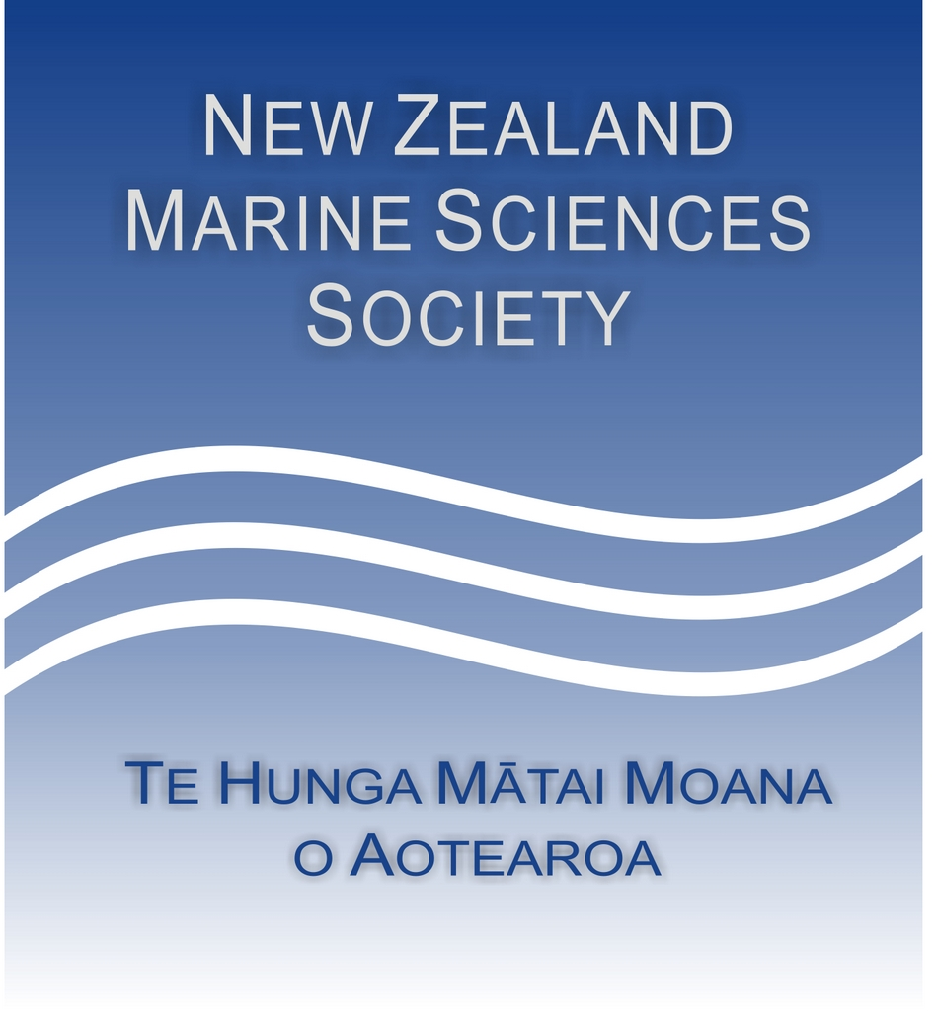

**Hauraki Gulf Forum 25th Anniversary Research Awards**

To commemorate the 25th anniversary of the Hauraki Gulf Marine Park, the Hauraki Gulf Forum, in partnership with the New Zealand Marine Sciences Society, is proud to sponsor two one-off research awards to support emerging marine researchers. These awards will celebrate and enable marine science research that contributes to the health and wellbeing of the Hauraki Gulf / Tīkapa Moana / Te Moananui ā Toi. Two awards of $5,000 each will be offered:

* **He Taonga te Moana,** supporting kaupapa Māori-led marine science being undertaken in and/or for the benefit of Te Moananui ā Toi / Tīkapa Moana / The Hauraki Gulf; and
* **General Marine Science award,** supporting impactful marine science research being undertaken in and/or for the benefit of Te Moananui ā Toi / Tīkapa Moana / The Hauraki Gulf.

These awards aim to recognise and uplift emerging voices in marine science who are committed to the future of Te Moananui ā Toi / Tīkapa Moana / The Hauraki Gulf.

To apply, please send a completed application form and a 2 page CV to [secretary@nzmss.org](mailto:secretary@nzmss.org) by 29th June 2025.

The awardees will be announced at the 2025 NZMSS Conference in Marlborough, 7-10 July 2025. The successful applicants will be asked to present their work to the Hauraki Gulf Forum within the following year, and at a future NZMSS conference.

**APPLICATION FORM**

|  |  |
| --- | --- |
| **Applicant Details** | |
| Title |  |
| Name |  |
| Address |  |
| City |  |
| Postcode |  |
| Telephone |  |
| Email |  |
| Marine science field |  |
| Current position |  |
| Are you a current member of NZMSS (required) | Yes/No |

|  |  |
| --- | --- |
| **Award Category (please select one)** | |
| He Taonga te Moana Award: | Supporting kaupapa Māori-led marine science being undertaken in and/or for the benefit of Te Moananui ā Toi / Tīkapa Moana / The Hauraki Gulf. Applicants must whakapapa Māori. |
| General Marine Science Award: | Supporting impactful marine science research being undertaken in and/or for the benefit of Te Moananui ā Toi / Tīkapa Moana / The Hauraki Gulf. |

|  |
| --- |
| **[A] Whakapapa or connection to Hauraki Gulf / Tīkapa Moana / Te Moananui ā Toi**  *Please describe your connection to the Hauraki Gulf Marine Park (max 300 words).* |
|  |

|  |
| --- |
| **[B] Project summary**  *Briefly describe your research project and its objectives (max 300 words).* |
|  |

|  |
| --- |
| **[C] Relevance to the Hauraki Gulf / Tīkapa Moana / Te Moananui ā Toi**  *How does your research support the health, understanding, or management of the Hauraki Gulf? (max 300 words).* |
|  |

|  |
| --- |
| **[D] Intended use of the award**  *Briefly outline how the award funding of $5,000 will be used. Include any specific activities, fieldwork, equipment, travel, etc. (max 200 words).* |
|  |

|  |
| --- |
| **[E] Emerging Researcher Eligibility**  *Please briefly describe your current career stage and how you meet the eligibility as an emerging researcher (max 100 words).*  *Emerging researchers include Postgraduate students currently enrolled in a Masters or PhD programme and early-career researchers (within 5 years of completing their highest postgraduate qualification, excluding career breaks).* |
|  |

|  |
| --- |
| **[F] Contribution to NZMSS, including history of membership, and promoting the vision and values of the Society.**  *For example: years of membership, NZMSS Council positions held, attendance and/or supporting student attendance at NZMSS conferences, contributions to NZMSS submissions, organising NZMSS conferences, etc. (max 200 words).* |
|  |

|  |
| --- |
| **[G] Supporting documentation and/or references.**  *Please attach a 2-page CV and list any other relevant documents or references that here.* |
|  |